**Year 1 Weekly Timetable Week Commencing 23.03.25**

**To contact your child’s class teacher, please email** [**schooloffice@dawpool.wirral.sch.uk**](mailto:schooloffice@dawpool.wirral.sch.uk) **or phone 0151 648 3412**

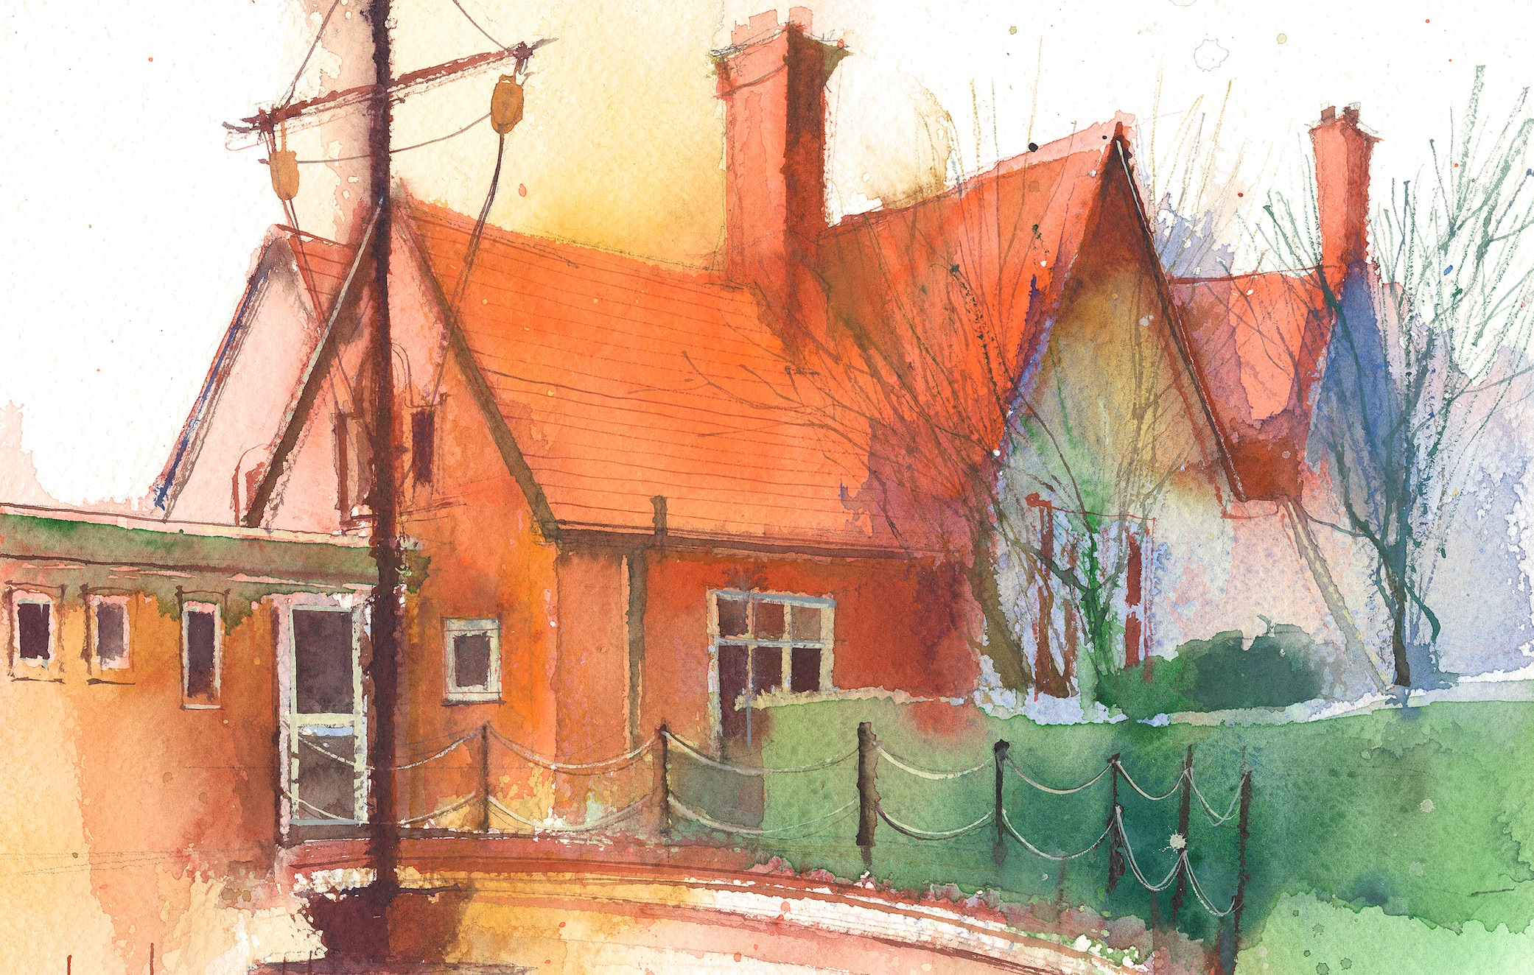

|  |  |  |  |  |  |  |
| --- | --- | --- | --- | --- | --- | --- |
|  | **Lessons 09:00 – 10:30** |  | **Lessons­­­­ 10:45 – 12:15** |  | **Lessons 13:15 – 15:30 (Incorporating 15-minute break)** | **Additional Tasks** |
| **Monday** | **Science:** I can observe my seed growing.  **Phonics:** ul as le (blending practice)  **Phonics:** ul as le (segmenting practice) | **Maths:** Maths Assessments.  **ERIC / GR** | **Fluent in 5**  **Forest School**  **My Happy Mind:** Appreciate. I can write a Mother’s Day card with the words “I appreciate”. | Useful Links / Other Recommended Activities  **Oak National Academy**  <https://classroom.thenational.academy/>  **BBC Bitesize**  <https://www.bbc.co.uk/bitesize>  **Purple Mash**  <https://www.purplemash.com/sch/dawpool#/>  **Recommended Reading List**  [See here](https://www.dawpool.wirral.sch.uk/website/recommended_reading_lists/577821) |
| **Tuesday**  **TITANIC DAY** | **English:** I can talk in role about how I felt being rescued from the Titanic. | **Maths:** I can find number bonds to ten in an iceberg game.  **ERIC / GR** | **PE:** I can learn how to dance like they did on the Titanic: waltz and country dance.  **Stories from the Titanic.** |
| **Wednesday** | **Phonics:** t and d as ed(blending practice)  **English:** I can write another diary entry using creative language. | **Maths:** To understand how to count in twos.  **ERIC / GR** | **Fluent in 5**  **Science:** I can observe my seed growing and record it in my diary.  **Picture News** |
| **Thursday** | **Phonics:** t and d as ed (segmenting practice)  **English:** Spag | **Maths:** Know how to compare mass.  **ERIC / GR** | **Fluent in 5**  **Heartsmart:** Don’t hold on to what’s wrong.  **PE:** Exploring dance with Titanic theme. |
| **Friday** |  | **See Mrs Clark’s Planning** |  |