Weekly Timetable Week Commencing 22.4.24
To contact your child’s class teacher, please email schooloffice@dawpool.wirral.sch.uk
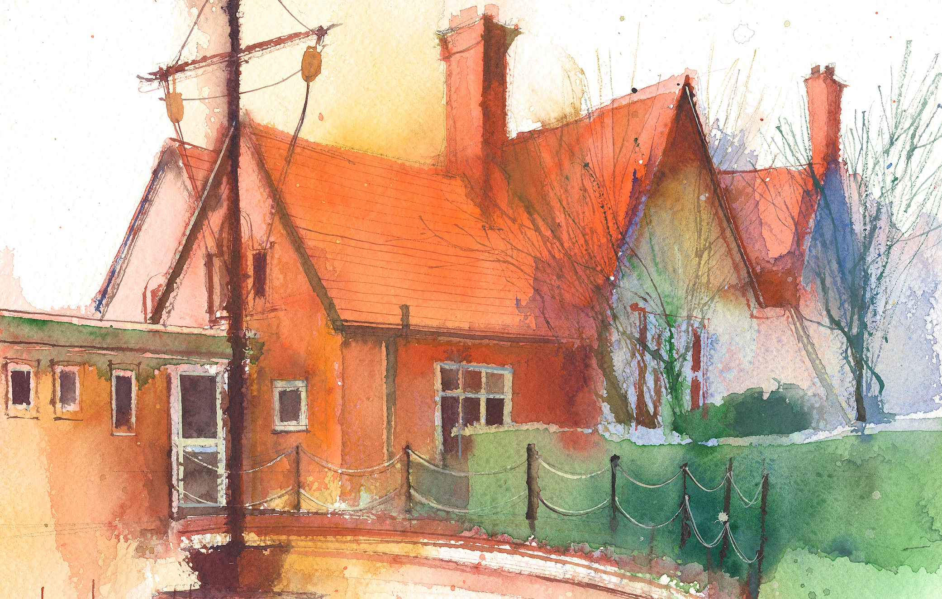

 | Session 1: 09:00-10:30 |  | Session 2: 10:45 – 12:15 |  | Session 3: 13:15 – 15:30 (Incorporating 15-minute break) |  | Additional Tasks
Monday  22.4.24 | Maths  By the end of this lesson pupils will:  To add decimals crossing the whole  Resources:  Third Space lesson slides and worksheets for Lesson 4 |  | .Literacy/science  By the end of this lesson children will learn how to spell science topic words and write sentences in their books to secure understanding:  Hardness solubility  Transparency transparent  Conductivity conductor  Magnetic filter evaporation  Dissolving mixing |  | Topic  By the end of this lesson your child will:  Find the main Rainforests on a world map and explain why they are located here. Write a report about rainforests based on the video on our class blog  Resources:  World Map  Purple Mash Year 5 Learning Blog. |  | Useful Links / Other Recommended Activities Oak National Academy https://classroom.thenational.acade my/ BBC Bitesize https://www.bbc.co.uk/bitesize Purple Mash https://www.purplemash.com/sch/d awpool#/  Daily Tasks:  - Daily reading “The Explorer  • Fluent in Five  • Rapid Reasoning  • Multiplication Tables  • Reading for Pleasure  - Heartsmart (Wednesday)  - Ising pop (Thursday)  - Picture News (Tuesday)  Homework is issued from Friday to Friday
Tuesday  23.4.24 | Maths  By the end of this lesson pupils will:  To add numbers greater than 1 with the same number of decimal places  Resources  Third Space Learning lesson slides and worksheets Lesson 5 |  | Literacy (The Explorer)  Lesson 9  By the end of this lesson your child should be able to:  Learn how to take clear and concise notes when  researching.  .  Children will take notes about a rainforest animal of their choice. They will learn how to take clear and concise notes in order to use these in a subsequent lesson to write a nonchronological  report. Some children will look at how to  create a bibliography. |  | ICT (cross curricular with topic)  By the end of this lesson pupils will:  Learn how to create goodies and baddies for a 3D Game with the theme of Rainforests.  Resources:  Purple Mash 3D DIY
Wednesday  24.4.24 | Mrs Hall |  | Mrs Hall |  | Mrs Hall
Thursday  25.4.24 | Maths  To subtract numbers with the same number of decimal places  Resources  Third Space Learning lesson slides and worksheets Lesson 6 |  | Literacy  Power of Reading  By the end of this lesson pupils will:  Write a non-chronological report.  Children will use notes taken in Lesson 9 to write a  non-chronological report about an Amazonian  creature of their choice. They will be encouraged to  use a range of DADWAVERS in their work to make  writing lively and interesting. |  | Reading  Journey to the River Sea. Chapter 1 Class to read and record their reflections on the class reading blog | P.E  Claremount  Basket Ball
Friday  26.4.24 | Maths  Arithmetic/Maths Assessment  Spelling test  Comprehension  Cracking Comprehension  All summer in a day  Resource P28 -29 |  | Science (Materials)  By the end of this lesson your child will learn the difference in the properties of materials:  To help them achieve this we will go to BBC Bitesizeand record findings on our class blog  https://www.bbc.co.uk/bitesize/articles/zm7ntrd |  | PPA

