**Year 5 Weekly Timetable Week Commencing 24.03.25**

**To contact your child’s class teacher, please email** [**schooloffice@dawpool.wirral.sch.uk**](mailto:schooloffice@dawpool.wirral.sch.uk) **or phone 0151 648 3412**

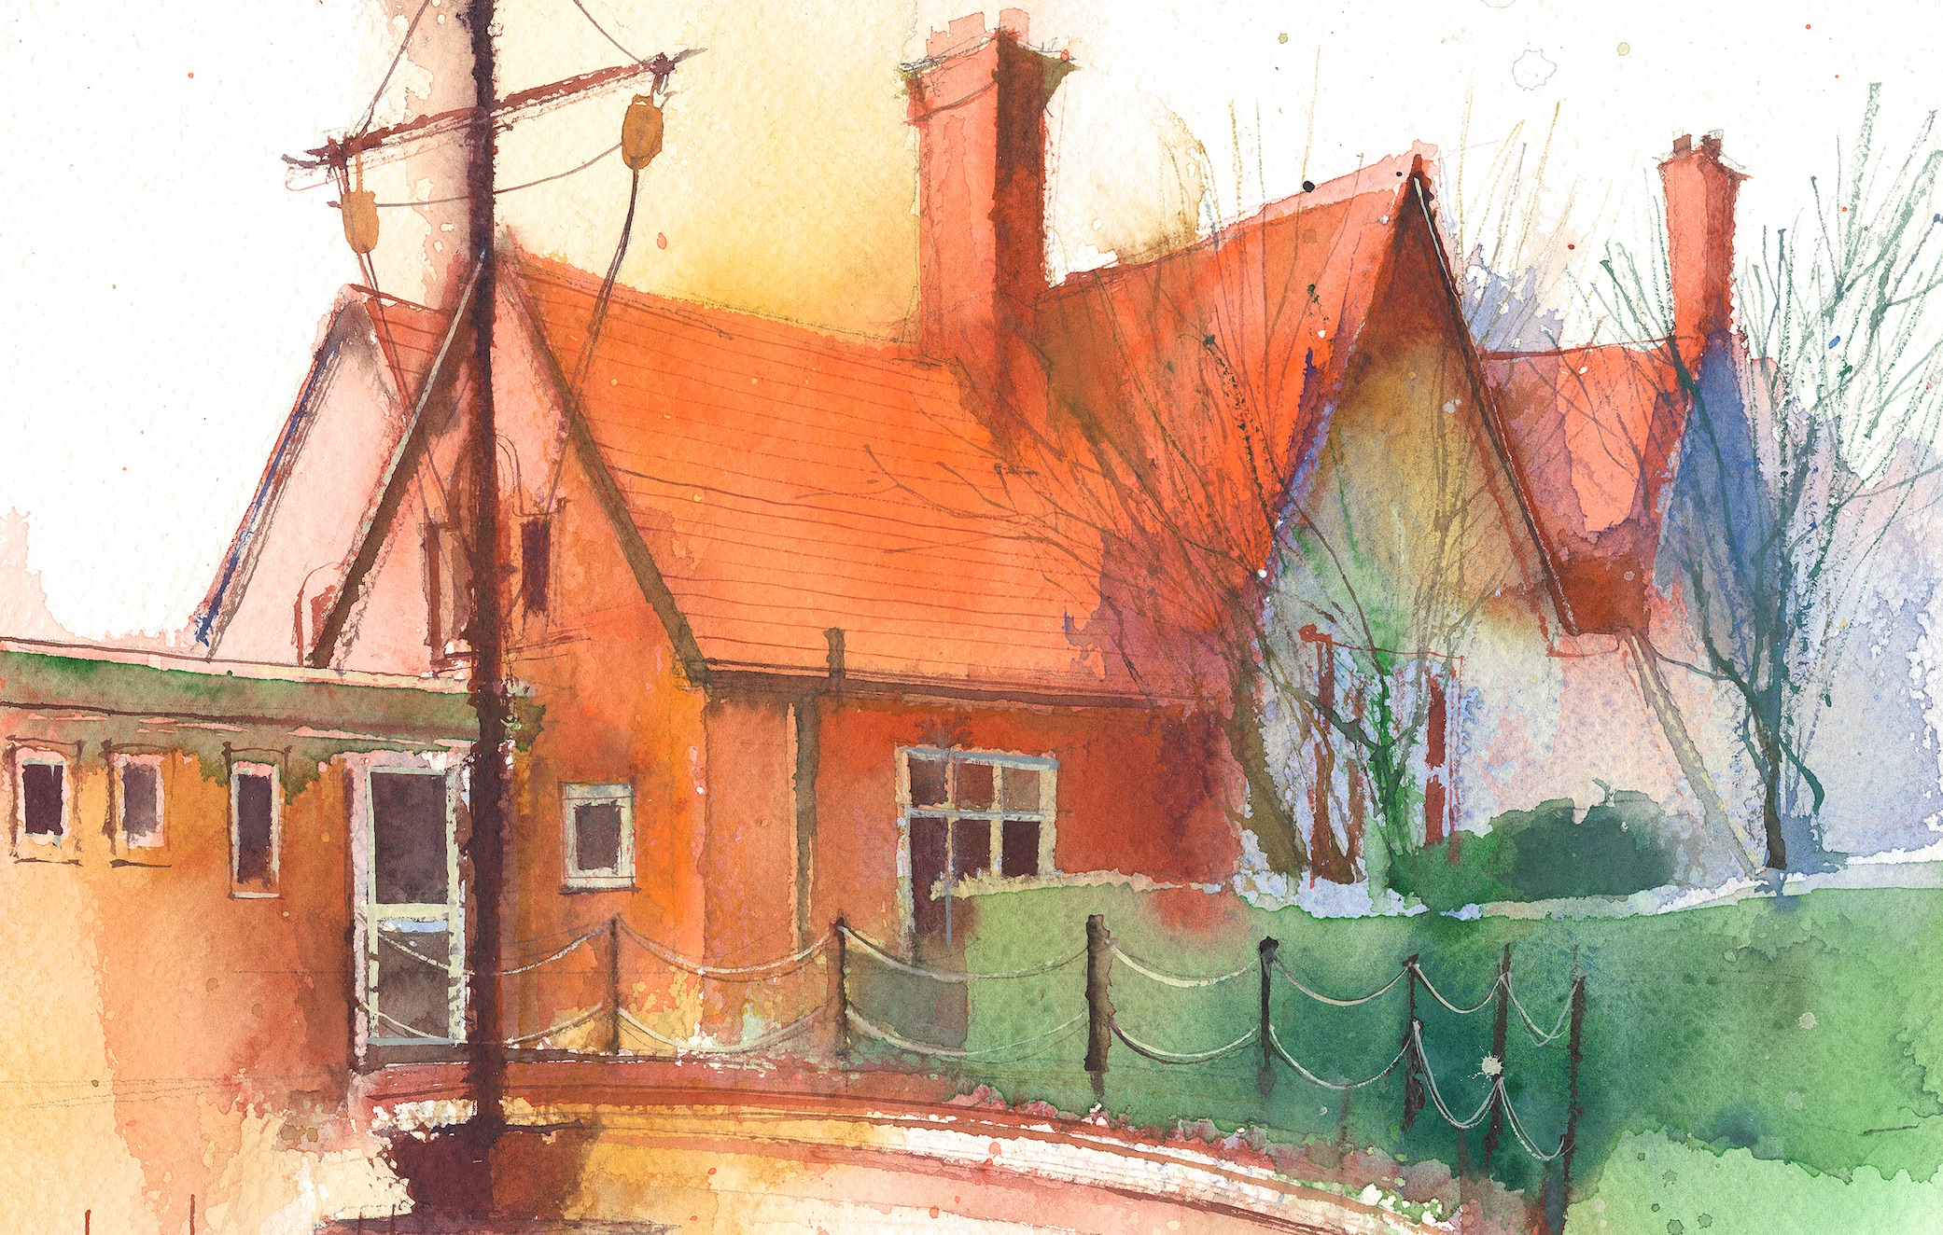

|  |  |  |  |  |  |  |
| --- | --- | --- | --- | --- | --- | --- |
|  | **Lessons 09:00 – 10:30** |  | **Lessons­­­­ 10:45 – 12:15** |  | **Lessons 13:15 – 15:30 (Incorporating 15-minute break)** | **Additional Tasks** |
| **Monday** |  |  |  | Useful Links / Other Recommended Activities  **Oak National Academy**  <https://classroom.thenational.academy/>  **BBC Bitesize**  <https://www.bbc.co.uk/bitesize>  **Purple Mash**  <https://www.purplemash.com/sch/dawpool#/>  **Recommended Reading List**  [See here](https://www.dawpool.wirral.sch.uk/website/recommended_reading_lists/577821) |
| **Tuesday** |  |  |  |
| **Wednesday** | **Year 5 Grammar**  **Miss Bowker to deliver** | **Year 5 Maths**  By the end of this lesson your child should be able to:  **Practise and reinforce arithmetic skills.** | **Year 5 Art**  By the end of this lesson your child should be able to:  **Create a bird print using Press Print.**  **Mother’s Day cards**  **Miss Bowker to deliver.**  **Year 5 Music – Liverpool Philharmonic – The World in One City: A Musical Journey**  By the end of this lesson your child should be able to: **Lesson 6 – Dance then, wherever you may be!**  **· appreciate and understand a wide range of high-quality live and recorded music drawn from different traditions and from great composers and musicians.**  **· develop an understanding of the history of music.**  **· build musical confidence through active engagement with music as creators and audience.**  **· further develop their shared knowledge of important moments in the evolution of music and of key musicians, including composers and performers, in a range of genres and styles.** |
| **Thursday** |  |  |  |
| **Friday** | **Year 5 Reading Comprehension – You can’t be that by Brian Patten**  By the end of this lesson your child should be able to: **Understand and respond to the poem accurately.** |  |  |