RFoundation 1 Weekly Timetable Week Commencing 11.01.21
To contact your child’s class teacher, please email foundation1@dawpool.wirral.sch.uk
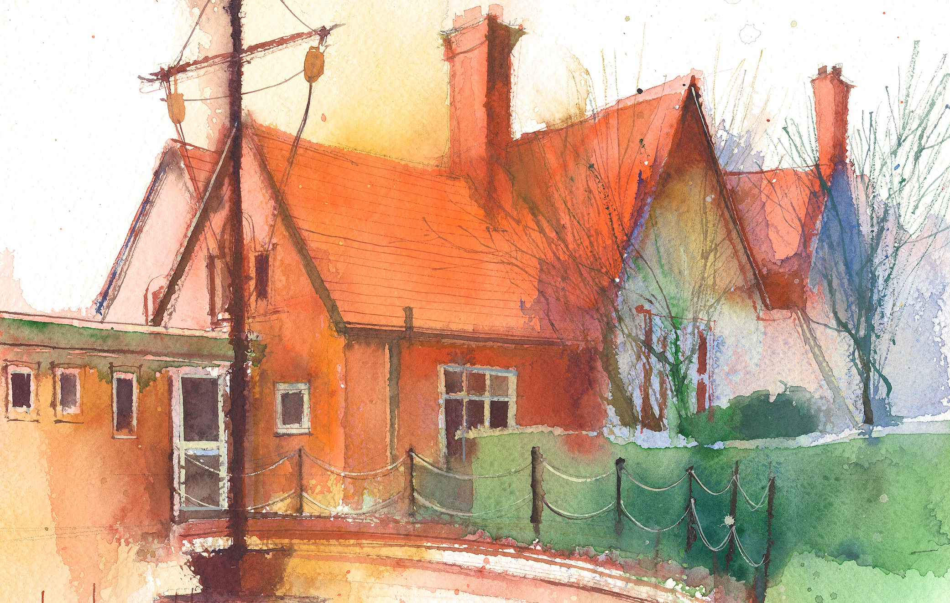

This timetable is available in the event that all Foundation 1 pupils are required to self-isolate at home. Please visit the Foundation 1 Remote Learning Page to
access any downloadable resources and activity sheets. The assessed task should be submitted to the teacher at the end of each day via Tapestry.

 | Session 1: |  | Session 2: |  | Assessed Task
Monday  11.01.21 | SUBJECT: Personal, social and emotional  By the end of this lesson your child should be able to:  - Understand others feelings  - Talk about own Feelings  We recommend the following resources and activities to achieve this objective:  Talk about the characters in the 3 little pigs and how they might have been feeling. Discuss when they where feeling like this and why they were feeling like this?  Have you ever felt similar to any of the characters? When was this? |  | SUBJECT: Phase 1 Phonics- Body percussion and voice sounds  By the end of this lesson your child should be able to:  - Use their voice and body to make different sounds  - Copy sounds and actions  - Remember a simple pattern  We recommend the following resources and activities to achieve this objective:  Model a pattern of actions and sounds to your child, for example shhhh, clap, can they copy this pattern? Ask them to do a 2 part pattern for you to copy? Once this is mastered move on to a 3 part pattern for example shhhh, clap, tap.  Once child is able to copy a pattern can you look at making the sounds made louder and quieter. |  | Login to Tapestry to submit today’s assessed task:  Use the templates on the home learning page and draw faces on the pig and the wolf to show how they are feeling.  Tell your grown up how their feeling and why they are feeling like this. (please write down what your child says)
Tuesday  12.01.21 | SUBJECT: Communication and Language  By the end of this lesson your child should be able to:  - Understand and answer who, what, why, where and how questions.  We recommend the following resources and activities to achieve this objective:  Use the worksheet on the home learning page and ask your child the who, what, why questions can they understand them and answer them correctly. If you have the book of the three pig little pigs use this to help if needed and encourage children to understand what is being asked and how to answer them correctly. |  | SUBJECT: understanding the world  By the end of this lesson your child should be able to:  - Explore collections of materials with different properties.  We recommend the following resources and activities to achieve this objective:  Discuss the different materials the pigs used to build their houses. What did these look like? What do you think they felt like? Why do you think some of the houses blew down? Talk about what your house is made of is it strong? Go outside and ‘huff and puff ‘like the wolf! Why didn’t it blow down? What would happen if you house was made of paper?  Talk with your child about different materials being stronger than others. But they are all good for different reasons for example straw is not good to make houses for people but It can be used for pets and animals to keep warm. |  | Design your own house (using the template on the home learning page)  - Draw what it would look like  - Tell an adult what it would be made from?  - Tell an adult why you would use these materials.  If you have any boxes or other materials can you have a go at making your house? Please send in picture.
Wednesday  13.01.21 | SUBJECT: Physical development  By the end of this lesson your child should be able to:  - Remember a sequence and pattern of movement.  - Develop core strength by balancing  We recommend the following resources and activities to achieve this objective:  Ask your child to practises some balances; can you balance on one leg, can you balance on the other leg? Can you balance on the floor with one leg in the air, can you balance with both your hands and feet on the floor. Now play some music and when the music stops strike a balance pose how long can you hold it for? Repeat this until all balances have been completed.  Watch the short utube video about moving like different animals. Now join in which move was your favourite?  https://youtu.be/6LndXdPdKaQ |  | SUBJECT Maths  By the end of this lesson your child should be able to:  - Say one number for each item in order  - Link numerals to the correct amount.  - Know that the last number reached when counting a small set of objects tells you the total.  We recommend the following resources and activities to achieve this objective:  Start of by warming your brain an count to 10 , remember to start from 0.  Use the counting and matching sheet on the home learning page.  Encourage your child to use the finger and carefully touch each one whilst counting the objects.  Can they tell you the total amount of objects?  Can they recognise the numbers on the cards and tell you which one matches the total. |  | Take a picture of some of your balances…. Can you hold it!!  Upload the picture to tapestry
Thursday  14.01.21 | SUBJECT: Maths  By the end of this lesson your child should be able to:  - Talk about 2d shapes using correct mathematical language – sides, corners, straight, flat, round  - Select Shapes appropriately to make a picture.  We recommend the following resources and activities to achieve this objective:  Watch the following video, pause it each time it asks to draw it in the air, for you child to have a go. Did they recognise any shapes before the name was said?  Once you have watched the video can they remember how many sides a square, rectangle, circle and rectangle have?  https://youtu.be/OEbRDtCAFdU |  | SUBJECT: Literacy  By the end of this lesson your child should be able to:  - Write some or all of their name  - Write some recognisable letters.  We recommend the following resources and activities to achieve this objective:  Does your child recognise their name?  Talk about what their name starts with.  Do they recognise any other letters from their name?  Have go at writing it on a piece of paper  If your child is finding it a bit tricky use a felt tip pen and write their name and ask them to careful go over it following the lines with a pencil. |  | On the home learning page there is a page of 2d shapes  - Print out the shapes  - Colour them in  - Have a go at cutting them out ask a grown up to help if you find it a bit tricky  - Use the shapes to make a house  - Tell your grown what shapes you have used to make your house.  - Can you tell your grown up any properties about the shapes.
Friday  15.01.20 | SUBJECT: Maths  By the end of this lesson your child should be able to:  - Talk about 2d shapes using correct mathematical language – sides, corners, straight, flat, round  We recommend the following resources and activities to achieve this objective:  Use the shape sheet on the remote learning page. What shapes can you see? Once you have identified the shapes go on a shape hunt and count how many of the 2d shapes you find. During the shape ask your child to tell you how they know it is a square ‘it has 4 sides’ If you can write the total inside the shape for each one,.  Which shape did you find the most of?  Which shape did you find the least of? |  | SUBJECT: Expressive arts and design  By the end of this lesson your child should be able to:  We recommend the following resources and activities to achieve this objective:  This will be the last session on Three Little pigs before we move on to another traditional tale. Ask your child to retell you the story, can they remember the repeated refrain used by the pigs and the wolf? Encourage them to change their voices for different characters. |  | Look at the image on the remote learning page of the handprint pig  - Draw round your hand  - Colour it in  - With some help cut out your hand  - Talk with your grown up what your pig needs (eyes, nose, mouth, tail, trotters)  - Add these to your pig  - Give you’re a pig a name  Take a picture of your pig and upload it to tapestry!

