Year 6 Weekly Timetable Week Commencing 20.04.26
To contact your child’s class teacher, please email schooloffice@dawpool.wirral.sch.uk or phone 0151 648 3412
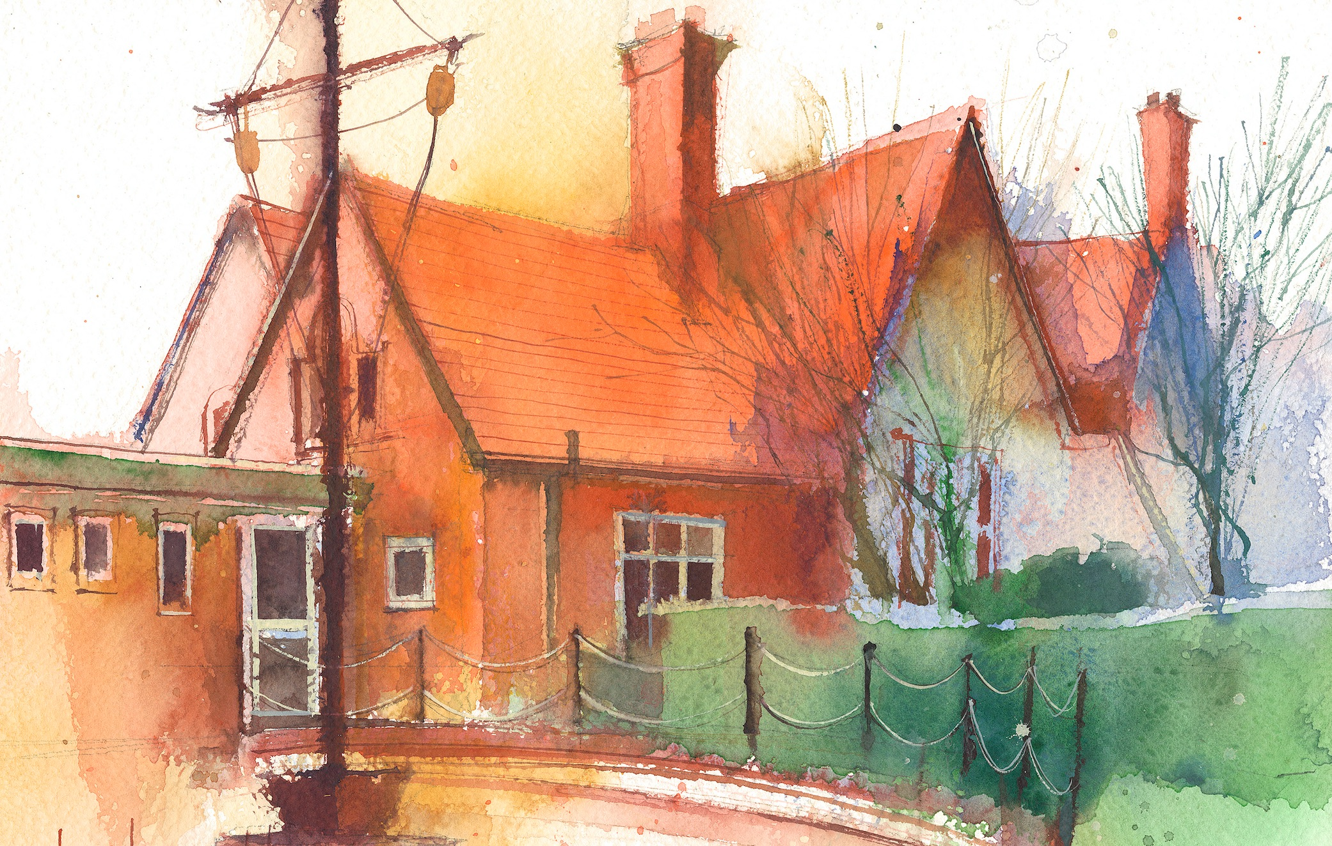

Mrs Croft Monday – Friday

 | Lessons 09:00 – 10:30 |  | Lessons 10:45 – 12:15 |  | Lessons 13:15 – 15:30  (Incorporating 15-minute break) | Additional Tasks
Monday | Fluent in Five/Rapid Reasoning and Arithmetic  Objective:  - To improve mental and written arithmetic strategies and algorithms within a timed period.  Maths  Objective:  - I can find the area of a parallelogram. |  | English:  Objectives:  - I can undertake a written comprehension on our class text.  - I can check the non-negotiables of spelling, punctuation and Capital letters. |  | Geography:  Objective:  - I can understand world time zones and explore these on a map of North America.  Heartsmart:  Objective:  - I can explore fake is a mistake and explore what it means to be loved just as we are. | - Create a fact file on a country in North America of your choice.  - Write a postcard from New York home.  - Draw your own New York skyline
Tuesday | Fluent in Five/Rapid Reasoning and Arithmetic  Objective:  1To improve mental and written arithmetic strategies and algorithms within a timed period.  Maths  Objective:  - I can explore volume by counting cubes. |  | English: Narrative  Objectives:  - I can use a range of punctuation for parenthesis.  - I can check the non-negotiables of spelling, punctuation and Capital letters. |  | Science: Living things and their habitats  Objectives  - I can classify plants and animals and record in a table  - I can classify and sort mini beasts using classification keys.
Wednesday | Fluent in Five/Rapid Reasoning and Arithmetic  Objective:  - To improve mental and written arithmetic strategies and algorithms within a timed period.  Maths  Objective:  - I can find the volume of different cuboids. |  | English: Narrative  Objectives:  - I can use a colon to mark the boundaries between two independent clauses.  - I can check the non-negotiables of spelling, punctuation and Capital letters. |  | PPA – Mrs Croft  RE Unit 6.5 Ascension and Pentecost  - I know the events of the story of Jesus' ascencion into heaven.  - I can discuss artistic impressions of this event and discuss whether they really reflect the event.  Computing - Coding  - I can follow flowcharts to create and debug code.  - I can create flowcharts for procedures.  - I can use coding skills to generate new visual effects within a simulation.
Thursday | Fluent in Five/Rapid Reasoning and Arithmetic  Objective:  - To improve mental and written arithmetic strategies and algorithms within a timed period.  Maths  Objective:  I can undertake an end of unit assessment in perimeter, area and volume. |  | English: Narrative  Objectives:  - I can use relative clauses.  - I can check the non-negotiables of spelling, punctuation and Capital letters. |  | PE: Specialist teacher from Claremount  Gymnastics.  Music:  Objectives:  - I can create my own piece of music based on identity.
Friday | Fluent in Five/Rapid Reasoning and Arithmetic  Objective:  1.To improve mental and written arithmetic strategies and algorithms within a timed period.  Maths  Objective:  - I can use different metric measurements. |  | English – Non-fiction  Objectives:  - I can plan my narrative on our class book.  - I can use embedded relative clauses. |  | Art  Objective:  - I can explore some of Monet’s landscapes.  Spanish:  Objective:  - I can create a story in Spanish.

