Year 6 Weekly Timetable Week Commencing 26.01.26
To contact your child’s class teacher, please email schooloffice@dawpool.wirral.sch.uk or phone 0151 648 3412
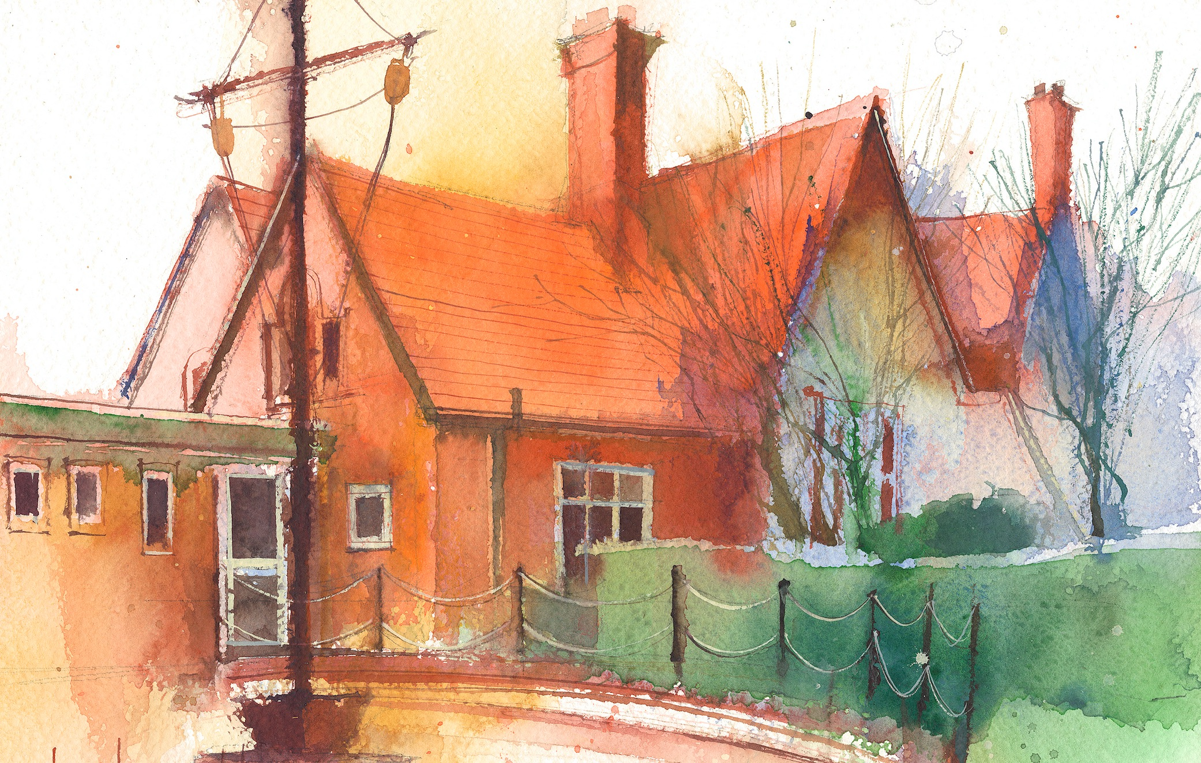

Mrs Croft Monday – Friday

 | Lessons 09:00 – 10:30 |  | Lessons 10:45 – 12:15 |  | Lessons 13:15 – 15:30  (Incorporating 15-minute break) | Additional Tasks
Monday | Fluent in Five/Rapid Reasoning and Arithmetic  Objective:  - To improve mental and written arithmetic strategies and algorithms within a timed period.  Maths  Objective:  - I can convert fractions to a percentage. |  | English:  Objectives:  - I can write a narrative including a range of grammatical devices.  - I can check the non-negotiables of spelling, punctuation and Capital letters. |  | History:  Objective:  - I can explain the difference between the axis and allies in WW2. | - Explore the life of an Evacuee during WW2. Write a letter home from an evacuee to their parents.  - BBC bitesize:  https://www.bbc.co.uk/bitesize/levels/zbr9wmn
Tuesday | Fluent in Five/Rapid Reasoning and Arithmetic  Objective:  - To improve mental and written arithmetic strategies and algorithms within a timed period.  Maths  Objective:  - I can use equivalent fractions, decimals and percentages. |  | English: Narrative  Objectives:  - I can write a narrative including a range of grammatical devices.  - I can check the non-negotiables of spelling, punctuation and Capital letters. |  | PE: Athletics  Objectives  - Specialist teacher in to teach the children Athletics.
Wednesday | Fluent in Five/Rapid Reasoning and Arithmetic  Objective:  - To improve mental and written arithmetic strategies and algorithms within a timed period.  Maths  Objective:  - I can order fractions, decimals and percentages. |  | English: Narrative  Objectives:  - I can write a narrative including a range of grammatical devices.  - I can check the non-negotiables of spelling, punctuation and Capital letters. |  | PPA – Mrs Croft  Mrs McCann RE/Computing
Thursday | Fluent in Five/Rapid Reasoning and Arithmetic  Objective:  1.To improve mental and written arithmetic strategies and algorithms within a timed period.  Maths  Objective:  - I can find a percentage of an amount. |  | English: Narrative  Objectives:  - I can write a narrative including a range of grammatical devices.  - I can check the non-negotiables of spelling, punctuation and Capital letters. |  | Art:  Objective:  I can use my sketchbook to sketch candid photographs from WW2.  Spanish:  Objective:  I can use some simple Spanish phrases to explain my appearance.
Friday | Fluent in Five/Rapid Reasoning and Arithmetic  Objective:  1.To improve mental and written arithmetic strategies and algorithms within a timed period.  Maths  Objective:  - I can undertake an end of unit diagnostics check in decimals. |  | English – Non-fiction  Objectives:  - I can identify the purpose and audience of a non-Chronological report.  - I can use embedded relative clauses. |  | Science: The Circulatory system  Objective:  - I can explain how nutrients are transported around the body.  Music:  A New Year Carol  Objective:  I can listen and appraise a New Year Carol.

