Year 1 Weekly Timetable Week Commencing 25.3.24
To contact your child’s class teacher, please email schooloffice@dawpool.wirral.sch.uk or phone 0151 648 3412
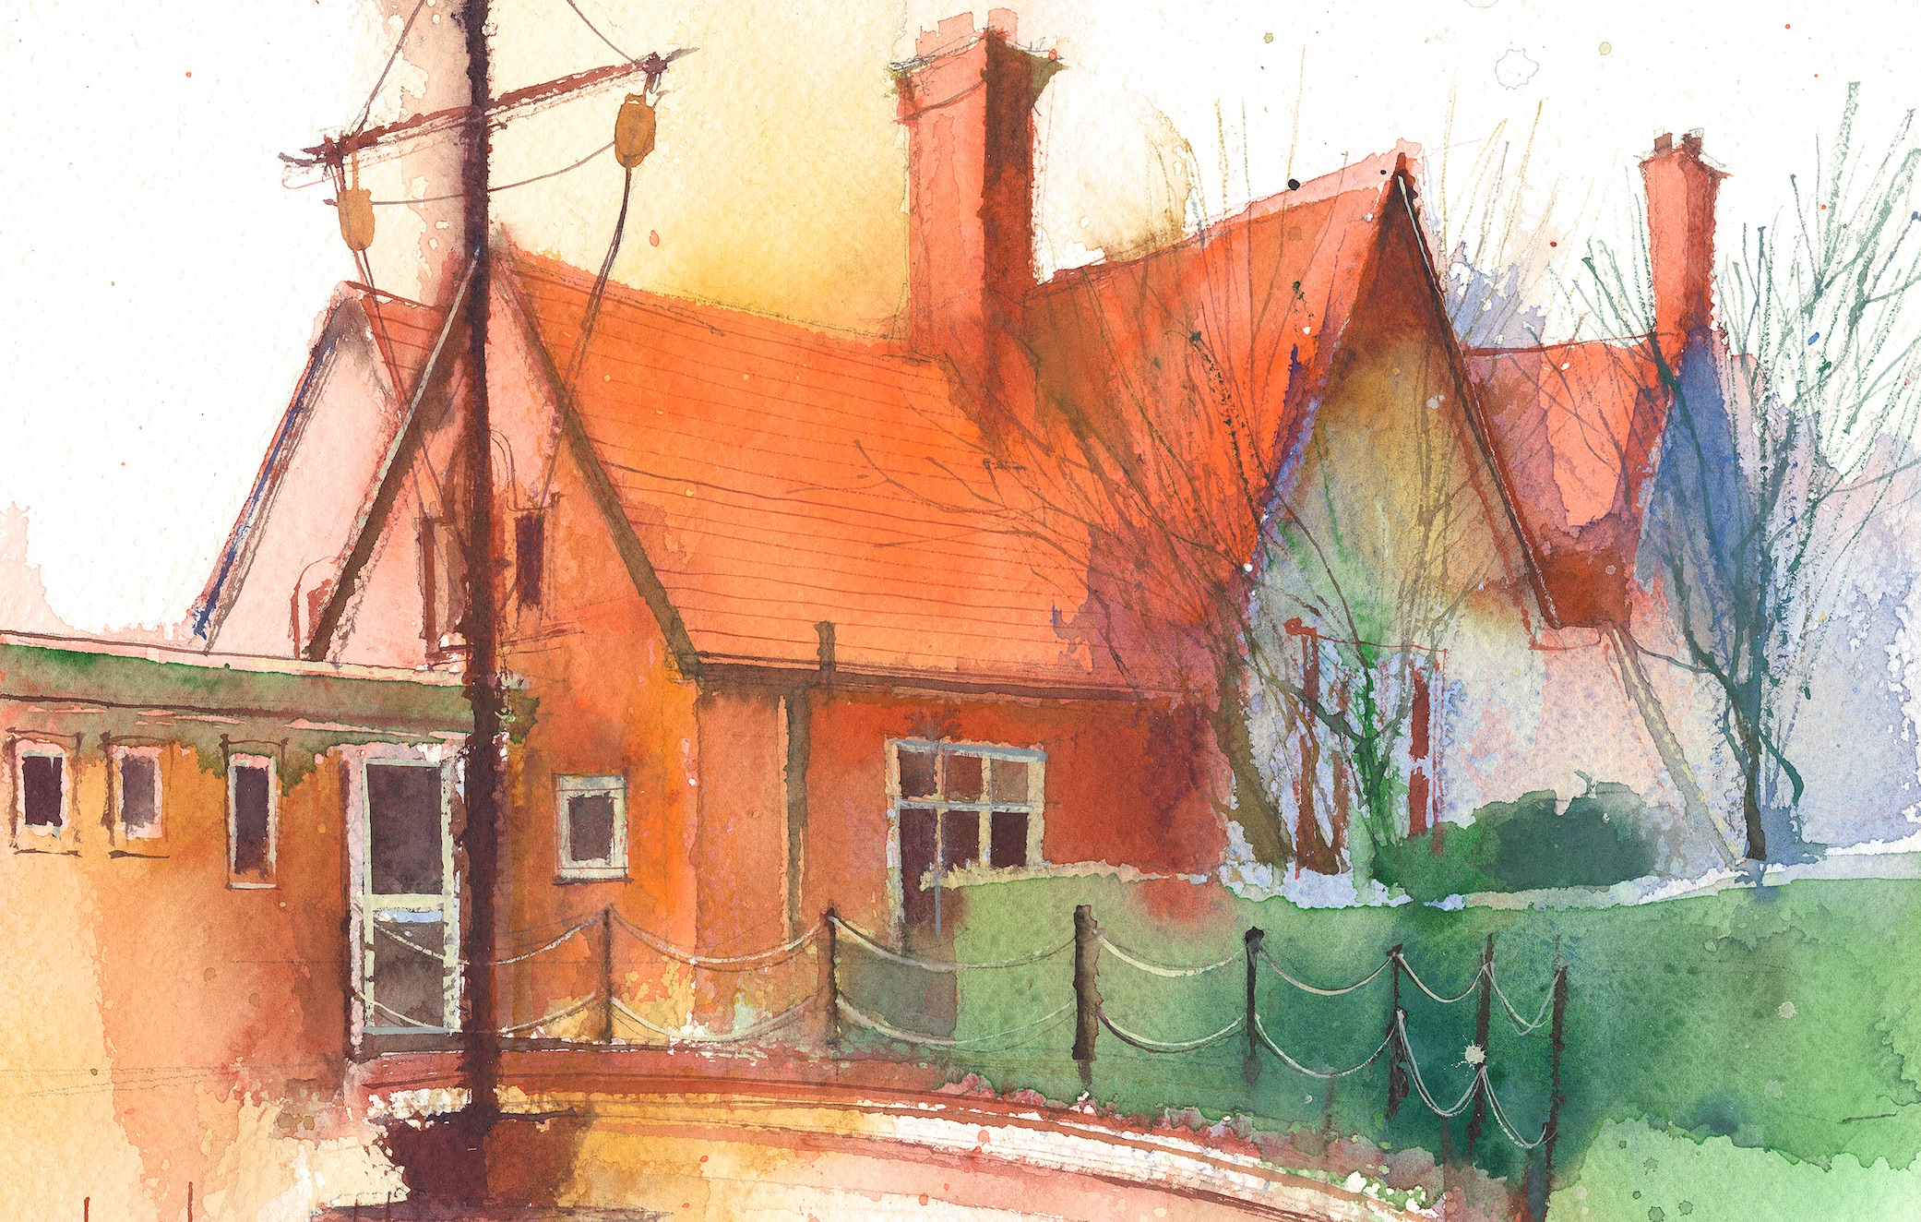

 | Lessons 09:00 – 10:30 |  | Lessons 10:45 – 12:15 |  | Lessons 13:15 – 15:30 (Incorporating 15-minute break) | Additional Tasks
Monday | Double Phonics: j as ge (blending & Segmenting practice) |  | Dance run-through.  Maths: I can play addition and subtraction games up to 50. |  | Science & RE: I can observe changes in how my seed is growing.  2.30 – dance performance | Useful Links / Other Recommended Activities  Oak National Academy  https://classroom.thenational.academy/  BBC Bitesize  https://www.bbc.co.uk/bitesize  Purple Mash  https://www.purplemash.com/sch/dawpool#/  Recommended Reading List  See here
Tuesday | Titanic day |  | Titanic day |  | Titanic day
Wednesday | Mrs Thompson Teaching Double phonics: uh as o (blending & segmenting practice)  English: I can write the next part of my own version of how to find Gold. |  | Maths: I can play addition and subtraction games up to 50. |  | Forest School  Picture News
Thursday | Phonics: Tricky words – asked, could  English: I can write the next part of my own version of how to find Gold. |  | Maths: I can play addition and subtraction games up to 50. |  | HeartSmart  Golden Time
Friday

