**Year 1 Weekly Timetable Week Commencing 22.9.25**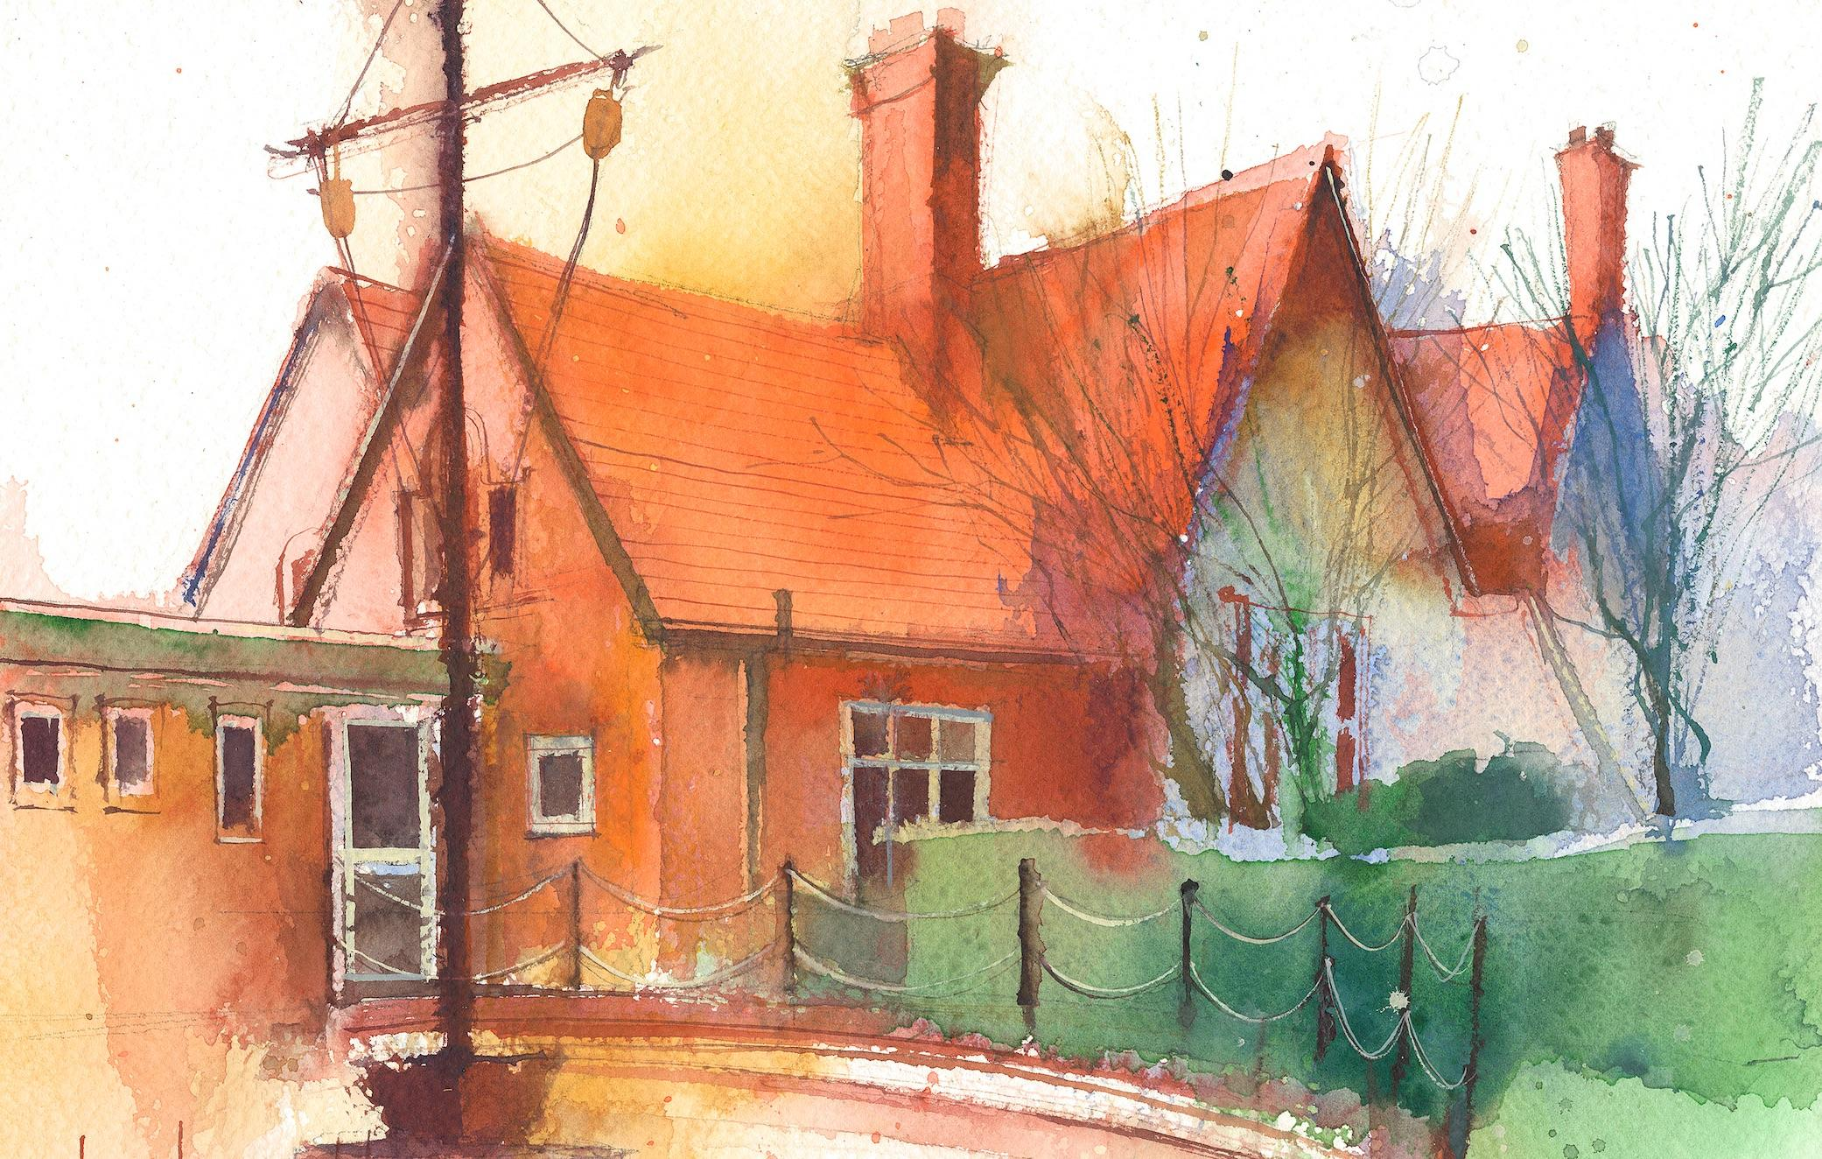

|  | **Lessons 09:00 – 10:30** | |  | **Lessons 10:45 – 12:15** |  | **Lessons 13:15 – 15:30 (Incorporating 15-minute break)** | **Additional Tasks** |
| --- | --- | --- | --- | --- | --- | --- | --- |
| **Thursday** | **Phonics:** o as ow (segmenting practise)  **Maths:** To count 1 more. | Singing Assembly | **RE: Harvest 1.1** I know that the Jewish festival for harvest is called Sukkot.  **ERIC/ GR** | **SPAG:** I know my alphabet and can put my letters in alphabetical order.  **Forest School:** I can make a sukkah (linked to our RE) |  |
| **Friday** | **Phonics:** Tricky words: were, when  **Cracking Comprehension** | Celebration Assembly | **Maths:** To count 1 less.  **ERIC/ GR** | **PE:** Pupils will understand what hand eye coordination means and will start to develop their throwing, bouncing and rolling skills to refining their hand eye coordination skills.  **Computing:** I can log in to purplemash.  **Golden Time:** Time to play with special toys! |