**Week 2 Year 5 Weekly Plan: 22.09.2025 26.09.2025**

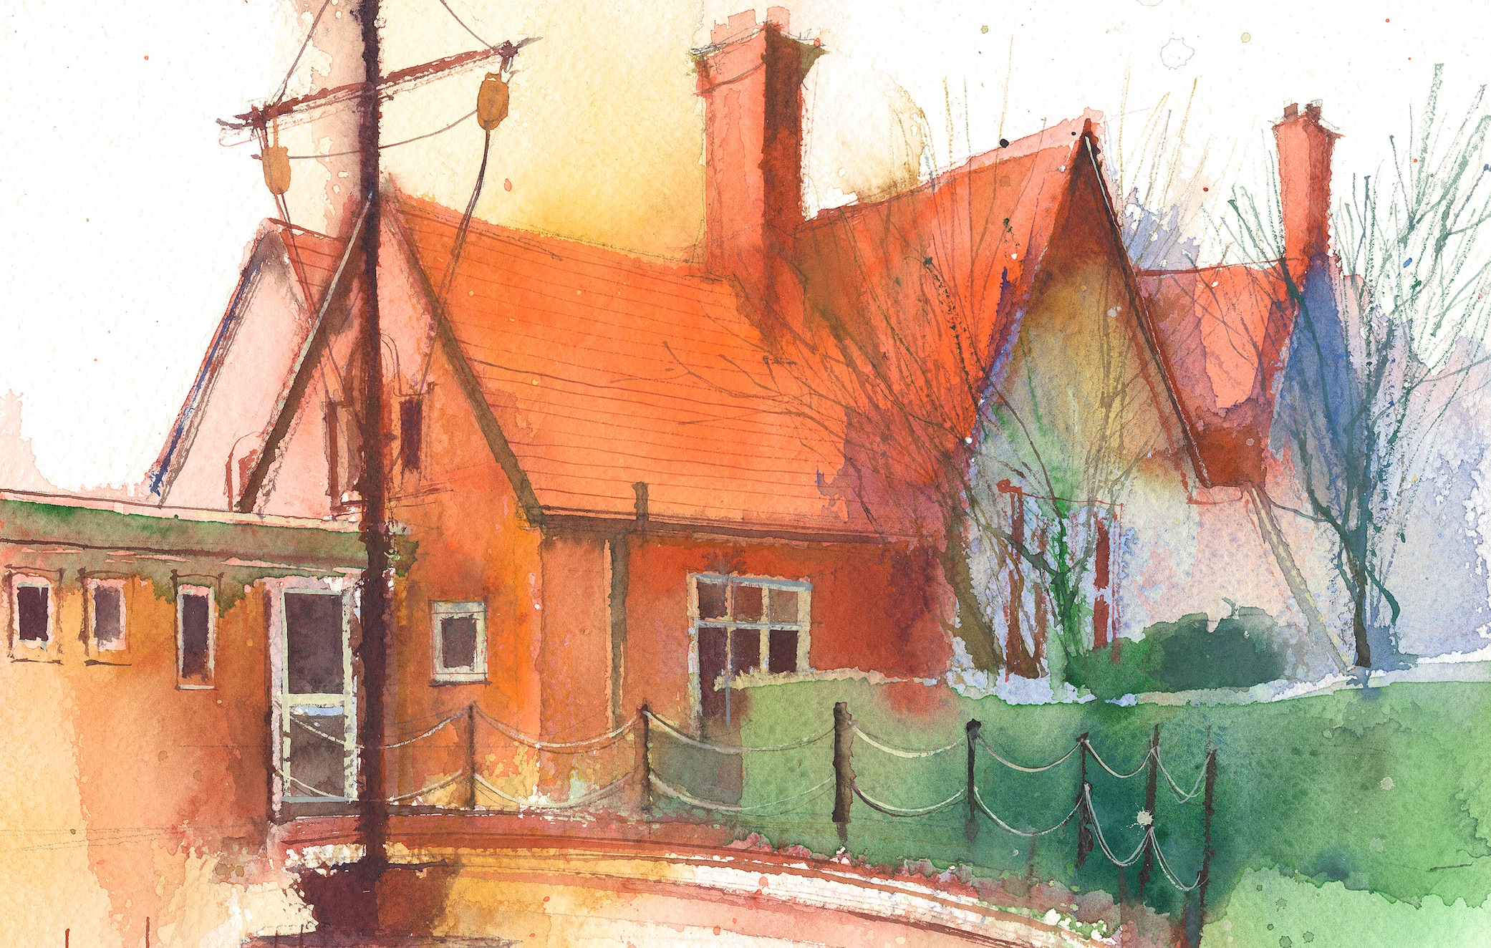

**To contact your child’s class teacher, please email** [**schooloffice@dawpool.wirral.sch.uk**](mailto:schooloffice@dawpool.wirral.sch.uk) **or phone 0151 648 3412**

|  |  |  |  |  |  |  |
| --- | --- | --- | --- | --- | --- | --- |
|  | **Lessons 09:00 - 10:30** |  | **Lessons­­­­ 10:45 - 12:15** |  | **Lessons 13:15 - 15:30**  **(Incorporating 15-minute break)** | **Additional Tasks** |
| **Monday**  **22/9/25** | **Maths**  Fluent in five/ Rapid Reasoning  By the end of this lesson your child should be able to:   * To demonstrate fluency in key mathematical concepts as part of the fluent in five and rapid reasoning tasks. ·To develop increasing accuracy in weekly arithmetic tasks. | **Power of Reading**   * By the end of this lesson your child should be able to: · To identify unfamiliar vocabulary and phrases. · Retrieve literal and inferred meanings from the given text. · Retell events from the text with accuracy. * **HeartSmart**   By the end of this lesson your child should be able to: · Research Richard the Lionheart then describe what ‘heart’ reputation they would want to have. | **Music**  By the end of this lesson your child should be able to: Living on a prayer. Lesson 1 Year 5    **Computing**  By the end of this lesson your child should be able to:   * By the end of this lesson your child should be able to answer: · What are some of the ways we can communicate online? · What are the differences between a meme, gif and emoji? · Are there any pros and cons of using these? |  |
| **Tuesday**  **23/9/25** | **Maths**  Fluent in five/ Rapid Reasoning  By the end of this lesson your child should be able to: By the end of this lesson your child should be able to: know how to write numbers up to 1,000,000. Lesson 4. |  | **Power of Reading**  By the end of this lesson your child should be able to: To write new spellings into sentences. To understand what a prefix is and how it can change a word. To use a different sentence starter in each sentence. |  | **PE**  We will be doing Athletics with Mr. Roberts till half term  **Picture news, British Values** | Meet  the parents 5pm- 5.30pm. |
| **Wednesday**  **24/09/25** | **Maths to**  Fluent in five/ Rapid Reasoning  By the end of this lesson your child should be able to understand the relationship between numbers in different columns. Lesson 5 |  | **Power of reading**  By the end of this lesson your child should be able to: Explore the features of a playscript so they can prepare to read aloud and to perform the myth of Baucis and Philemon through intonation, tone and volume |  | **Topic/Art**  By the end of this lesson your child should be able to: be introduced  to Greek art, including the pottery and the designs and patterns made on pots and vases. Also to look at the architecture. that we can see in Liverpool that has many Greek columns similar to the Parthenon.  **Handwriting** | Staff Meeting/Chess |
| **Thursday**  **25/09/25** | **Maths**  Fluent in five/ Rapid Reasoning  By the end of this lesson your child should be able to: know how to find 10,100,1,000, 10,000 and 100,000 more or less than a given number.Lesson 6 |  | **Power of Reading**    By the end of this lesson your child should be able: to: Explore the features of a playscript and complete a differentiated reading comprehension about the play. |  | **Science**  By the end of this lesson your child should be able to: use evidence to prove that the earth is spherical using evidence for and against to reach their conclusion. To continue to develop their knowledge of the 8 planets in our solar system  **Handwriting** |  |
| **Friday**  **26/09/25** | **Maths**  Fluent in five/ Rapid Reasoning  By the end of this lesson your child should be able to: revise our place value work from the week and understand the different ways we can read, represent and spell numbers up to 1,000,000 |  | **English**  By the end of this lesson your child should be able to:  Do their spelling test on Prefix words and then continue their work on the myth of Baucis and Philemon |  | **SPAG**  By the end of this lesson your child should be able to: Understand possessive pronouns and adjectives, Unit 2 Nelson Grammar  **RE**  By the end of this lesson your child should be able to: understand about the bible unit 5.1 the bible, Questful RE.. | **Celebration of weeks work** |