Year 1 Weekly Timetable Week Commencing 11.01.21
To contact your child’s class teacher, please email year1@dawpool.wirral.sch.uk
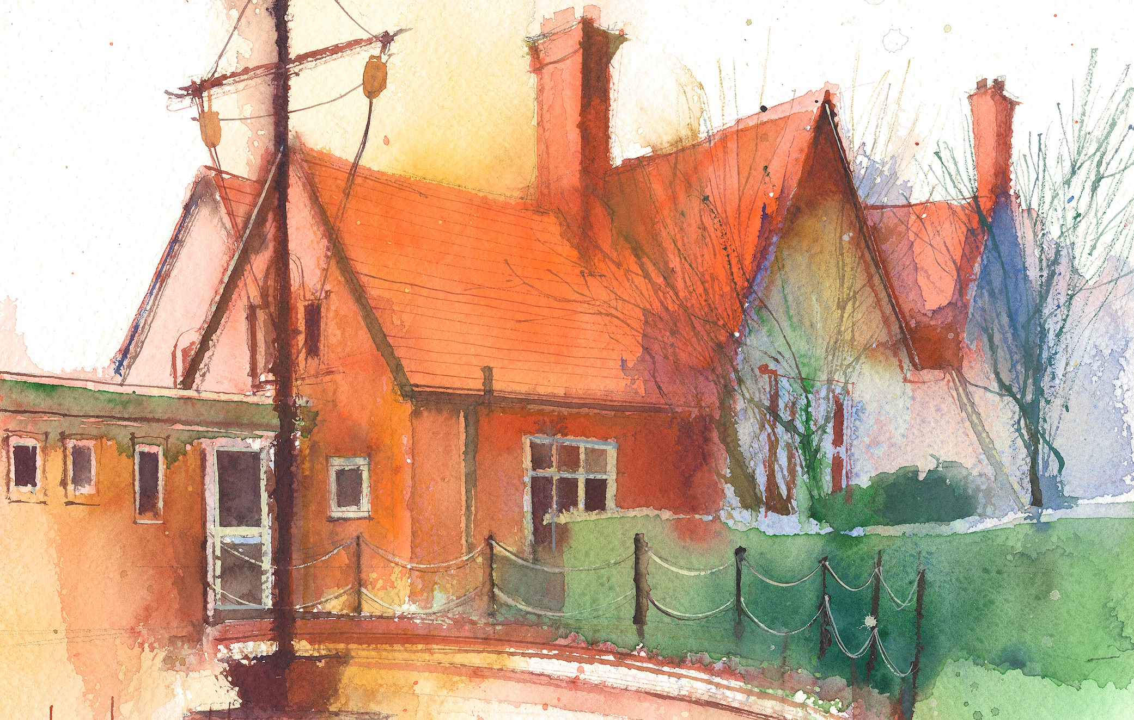

This timetable is available in the event that all Year 1 pupils are required to self-isolate at home. Please visit the Year 1 Remote Learning Page to
access any downloadable resources and activity sheets. The assessed task should be submitted to the teacher at the end of each day via Purple Mash.

 | Session 1: 09:00-10:30 |  | Session 2:10:45 – 12:15 |  | Session 3: 13:15 – 15:30 (Incorporating 15-minute break) | Assessed Task
Monday  11.01.21 | Literacy  By the end of this lesson your child should be able to:  *To use finger spaces, and simple punctuation.  *Spell words by identifying sounds in them and representing the sounds with a letter or letters.  We recommend the following resources and activities to achieve this objective:  *Read Lost in the Toy Museum by David Lucas  *Discuss what it means to be lost and how you could find something.  *Using the Lost poster template, model writing the information needed on the poster.  *Ensure sentences are kept short, usually five or six words in total.  Concentrate on finger spaces, Capital letters ant the start of a sentence and full stops at the end.  The YouTube link to this story can be found here.  https://www.youtube.com/watch?v=4LeqZTm46KI  Phonics  Phonics takes place every day and is usually 45 minutes long. It is a fast paced process that involves a lot of repetition which is so important for embedding children’s learning.  By the end of this lesson your child should be able to:  *Reads words consistent with their phonic knowledge by sound blending.  *Spell words by identifying sounds in them and representing the sounds with a letter or letters.  We recommend the following resources and activities to achieve this objective:  This week in Phase 5 Phonics our focus is:  Sounds: ‘oy that says oi’  Words: Would and What  We will use a series of Phonics Powerpoints to support our learning. These can be found on the website.  If you follow through the Powerpoint, stopping at regular points to complete the set tasks  Throughout the week, the children will undertake the following activities.  - London caption match game.  - Adverts on a Billboard word matching  - Royal playroom word sorting activity.  - Letter to the Queen writing activity.  - Read and Write books. |  | SUBJECT  By the end of this lesson your child should be able to: Recognise Number Bonds to 10  We recommend the following resources and activities to achieve this objective:  Whilst we are learning from home, I have set some ‘White Rose Maths’ lesson videos for you to follow. These are the videos we will work from in school as well.  They contain starter activities before moving onto the focus of the lesson.  Each video talks you through the activity and models the different techniques we do at school.  During the video there are pause points, where they ask you to pause the video and have a go at the task yourselves.  Before starting the lessons please make sure you have a pencil, some paper and 20 objects for counting (cubes, lego pieces, cheerios, raisins!)  We are starting with Number bonds to 10. This is a concept the children are familiar with. However, the styles may need refreshing and whilst they are following these videos for the first time it may help to have a familiar concept. It is important that all children undertake these activities as next week we will move onto Number bonds to 20.  Throughout the week there are five videos to follow.  Video 1 – Fact Families Addition Facts  Video 2 – Find Number Bonds within 10  Video 3 - Systematic Number Bonds  Video 4 – Number Bonds to 10  Video 5 - Compare Number Bonds  I will attach the following additional activities to the website for you to tackle. These will be optional.  Year 1 Addition and Subtraction Number Bonds to 10 x 3 worksheets  Number Bonds to 10 – Sticks  Number Bonds to 10 – Tens Frame |  | History  By the end of this lesson your child should be able to:  I can use different sources to find out about toys from the past.  I can name two popular toys from the past.  I can ask a sensible question.  I can use information from a source to answer a question.  We recommend the following resources and activities to achieve this objective:  *Our History focus this term is The Time Machine  *Today we are going to climb into a time machine and travel back to when Mum’s and Dad’s were younger.  *Go through the Toys Timeline PowerPoint presentation.  *Discuss toys that your Mum and Dad played with.  *Reinforce that these toys are older than toys played with today.  Task 1: Use the computer or books to find out about toys (research) your Mum or Dad played with.  Task 2: Interview your Mum or Dad about toys they played with .  Ask these questions-  What is it called? What is it made of? What do you do with it/how do you play with it? How does it work?  *The Oak National Academy have live lessons linked to this subject. Click on this link here.  https://classroom.thenational.academy/lessons/how-have-toys-changed-part-1-71h62c | Login to Purple Mash to submit today’s assessed task:  History  Print off or draw a picture of a toy that your Mum or Dad played with.  Write down the answers to the following questions:  What is it called?  What is it made of?  What do you do with it/how do you play with it?  How does it work?
Tuesday  12.01.21 |  |  |  |  | Science  By the end of this lesson your child should be able to:  Distinguish between an object and the material it is made from  Identify and name a variety of everyday materials including; wood, plastic, glass, rock  We recommend the following resources and activities to achieve this objective:  *Our Science focus this term is ‘Everyday Materials’  *We will have a feely bag with five objects in wood, metal, plastic, material, glass.  *We will pull one object out at a time and discuss what we think it is made of. Which categrory does it fit into?  *Next we will decide if the object is hard or soft. Explain that hard items can’t be bend or stretched.  *Undertake a sorting activity to sort items into hard or soft.  *The Oak National Academy have live lessons linked to this subject. Click on this link here  https://classroom.thenational.academy/lessons/what-is-a-material-74u30t | Login to Purple Mash to submit today’s assessed task:  Science  Complete the sorting activity for hard and soft. This sheet can be found on the attachments for Tuesday.  If you are unable to print, then please sort your own selection of objects at home into groups of hard or soft
Wednesday  13.01.21 |  |  |  |  | R.E.  By the end of this lesson your child should be able to:  - discus what makes a good ruler  We recommend the following resources and activities to achieve this objective:  Think about the most important person to you and why they are important - slide 2 Kingdom of God PowerPoint  * What does the word ‘kingdom’ mean? (a kingdom is ruled by a king or queen)  * Who is important in our school / community?  Look at slide 3-4, who are these people? These people are rulers and tell us the rules of what we can and can’t do.  If Dawpool was a kingdom, Mr Burrows would be the “king”. Think about the type of rules we have at school.  God is the ruler of creation as he made it  Think about a kingdom that you could be ruler of.  * What would it be like?  * What would happen there?  * What would the rules be?  * Can you write your most important kingdom rule? You can use the crown template if you would like – ‘If I were a ruler I would…’ | Login to Purple Mash to submit today’s assessed task:  Literacy  Complete the Lost in the Toy Museum poster.  If you are unable to print, then please write this on you own paper,
Thursday  14.01.21 |  |  |  |  | P.E.  By the end of this lesson your child should be able to:  - develop balance and co-ordination  - perform dances using simple movement patterns  We recommend the following resources and activities to achieve this objective:  * What are the 4 seasons of the year?  Look at slide 5 of PowerPoint, from the title what season might we be starting with?  Look at slide 6 or watch clip of ice dancer https://www.youtube.com/watch?v=TlXCk1LDlC0  * Does she change direction / travel on one level?  Warm up: move around to the ice dancing movement and create some ice statue shapes.  * Can you make low / tall / wide / balanced shapes?  Dance: Spend some time exploring different ways to jump and spin. Choose one of each that you like the best.  * Can you add interesting arm movements?  Look at slide 13, can you create a motif using a slide, jump and some travels (they can be in any order) Practice  If you can, try performing in front of a mirror or to someone and look / ask for things you did well. Is there anything you could improve on?  Perform  Cool down: Think of different winter activities you can act out (throwing snowballs, putting on winter clothes, skiing, building snowman) | Login to Purple Mash to submit today’s assessed task:  Maths  Please complete the Number Bonds to 10 – Robots sheets or complete the Purple Mash To Do.
Friday  15.01.21 |  |  |  |  | Forest Schools  By the end of this lesson your child should be able to:  * Work and play co-operatively and take turns with others  We recommend the following resources and activities to achieve this objective:  *Go into the outdoor environment with your child and build dens together or create a minibeast hotel.  *What birds can you see/hear?  Can you make nests for them using the materials you find in the woods? | Login to Purple Mash to submit today’s assessed task:  Phonics  This week our sound was ‘oy’.  Can you send me a list of five ‘oy’ words and choose one of the words to put in a sentence?
Additional Tasks

We also advise your child to complete the following tasks this week:

- Practice spelling Phase 2, 3 and 4 tricky words. Can they write them without support?
- Handwriting practice on the letters c, g, d, q, o, a. Practice writing these letters sitting neatly on a line, in a controlled size and facing the correct way. All of these letters are formed by writing a ‘c’ first. Ensure children are secure with correctly forming this letter, then all others can follow. A handwriting sheet is provided in the attachments.

