Year 6 Weekly Timetable Week Commencing 18.01.21
To contact your child’s class teacher, please email year6@dawpool.wirral.sch.uk
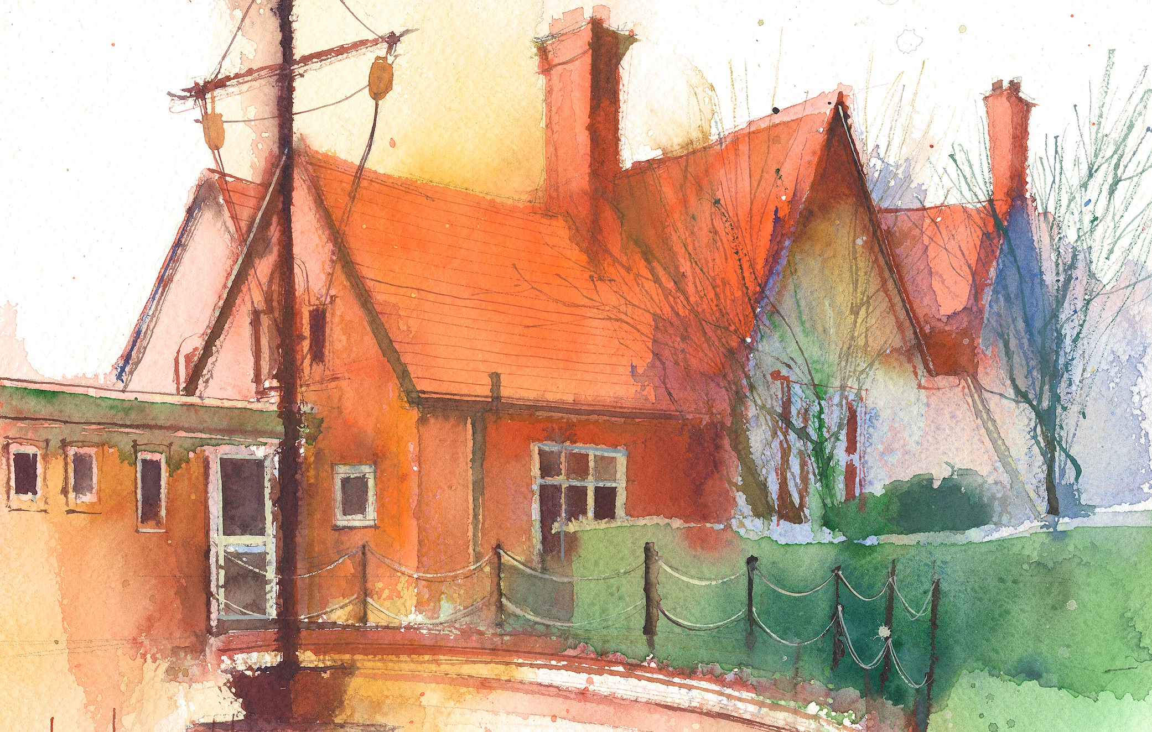

This timetable is available in the event that all Year 6 pupils are required to self-isolate at home. Please visit the Year 6 Remote Learning Page to
access any downloadable resources and activity sheets. The assessed task should be submitted to the teacher at the end of each day.

 | Session 1: 09:00-10:30 |  | Session 2:10:45 – 12:15 |  | Session 3: 13:15 – 15:30 (Incorporating 15-minute break) | Assessed Task
 | Remember your daily Literacy Tasks:  - Spellings –  Prefixes 1  - Starting – Beowulf  and the Sea-hag |  | Remember your daily Maths Tasks:  - Fluent in five –  week 17  - Rapid Reasoning  Week 16  - Times Tables X8 and X9 |  | Additional Optional extension / Homework  - Decimal Code Cracker | Login to Purple Mash to submit today’s assessed task:  - Check The 2Dos on Purple Mash  - Remember to click on Hand in or it will not reach me
Monday  18.01.21 | MATHS  By the end of this lesson your child should be able to:  To convert fractions to decimals  We recommend the following resources and activities to achieve this objective:  Follow Third Space Learning  Teaching Slides:  Decimals Lesson 8 - PowerPoint 8  Task: Complete the attached Independent activities and then follow the mark scheme.  Look carefully at any mistakes and look back over the slides  Remember these worksheets are in stages:  Section 1 is for everyone,  Section 2 is harder  Section 3 is the challenge.  Go as far as you can and keep persevering. |  | LITERACY - Grammar  By the end of this lesson your child should be able to:  To recognise and be able to use adverbs and fronted adverbials  We recommend the following resources and activities to achieve this objective:  Follow the Oak Academy Video Lesson on Prepositions (22 minutes)  - Follow the Oak link  - Click on subjects  - Click on KS2  - Click on English Grammar  - Find T2 Word Level Objectives  Watch Lesson 4 (22 minutes)  To explore Prepositions  Follow the attached PowerPoint on Prepositions  Grammar revision - Prepositions  (Have pen and paper handy to complete the tasks)  Purple Mash Assessed Task – Story Gaps – an exercise to identify nouns, verbs, adjectives and prepositions(See 2Dos)  Campsite Jim – if you want to recap fronted adverbials from last week |  | SCIENCE  By the end of this lesson your child should be able to:  To understand what circuit diagrams and how to represent components with circuit symbols  We recommend the following resources and activities to achieve this objective:  NB – you will have time to complete this tomorrow morning  Follow the Lesson PowerPoint Presentation:  Circuit Symbols  Watch the Oak Academy Video Lesson on Electricity:  - Follow the Oak link  - Click on subjects  - Click on KS2  - Click on Science  - Click on Electrical Circuits  Watch Lesson 5 –  What are Circuit Diagrams  We will be learning how electrical circuits are represented by diagrams. (You will need a pencil and pen ready)  Other independent tasks:  - Complete the activity – interpreting and drawing circuits  - Home Learning practise tasks | Login to Purple Mash to submit today’s assessed task:  Purple Mash Assessed Task – Story Gaps – an exercise to identify nouns, adjectives, prepositions (See 2Dos)  Don’t forget to keep going to the next level on the task  Don’t forget to CLICK the HAND IN button
Tuesday  19.01.21  World Religion Day | SCIENCE  By the end of this lesson your child should be able to:  You have this time to catch up on your science tasks from yesterday afternoon.  We recommend the following resources and activities to achieve this objective:  Re- visit the PowerPoints  Complete any independent tasks  Study the knowledge organiser |  | MATHS  By the end of this lesson your child should be able to:  To convert fractions to decimals  We recommend the following resources and activities to achieve this objective:  Follow Third Space Learning  Teaching Slides:  Decimals Lesson 9 - PowerPoint 9  Task: Complete the attached Independent activities and then follow the mark scheme.  Look carefully at any mistakes and look back over the slides |  | RE  By the end of this lesson your child should be able to:  To understand the importance of the Ganges river to Hindus  To complete a short brochure about the river  We recommend the following resources and activities to achieve this objective:  Watch the Oak Academy Video Lesson on Electricity:  - Follow the Oak link  - Click on subjects  - Click on KS2  - Click on Religious Education  - Click on Hinduism  Watch Lesson 5 –  What is the story of Shiva and the Ganges river?  (It will help you if make notes while you watch these videos)  Log on to Purple Mash  In the To Do for today you will find a video about the Ganges river and a brochure blank to complete to write your news report on. | Purple Mash Assessed Task – Writing a brochure about the Ganges –  (See 2Dos)  Don’t forget to CLICK the HAND IN button
Martin Luther King Day  Wednesday  20.01.21 | MATHS – % Topic  By the end of this lesson your child should be able to:  Convert fractions and Percentages  We recommend the following resources and activities to achieve this objective:  Follow Third Space Learning  Teaching Slides:  Percentages Lesson 1 - PowerPoint 1  Task: Complete the attached Independent activities and then follow the mark scheme.  Look carefully at any mistakes and look back over the slides  Remember these worksheets are in stages:  Section 1 is for everyone,  Section 2 is harder  Section3 is the challenge.  Go as far as you can and keep persevering. |  | LITERACY/ HISTORY  By the end of this lesson your child should be able to:  To find out and understand who Martin Luther King was and his contribution to the civil rights movement and equality.  We recommend the following resources and activities to achieve this objective:  Follow: the attached PowerPoint about Martin Luther King.  (It may help you to make notes)  Task: Complete the attached comprehension.  A = for average ability  Ext = More challenging  Both contain answers so you can mark your work when you have finished.  TOP TIPS:  Read slowly and carefully – the answer is always there!  Look for key words in the question and scan for them as you read.  Think about how much detail is needed – you should need to fill the space provided to answer well.  Remember to use “ “ |  | LITERACY/HISTORY  By the end of this lesson your child should be able to:  To find out and understand who Martin Luther King was and his contribution to the civil rights movement and equality.  We recommend the following resources and activities to achieve this objective:  Complete any outstanding tasks from this morning on Martin Luther King  Log on to Purple Mash and follow the To Do link. You will have to complete an information text about Martin Luther King.  Top Tips  Use sub-headings and paragraphs to organise your writing.  Try to organise the facts in chronological order  Check your writing for accurate punctuation and spelling.  Does your writing flow smoothly and make sense? | Purple Mash Assessed Task – Create an information text showing what you know about Martin Luther King –  (See 2Dos)  Don’t forget to CLICK the HAND IN button
Thursday  21.01.21 | MATHS  By the end of this lesson your child should be able to:  To use fraction, decimal and percentage equivalents  We recommend the following resources and activities to achieve this objective:  Follow Third Space Learning  Teaching Slides:  Percentage Lesson 2 - PowerPoint 2  Task: Complete the attached Independent activities and then follow the mark scheme.  Look carefully at any mistakes and look back over the slides  Remember these worksheets are in stages:  Section 1 is for everyone,  Section 2 is harder  Section3 is the challenge.  Go as far as you can and keep persevering. |  | LITERACY – Beowulf – Read  By the end of this lesson your child should be able to:  To begin to read “Beowulf and The Sea-Hag” and be able to answer questions on the text.  We recommend the following resources and activities to achieve this objective:  Read the attached Text  (68- 74. I have marked where to read to)  Task: Complete the comprehension questions.  Remember to be precise and detailed in your answers and to read carefully.  Log on to Purple Mash and in the To Do for today you will find a blank to write your answers on or you can email them to me.  (year6@dawpool.wirral.sch.uk)  TOP TIPS:  - Don’t forget to number the questions  - You do not need to include part of the question in your answer.  - Remember not to begin sentences with joining words  - Describe and Explain questions need more detail.  - Use “ “ to quote words from the text |  | LITERACY – Note making  By the end of this lesson your child should be able to:  To begin to read “Beowulf and The Sea-Hag” and make notes on the appearance and personality of the Sea-Hag  We recommend the following resources and activities to achieve this objective:  Read the attached Text  (68- 74. I have marked where to read to)  Go through the pages and find descriptive phrases that you could use.  Study the colour picture and IMAGINE MORE  Complete a mind map of your ideas. I have attached a model one for you to see.  You will use this to write a descriptive paragraph tomorrow morning or you may have time to complete it now. | Purple Mash Assessed Task – Answering the questions about the Sea Hag pages (68-74)  (See 2Dos)
Friday  22.01.21 | MATHS  By the end of this lesson your child should be able to:  Apply strategies and algorithms learned to complete the attached arithmetic test.  We recommend the following resources and activities to achieve this objective:  Arithmetic – Test 3 (with answers at the end). Aim for 30 minutes but go up to 45 to complete the test if you need to.  Top Tips:  Remember to show your working out and not to rush - Check your answers  Use a fact box for long division  For mixed operations use “BIDMAS”  Fraction answers must be cancelled down – “as low as they can go”  When dividing fractions – remember to put the whole number over 1 and then “fliperoo” and treat it like a multiplication  Use the Lego base brick for %  (start with 10% - divide by 10 or 1% - divide by 100)  To change a fraction into a decimal - divide the numerator by the denominator. |  | LITERACY  By the end of this lesson your child should be able to:  Write a description of the Sea-Hag using descriptive techniques and vocabulary for impact.  We recommend the following resources and activities to achieve this objective:  Use the colour picture and text  Use your mind map to write your paragraph think about personality and appearance.  See the attached Descriptive writing Checklist  Log on to Purple Mash and follow the To Do link. You will find a blank to write your description on or you can email your writing to (year6@dawpool.wirral.sch.uk)  or send a screen shot. |  | ART  By the end of this lesson your child should be able to:  To learn about Hindu Mehndi art which is used for religious festivals and celebrations  Complete your own Mehndi design  We recommend the following resources and activities to achieve this objective:  Follow the attached Mehndi inspirational PowerPoint  Open The task setter pictures and try your own | Assessed Task – Complete your Arithmetic paper and send me your score. Make sure you check your work and let me know if you have a PB.  (See 2Dos on Purple Mash or email me)  Assessed Task – Complete your descriptive writing task  (See 2Dos on Purple Mash or email me)
Finding a Percentage – Step by Step Guidance:

- To find 10% divide by 10
To find 5% half 10%
- To find 20% - divide by 10 and x by 2
- To find 30% - divide by 10 and x by 3
- To find 35 % Find 30% and 5 % and add them together

- To find 1% you divide by 100

- So, if you had to find 3% you divide by 100 and x by 3
- To find 21 %- Find 20% - find 10% by dividing by 10 - next x by 2 to make it 20) Finally, find 1% (by dividing by 100) and then add the totals together.

