Foundation 2 Weekly Timetable Week Commencing 21.11.22
To contact your child’s class teacher, please email schooloffice@dawpool.wirral.sch.uk or phone 0151 648 3412
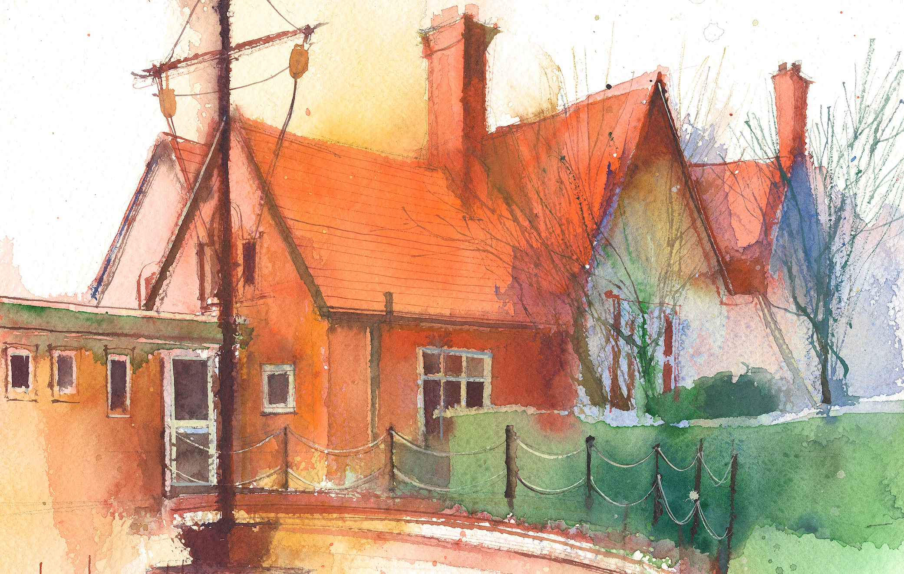

This timetable is available in the event that a Foundation 2 pupil is required to self-isolate at home, but the cohort remains open to other pupils.
Please visit the Foundation 2 Remote Learning Page on the school website to access any downloadable resources and activity sheets.

 | Session 1: 09:00-10:30 |  | Session 2: 10:50 – 12:00 |  | Session 3: 13:15 – 15:25
Monday  21/11/22 | Phonics  By the end of this lesson your child should be able to:  Recognise and say the sound ‘h’  We recommend the following resources and activities to achieve this objective:  Blending practice.  Children will complete activities in their individual rocket phonics workbooks.  (Week 9) |  | Maths  By the end of this lesson your child should be able to:  To understand the composition of the number 5  We recommend the following resources and activities to achieve this objective:  Today is Timmy’s 5th Birthday. We are going to give him some presents. However, he only wants presents that represent the number 5.  In a bag I have a selection of objects. Which ones represent 5? How do we know?  If they don’t are they more or less than 5? How do we know?  Sort all the gifts out for Timmy. |  | Topic  During the afternoons we will undertake activities linked to all areas of the Early Years Curriculum;  Prime Areas; Communication and Language;  Personal, Social and Emotional Development;  Physical Development.  Specific Areas; Literacy, Maths, Understanding the World and Expressive Arts and Design.  Afternoon sessions will also include RE, HeartSmart and Forest Schools.  Activities will be linked to our class topic which is ‘Where in the World’. We aim to use children’s films as a hook for learning to help us find out more about the world around us. Throughout the year we will select films that enable us to cover all requirements of the Early Years Curriculum.  We will talk about where the film is set and find out where this country is on a map. We will then the theme of the film as a way of guiding our planning.  PLEASE NOTE  The very nature of the EYFS curriculum enables us to go with the interests of the children. The activities we plan are for a guide only.  Staff can use and adapt activities or add additional activities and not cover others. It is all dependent on how and where the children’s interests take us.  Activities are designed to cover several weeks, if needed.  A copy of the current topic plan is available to view on the class website page.
Tuesday  22/11/22 | Phonics  By the end of this lesson your child should be able to:  Recognise and write the sound ‘h’  We recommend the following resources and activities to achieve this objective:  Segmenting practice.  Children will complete activities in their individual rocket phonics workbooks. |  | Maths  By the end of this lesson your child should be able to:  Subitise - To recognise quantities without counting.  We recommend the following resources and activities to achieve this objective:  Yesterday was Timmy’s birthday. He was 5 years old.  I need to put some candles on his cakes. However, I only have 5 candles but I have two cakes. I will draw two cakes on the board.  How many candles will they put on each cake?  Can we write down each one as a number sentence? Check each time it adds up to 5. Demonstrate this as a part, part whole.
Wednesday  23/11/22 | Phonics  By the end of this lesson your child should be able to:  Recognise and say the sound ‘b’  We recommend the following resources and activities to achieve this objective:  Blending practice  Children will complete activities in their individual rocket phonics workbooks. |  | Maths  By the end of this lesson your child should be able to:  Subitise - To recognise quantities without counting.  We recommend the following resources and activities to achieve this objective:  On the carpet lay out the giant tens frame and remind the children what it is called.  I will have 5 cars to park in the car park. Can the children drive them onto the spaces on the tens frame? How did they choose to park them in the spaces? Can they choose another way? How many different ways are there to park them on the tens frame?
Thursday  24/11/22 | Phonics  By the end of this lesson your child should be able to:  Recognise and write the sound ‘b’  We recommend the following resources and activities to achieve this objective:  Segmenting practice  Children will complete activities in their individual rocket phonics workbooks. |  | Maths  By the end of this lesson your child should be able to:  To be able to recognise and name a pentagon and star and their properties.  We recommend the following resources and activities to achieve this objective:  Play What’s in the Bag.  Put hand in a bag and describe a shape to the children “It has 5 sides and 5 corners” Can they name it? Is there any other shape it could be?  Discuss the difference between pentagon and star.
Friday  25/11/22 | PE  By the end of this lesson your child should be able to:  Revise and refine fundamental movement skills already acquired.  We recommend the following resources and activities to achieve this objective:  During this half term the children will use the hall space to undertake games and activities that require them to roll, crawl, walk, jump, run, hop, skip and climb.  Children will also learn to stop and change directions safely. |  | Phonics  By the end of this lesson your child should be able to:  To consolidate learning of the sounds satipnmdgockeurhb and CEW ‘I, the, to, go, no, into’.  To practice writing the CEW ‘go’  We recommend the following resources and activities to achieve this objective:  Children will complete activities in their individual rocket phonics workbooks.

