19Year 6 Weekly Timetable Week Commencing 21.06.21
To contact your child’s class teacher, please email schooloffice@dawpool.wirral.sch.uk
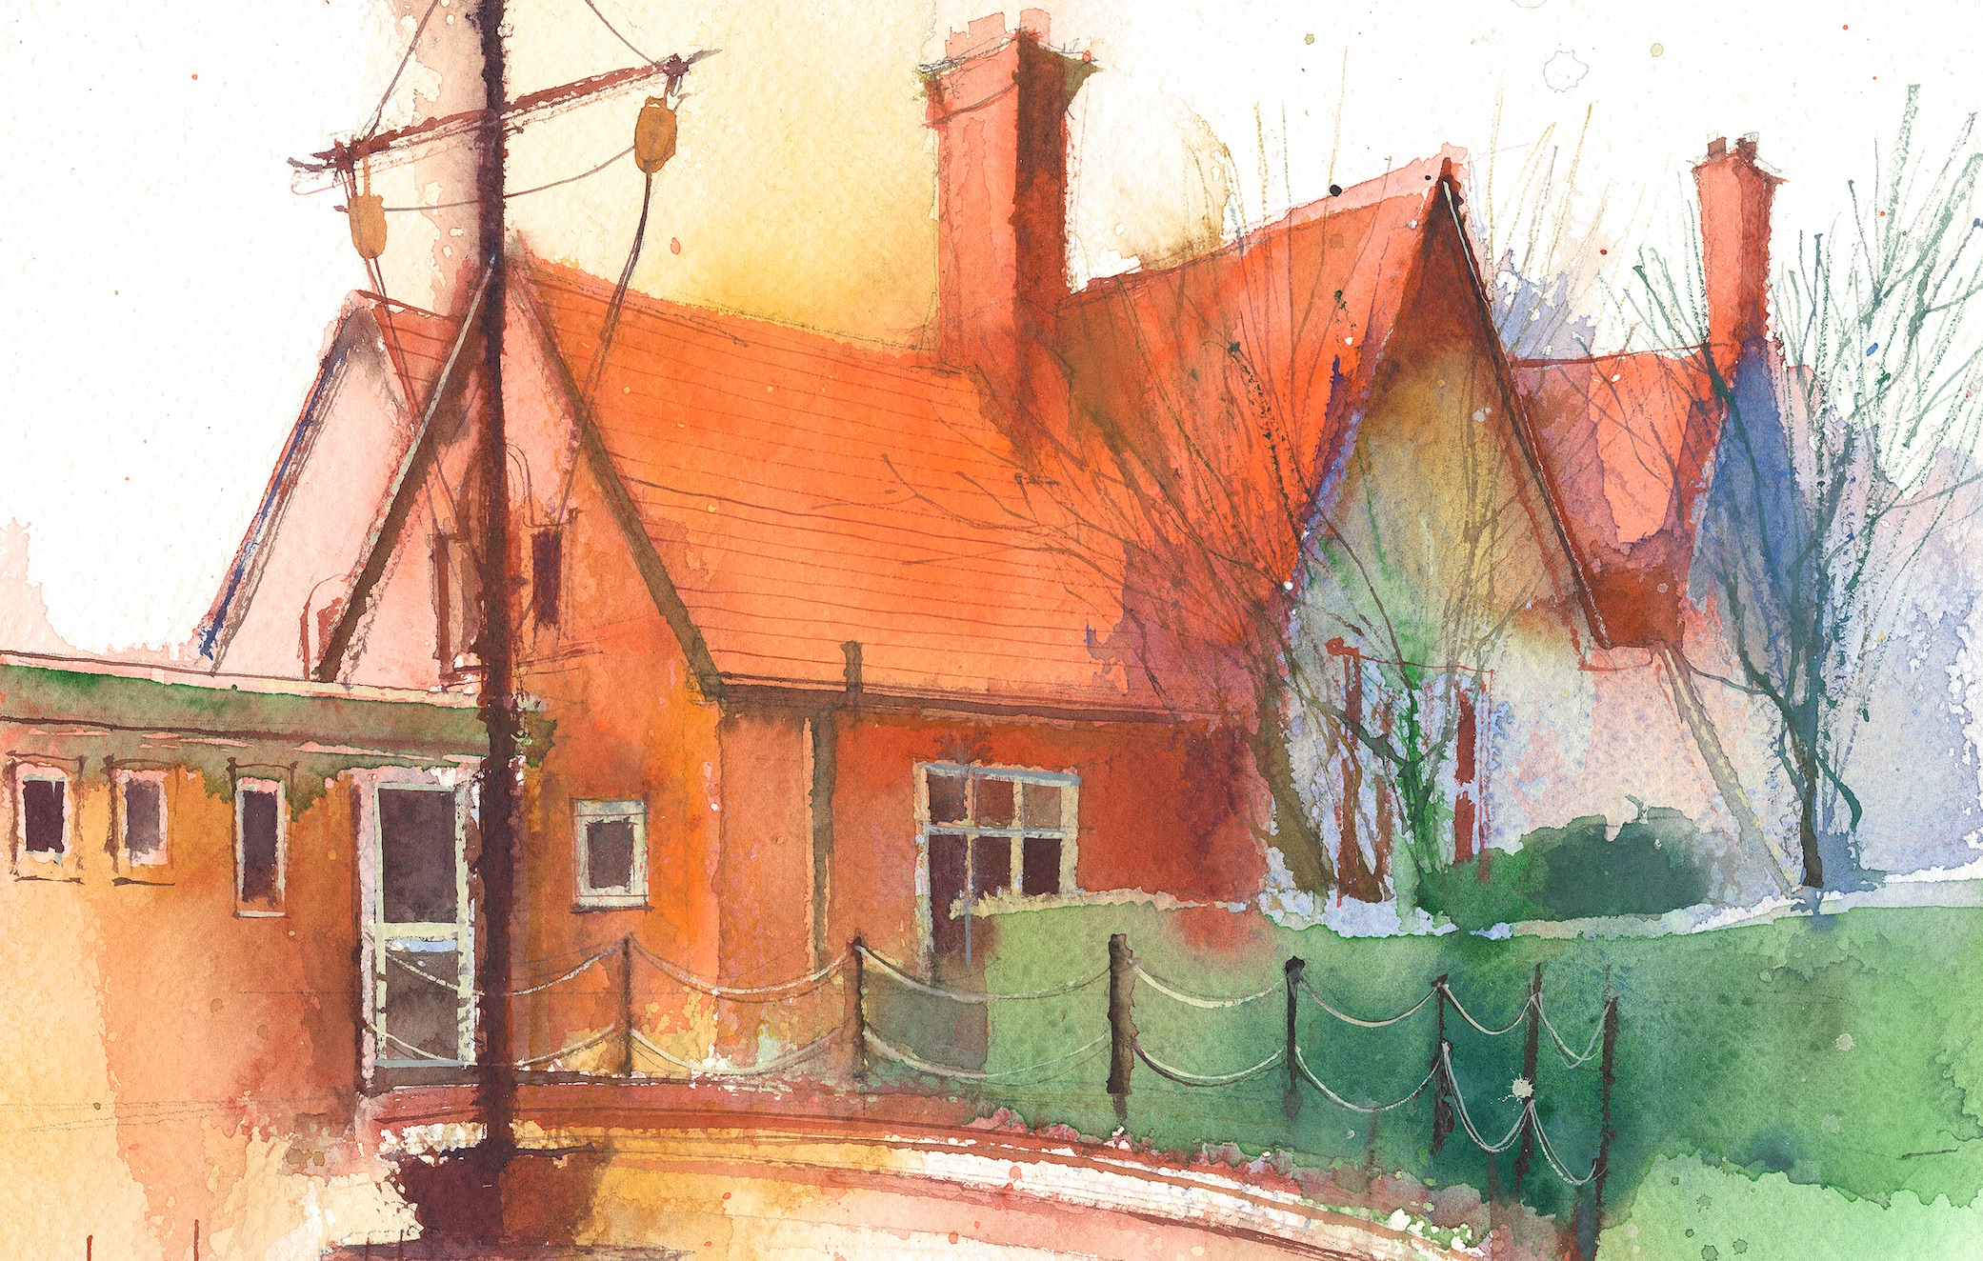

This timetable is available in the event that a Year 6 pupil is required to self-isolate at home, but the cohort remains open to other pupils.
Please visit the Year 6 Remote Learning Page on the school website to access any downloadable resources and activity sheets.

 | Session 1: 09:00-10:30 |  | Session 2: 10:45 – 12:15 |  | Session 3: 13:15 – 15:30 (Incorporating 15-minute break) | Additional Tasks
Monday  21.06.21 | MATHEMATICS  By the end of this lesson your child should be able to:  Angles in a quadrilateral recap lesson  end the following resources and activities to achieve this objective:  FOLLOW recap tasks  FOLLOW: Third Space Learning  Teaching Slides:  Shape: PowerPoint Lesson 8  TASK 1: Shape: Worksheet 8  Complete the attached Independent activities and then follow the mark scheme.  Look carefully at any mistakes and look back over the slides  Remember these worksheets are in stages:  Section 1 is for everyone,  Section 2 is harder  Section 3 is the challenge.  Go as far as you can and keep persevering.  TASK 2:  MNP activities |  | TOPIC / LITERACY  By the end of this lesson your child should be able to:  Be able to answer questions about the life and work of Claude Monet.  Begin to plan a short Biography  We recommend the following resources and activities to achieve this objective:  READ:  The Comprehension about the life and work of impressionist artist Claude Monet  TASK: Answer questions deeply and thoughtfully – remembering to use quotation and evidence from the text.  FOLLOW:  PowerPoints: on Claude Monet:  - PowerPoint 6  - PowerPoint: Claude Monet  TASK: Make brief notes |  | ART – Claude Monet  By the end of this lesson your child should be able to:  To explore the Artwork Monet produced at his garden in Giverny  We recommend the following resources and activities to achieve this objective:  FOLLOW teaching slides 5 and study prints and copies of the Japanese bride and lillies  LOOK at lesson slides 5  Attempt watercolours in this style | We also advise your child to complete the following tasks this week:  - Times Tables X7, X8, X9 and X12  - Daily Fluent in Five – Week 32  - Daily Rapid Reasoning – Week 31  Homework  - Arithmetic Test  - Comprehension – Judy – The Hero Dog of WWII
Tuesday  22.06.21 | TOPIC/ART  By the end of this lesson your child should be able to:  BISQUE-IT POTTERY WORKSHOP & AFTERNOON TEA  We recommend the following resources and activities to achieve this objective: |  |  |  | TOPIC / LITERACY  By the end of this lesson your child should be able to:  Be able to answer questions about the life and work of Claude Monet.  Begin to plan a short Biography  We recommend the following resources and activities to achieve this objective:  READ:  The Comprehension about the life and work of impressionist artist Claude Monet  TASK: Answer questions deeply and thoughtfully – remembering to use quotation and evidence from the text.  FOLLOW:  PowerPoints: on Claude Monet:  - PowerPoint 6  - PowerPoint: Claude Monet  TASK: Make brief notes
Wednesday  23.06.21 | MATHEMATICS  By the end of this lesson your child should be able to:  Convert Fraction to %  (Recap converting Fractions to Decimals)  end the following resources and activities to achieve this objective:  FOLLOW: Third Space Learning  Teaching Slides:  %: PowerPoint Lesson 1  TASK 1: %: Worksheet 1  Complete the attached Independent activities and then follow the mark scheme.  Look carefully at any mistakes and look back over the slides  Remember these worksheets are in stages:  Section 1 is for everyone,  Section 2 is harder  Section 3 is the challenge.  Go as far as you can and keep persevering. |  | SCIENCE  By the end of this lesson your child should be able to:  - To identify inherited characteristics  - Understand variation occurs within offspring as well as across species  - Be able to explain the scientific concept of inheritance  We recommend the following resources and activities to achieve this objective:  FOLLOW  Inheritance PowerPoint  TASKS:  - DNA activity  READ  - Complete Inheritance comprehension  - Gregor Mendel comic strip  Write bullet point facts explaining who he was |  | SPORTS DAY PRACTICE
Thursday  24.06.21 | SCIENCE/ GEOG all am  By the end of this lesson your child should be able to:  - To identify world climate zones  - Understand their climate and landscape features  - To recognise how animals and plants adapt  We recommend the following resources and activities to achieve this objective:  FOLLOW:  attached PowerPoint: World Climate Zones  - Think what it could be link in terms of Rainfall and temperature.  TASKS:  - Card sort activity – match the climate zone picture with the correct description and climate graph. Use the resource map: World Climate Zones to help you.  - World Climate Zones shading activity: shade the climate zone and write a brief summary using info you found in the card sort.  - Which Climate Zone: locate different areas and which climate zone they are in. Use an atlas or google search. |  |  |  | MATHEMATICS  By the end of this lesson your child should be able to:  ARITHMETIC TEST  Use methods and algorithms taught to complete arithmetic questions  We recommend the following resources and activities to achieve this objective:  COMPLETE Arithmetic – Test  (With answers at the end). Aim for 30 minutes to complete the test  Take longer if you need to.  TOP TIPS:  Show your working out and don’t rush - Check your answers  Use a fact box for long division  For mixed operations use “BIDMAS”  Fraction answers must be cancelled down – “as low as they can go”  When subtracting, adding, comparing or ordering fractions you must first make mixed numbers improper and then find a common denominator  When dividing fractions – remember to put the whole number over 1 and then “fliperoo” and treat it like a multiplication
Friday  25.05.21 | MATHEMATICS  By the end of this lesson your child should be able to:  Fraction, Decimal and Percentage equivalents  end the following resources and activities to achieve this objective:  FOLLOW: Third Space Learning  Teaching Slides:  %: PowerPoint Lesson 2  TASK 1: %: Worksheet 2  Complete the attached Independent activities and then follow the mark scheme.  Look carefully at any mistakes and look back over the slides  Remember these worksheets are in stages:  Section 1 is for everyone,  Section 2 is harder  Section 3 is the challenge.  Go as far as you can and keep persevering. |  | TOPIC  By the end of this lesson your child should be able to:  To recognise some of the major battles of WW1  To understand the significance of The Battle of the Somme and key facts  end the following resources and activities to achieve this objective: |  | SPANISH  By the end of this lesson your child should be able to:  This will be a recap and revision session

