Year 2 Weekly Timetable Commencing: 12.10.26
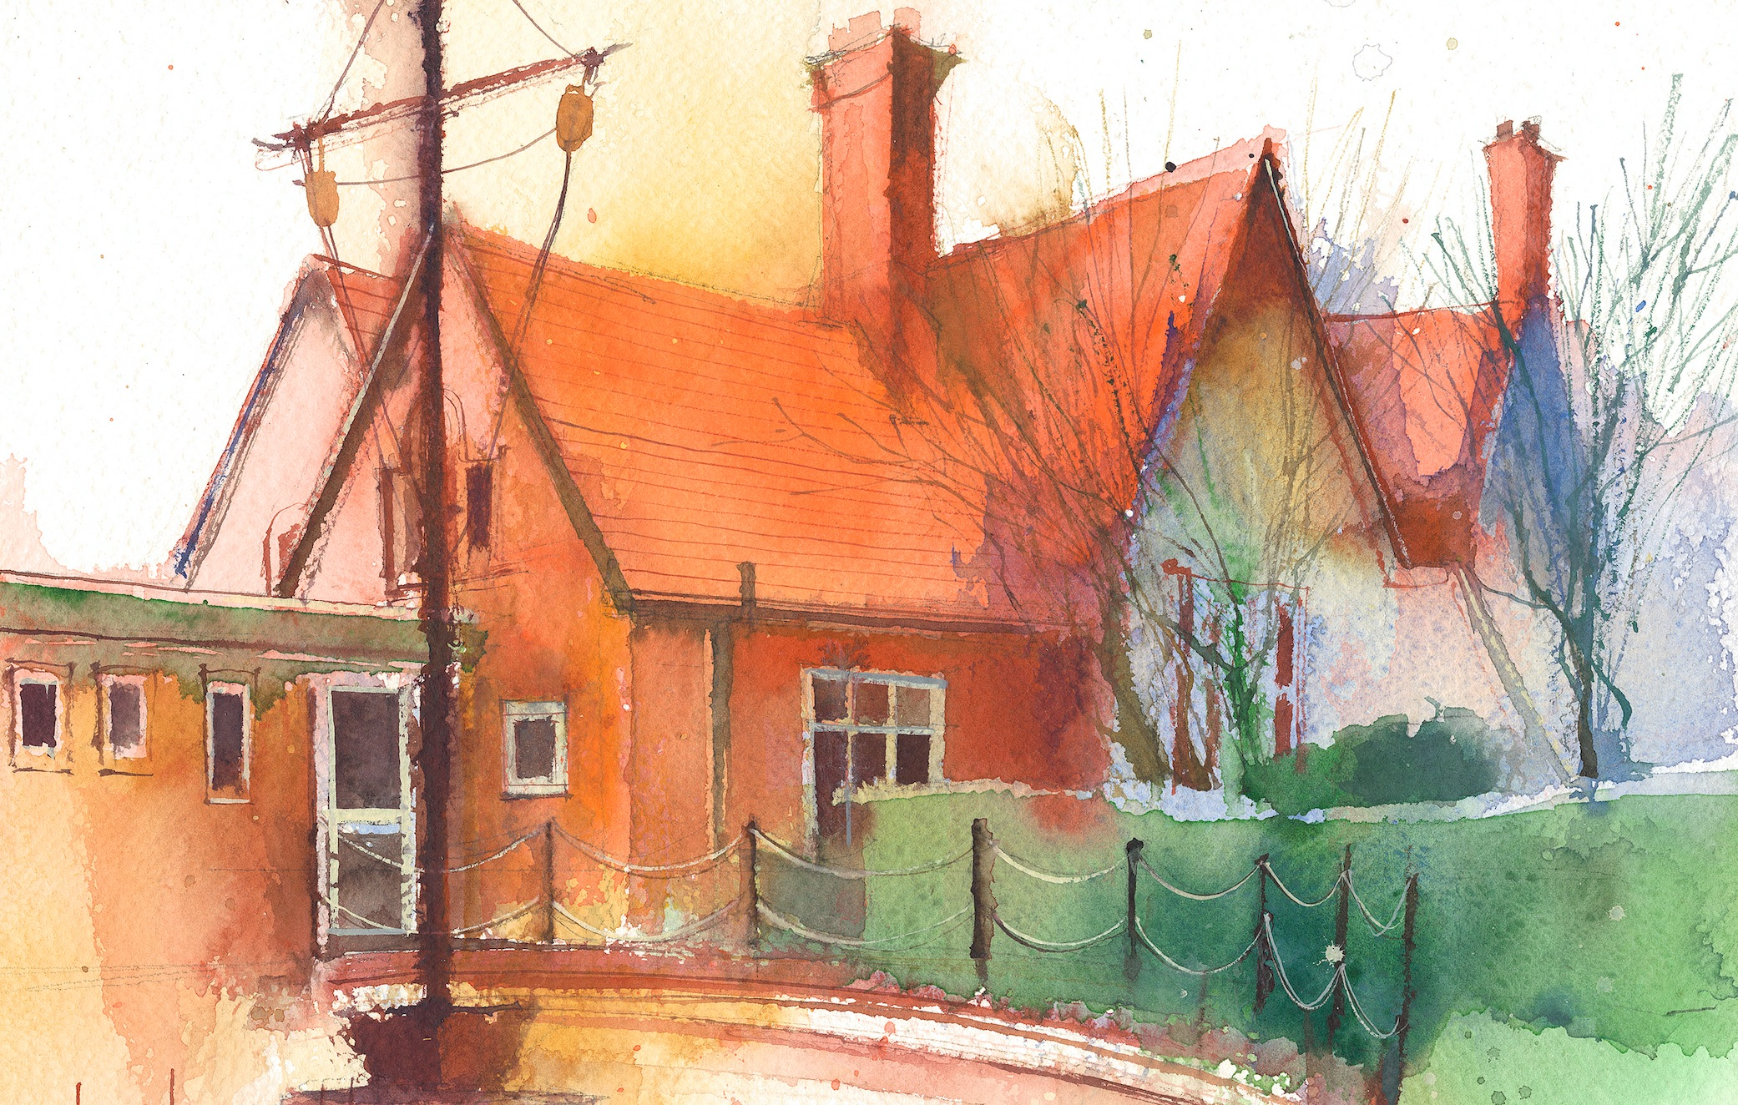
To contact your child’s class teacher, please email schooloffice@dawpool.wirral.sch.uk or phone 0151 648 3412

 | Lessons 09:00 – 10:30 |  | Lessons 10:45 – 12:15 |  | Lessons 13:15 – 15:30 (Incorporating 15-minute break) | Additional Tasks
Monday | Maths  To add by making 10  Collective Worship |  | Phonics  /ee/ phoneme as ie  Comprehension  To respond to a shared text using literal retrieval skills. |  | RE  To talk about special books.  To consider what makes a book Holy?  .  PE  To use dodging and tagging with increasing skill. | Useful Links / Other Recommended Activities  Oak National Academy  https://classroom.thenational.academy/  BBC Bitesize  https://www.bbc.co.uk/bitesize  Purple Mash  https://www.purplemash.com/sch/dawpool#/  Times table practise:  https://www.timestables.co.uk/multiplication-tables-check/  Hit the button  https://www.topmarks.co.uk/maths-games/hit-the-button
Tuesday | Class Trip |  | Class Trip |  | Class Trip
Wednesday | Maths  To add 3 1-digit numbers  Class worship |  | Phonics  /ee/ phoneme as ea or y grapheme  English  To write my narrative |  | Science  I can find out how the shape of solid objects made from materials can be changed  Comprehension
Thursday | Sing worship 9:10  Maths  To add to the next 10 |  | Phonics  /ee/ phoneme as ey or e grapheme  English  To continue to write my narrative |  | Science  To identify and compare the suitability of a variety of everyday materials
Friday | Maths  To add across 10  Celebration worship 10:10 |  | Phonics  /igh/ as igh or i  English  To continue to write my narrative  Heart Smart |  | Computing  To create a portfolio of digital art  Spellings  Common exception words

