**Year 1 Weekly Timetable Week Commencing 20.03.23**

**To contact your child’s class teacher, please email** [**schooloffice@dawpool.wirral.sch.uk**](mailto:schooloffice@dawpool.wirral.sch.uk) **or phone 0151 648 3412**

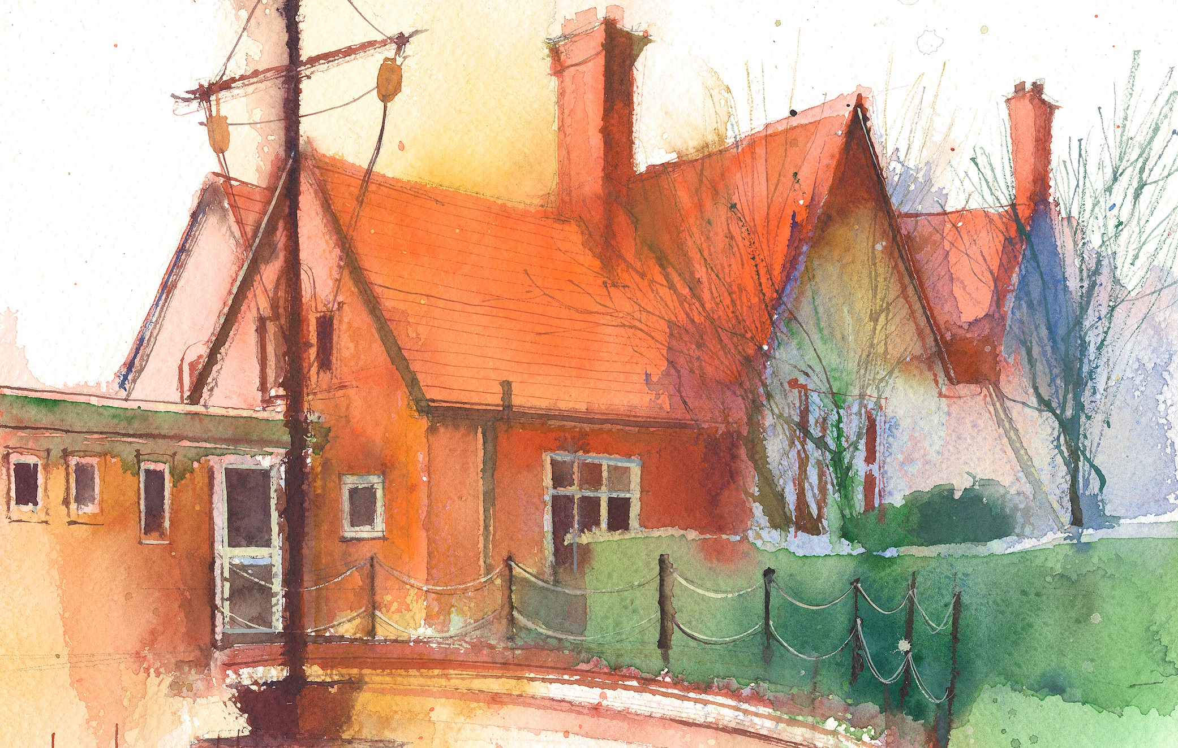

|  |  |  |  |  |  |  |  |  |  |
| --- | --- | --- | --- | --- | --- | --- | --- | --- | --- |
|  | **Lessons 09:00 - 10:30** | | |  | **Lessons­­­­ 10:45 - 12:15** | |  | **Lessons 13:15 - 15:30 (Incorporating 15-minute break)** | **Additional Tasks** |
| **Monday**  **20.03** | **Phonics**  - practise blending and applying ea as /e/ | **English-Adventures of an egg box dragon**  We are learning to:  -respond to illustrations.  By the end of this lesson your child should be able to:  -Reflect on the language choices of the author  -explain what they think the text is about.  **Collective Worship** | | **Maths**  We are learning to:  look for patterns with numbers up to 20, focusing on one more and one less than a number.  By the end of this lesson your child should be able to:  -subtract single-digit numbers  -use a number line.  -use number squares. | | **Topic – Titanic**  We are learning to:  Know the difference between 1st and 3rd class passengers.  By the end of this lesson your child should be able to:  -describe the differences between the different class passengers.  **write a postcard home** describing what life is like on board for them. | Useful Links / Other Recommended Activities  **Oak National Academy**  <https://classroom.thenational.academy/>  **BBC Bitesize**  <https://www.bbc.co.uk/bitesize>  **Purple Mash**  <https://www.purplemash.com/sch/dawpool#/>  **Recommended Reading List**  [See here](https://www.dawpool.wirral.sch.uk/website/recommended_reading_lists/577821) |
| **Tuesday**  **21.03** | **Phonics**  - practise segmenting ea as /e/ | **English-Adeventures of an egg box dragon**  We are learning to:  Make a prediction about events in a text.  By the end of this lesson your child should be able to:  -Draw a prediction of what they think will happen in the next part of the story.  -Use verbs and expanded noun phrases to annotate their drawings to give further explanation. | | **Maths**  We are learning to:   make subtraction stories and represent them in subtraction sentences.  By the end of this lesson your child should be able to:  -find the whole amount from a picture or concrete materials.  -find a part from a picture or concrete materials.  -create a number sentence from a picture or concrete materials.  -find the remainder of a subtraction question. | | **PE**  Led by Claremount Teachers |
| **Wednesday**  **22.03** | **Phonics**  - practise blending and applying se as /s/ | **English-Adventures of an egg box dragon**  We are learning to: make predictions about the events in the text.  By the end of this lesson your child should be able to:  Write the next part of the story, answering questions about what happens under the moon that night. | | **Maths**  We are learning to:  solve picture problems involving subtraction.  By the end of this lesson your child should be able to:  -solve subtraction problems using pictures.  -create number sentences to match the pictures.  -use a number line to support the solution in a picture problem.  -use counting backwards to support the solution in a picture problem.  -use number bond diagrams to support the solution in a picture problem. | | **Spellings**  **Guided Reading Groups** |
| **Thursday**  **23.03** | **Phonics**  - practise segmenting se as /s/ | **English-Adventures of an egg box dragon**  Continuation from previous lesson | | **Science - Plants**  We are learning to:  Describe the functions of a plants structure  Develop observational drawing skills  By the end of this lesson your child should be able to:  * explain the purpose of the roots, stems / trunk, leaves, flowers  * follow step-by-step instructions | | **Maths - Height & Length**  We are learning to:  Use rulers to measure height and length  By the end of this lesson your child should be able to:  * recognise we start measuring at the end of an object  * use the term ‘cm’ when measuring height and length  * know we write ‘cm’ when showing measurements |
| **Friday**  **24.03** | **RE**  We are learning to:  Talk about what communion is and its importance  By the end of this lesson your child should be able to:  * say what items make up communion  * explain why communion is taken | | **Whole School Assembly** | **Phonics**  - practice reading and writing: eyes, friends, once, please, who, again | **Reading Comprehension**  We are learning to:  Answer comprehension questions  By the end of this lesson your child should be able to:  * retrieve information from a text | **Forest Schools**  Led by Grow Wellbeing |