**IRBY METHODIST CHURCH**

ARE HOLDING THEIR ANNUAL

CHRISTMAS FAIR

ON

**SATURDAY 23rd NOVEMBER**

**10.00AM-12.00 PM**

CAKES

BOTTLE TOMBOLA

GIFTS RAFFLE

CHRISTMAS

PAPER & CARDS

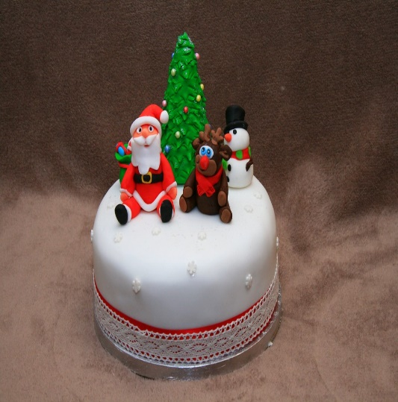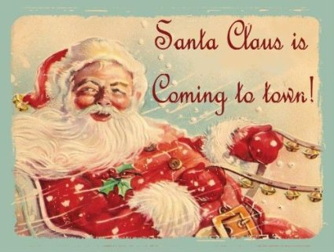

**TOY STALL GAMES**

**CUDDLY TOMBOLA**

**COME AND SEE SANTA**

BOTTLE TOMBOLA

CHRISTMAS CARDS&PAPER

ADMISSION £1.50 ADULTS & 50P CHILD WHICH INCLUDES REFRESHMENTS