Year 5 Weekly Timetable Week Commencing 16.05.22
To contact your child’s class teacher, please email schooloffice@dawpool.wirral.sch.uk or phone 0151 648 3412
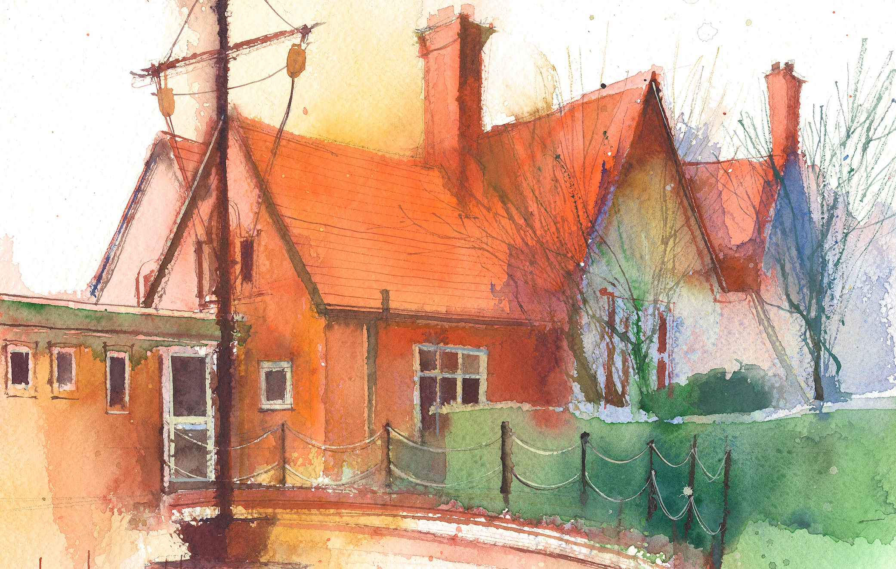

This timetable is available in the event that a Year 5 pupil is required to self-isolate at home, but the cohort remains open to other pupils.
Downloadable resources and activity sheets will be available when a child tests positive for Covid.

 | Session 1: 09:00-10:30 |  | Session 2: 10:45 – 12:15 |  | Session 3: 13:15 – 15:30 (Incorporating 15-minute break) | Additional Tasks
Monday  16.05.22 | MATHS  By the end of this lesson your child should be able to:  Measure angles using a protractor.  We recommend the following resources and activities to achieve this objective: Third space lesson slides and worksheet Shape Lesson. |  | ENGLISH  By the end of this lesson your child should be able to: Answer Comprehension questions effectively based on a text.  We recommend the following resources and activities to achieve this objective: Cracking Comprehension Resources. |  | RE  By the end of this lesson your child should be able to: Use notes made last week and develop these to make an information booklet about the Mucknell Abbey Monks.  We recommend the following resources and activities to achieve this objective: Mucknell Abbey Fact Sheets. Notes made last week. | We also advise your child to complete the following tasks this week:  Read non-fiction books about Living Things and Their Habitats and The Rain Forest. This will build up their knowledge about the topics we are studying in the Spring term.  Use the Nrich Mathematics website for exploration and reasoning activities.
Tuesday  17.05.22 | MATHS  By the end of this lesson your child should be able to:  Subtract two mixed numbers. (Lesson 15)  We recommend the following resources and activities to achieve this objective:  Third Space Slides |  | ENGLISH  By the end of this lesson your child should be able to:  Understand that sentences have 2 parts- a subject and a predicate.  We recommend the following resources and activities to achieve this objective:  Nelson Grammar Unit 15  Watch this film as a stimulus.  https://www.youtube.com/watch?v=B7FqqeIck5Q |  | MUSIC/PE  Rounders with WL  By the end of this lesson your child should be able to:  Play instruments and write musical notation.  We recommend the following resources and activities to achieve this objective:
Wednesday  18.05.22 | ENGLISH  By the end of this lesson your child should be able to:  Study letters to persuade in preparation for deforestation letter.  We recommend the following resources and activities to achieve this objective:  Letters to persuade samples. |  | MATHS  By the end of this lesson your child should be able to:  Multiply a unit fraction by an integer.(Lesson 16)  We recommend the following resources and activities to achieve this objective:  Third Space Slides  MNP Lesson 15 page 272 In Focus task |  | SCIENCE  By the end of this lesson your child should be able to:  Why do plants have flowers?  We recommend the following resources and activities to achieve this objective:  Oak Academy Lesson  Children work in groups to analyse and identify parts of a real flower.
Thursday  19.05.22 | MATHS  By the end of this lesson your child should be able to:  Multiply a non-unit fraction by an integer.  We recommend the following resources and activities to achieve this objective:  Third Space Slides |  | ENGLISH  By the end of this lesson your child should be able to:  Understand the damage and destruction of deforestation.  We recommend the following resources and activities to achieve this objective:  Reading Comprehension. |  | GEOGRAPHY  By the end of this lesson your child should be able to:  Identify where the rainforests are located and what the 4 layers of the rainforest are.  We recommend the following resources and activities to achieve this objective:  Film https://www.nationalgeographic.  org/video/rainforests-101/  Maps, globe
Friday  20.05.22 | MATHS  By the end of this lesson your child should be able to:  Consolidate Arithmetic skills  We recommend the following resources and activities to achieve this objective:  Rising Stars –Summer Test 4 |  | ENGLISH  By the end of this lesson your child should be able to:  Revise and practice ough spelling letter string.  We recommend the following resources and activities to achieve this objective:  Twinkl Activities |  | ART  By the end of this lesson your child should be able to:  Understand the style of the artist Rousseau.  We recommend the following resources and activities to achieve this objective  Plan Bee Week 1

