**Year 5 Weekly Timetable Week Commencing 13.11.23**

**To contact your child’s class teacher, please email** [**schooloffice@dawpool.wirral.sch.uk**](mailto:schooloffice@dawpool.wirral.sch.uk) **or phone 0151 648 3412**

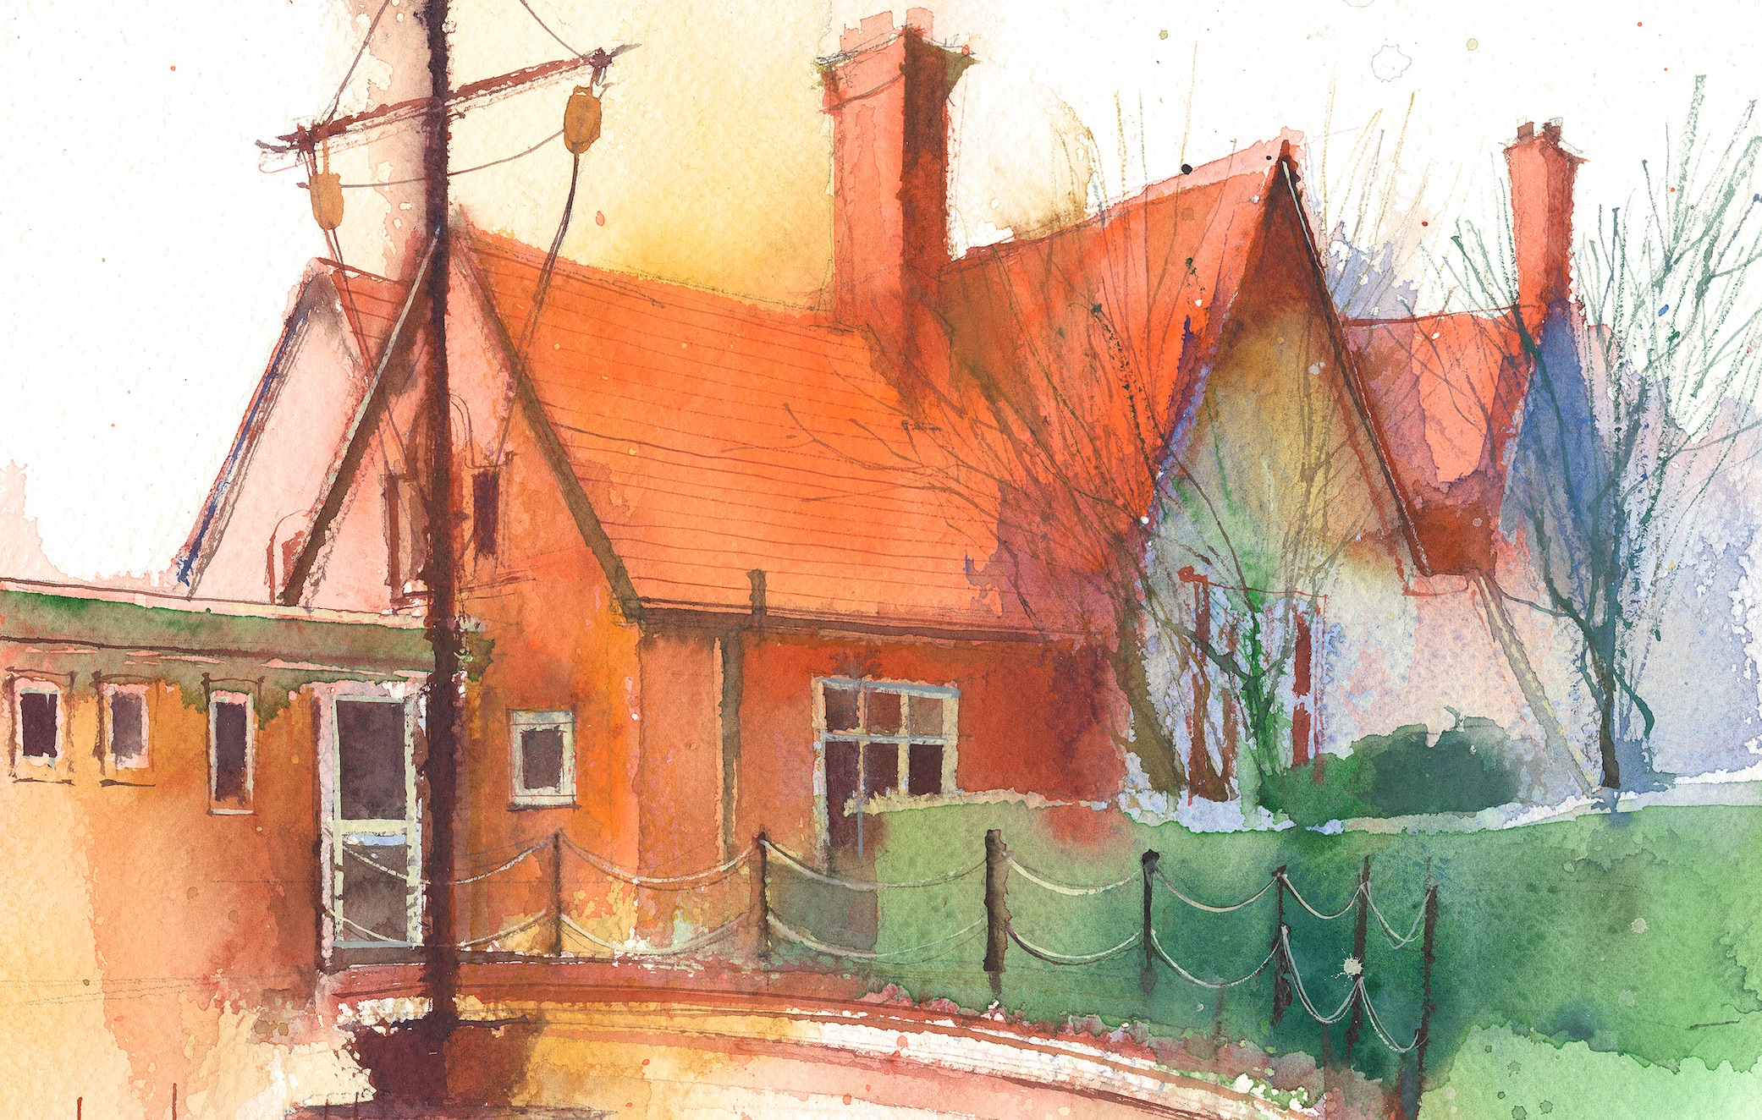

|  |  |  |  |  |  |  |
| --- | --- | --- | --- | --- | --- | --- |
|  | **Lessons 09:00 - 10:30** |  | **Lessons­­­­ 10:45 - 12:15** |  | **Lessons 13:15 - 15:30**  **(Incorporating 15-minute break)** | **Additional Tasks** |
| **Monday**  **13/11/23** | **Maths**  Fluent in five/ Rapid Reasoning  By the end of this lesson your child should be able to draw, read and interpret line graphs using temperature, rainfall (mm) and heartrate (bpm) | **Literacy**  By the end of this lesson your child should be able to write new spellings into ten sentences that make sense; Every sentence has to start with a different sentence starter. Spelling frame Yr 5 ,43 | **Topic/Science**  By the end of this lesson your child should be able to research and develop scientific questions on the Earth and Space work we have done. Question making, question sharing and pinpointing a final question. | 2pm Visit frim Janet Trigg, Interfaith week, Christianity |
| **Tuesday**  **14/11/23** | **Maths**  Fluent in five/ Rapid Reasoning  By the end of this lesson your child should be able to complete all three graphs from yesterday. They will then ask and answer questions with a partner and to the class |  | **Literacy**  By the end of this lesson your child will produce a ten line paragraph describing Theseus’ feelings. Putting into practise our work on better descriptive adjectives. |  | **PE**  By the end of this lesson your child should be able to complete PE lesson. We will continue to learn cricket, this week we will be learning. This week we will be learning how to bowl. | Parents Evening.  Chess will need to move to another class |
| **Wednesday**  **15/11/23** | **Maths**  Fluent in five/ Rapid Reasoning  By the end of this lesson your child should be able to know how to solve problems involving line graphs |  | **Literacy**  By the end of this lesson your child should be able to understand |  | **RE**  By the end of this lesson your child should be able to:  QUESTFUL RE - Unit 5.1 The Bible Objectives: 1. To understand that for Christians, the Bible is believed to be the inspired word of God. 2. To compare and contrast different versions of Psalm 23. | Parents Evening  Year 5 pupils’ interfaith art work is being exhibited at Birkenhead Central Library, from Wednesday 8th November until Thurs 30th November. (Mon-Sat 10am-1pm & 2- 5pm ) |
| **Thursday**  **16/11/23** | **Maths**  Fluent in five/ Rapid Reasoning  By the end of this lesson your child should be able to work with a partner to produce their own line graph on proper graph paper. They will set 5 questions and swap graphs with another group and answer the questions . |  | **Literacy-** till 11.45 because of early lunch for trip  **Reading Comprehension**  By the end of this lesson your child should be able to do a year 5 comprehension the |  | **TOPIC**  Trip to Walker Art Gallery Liverpool  Greek Storytelling and the myth of Atlanta and Meleager |  |
| **Friday**  **17/11/23** | **Maths**  Fluent in five/ Rapid Reasoning  Rounding and sequencing up to 6 digit numbers. |  | **Literacy- Spelling**  To do spelling test and mark with children and use word wall for any words that they have found hard |  | **Topic/Art/DT**  The children will do some abstract art based on work seen in the Walker Art Gallery |  |