Year 4 Weekly Timetable Week Commencing: 16.11.25
To contact your child’s class teacher, please email schooloffice@dawpool.wirral.sch.uk or phone 0151 648 3412
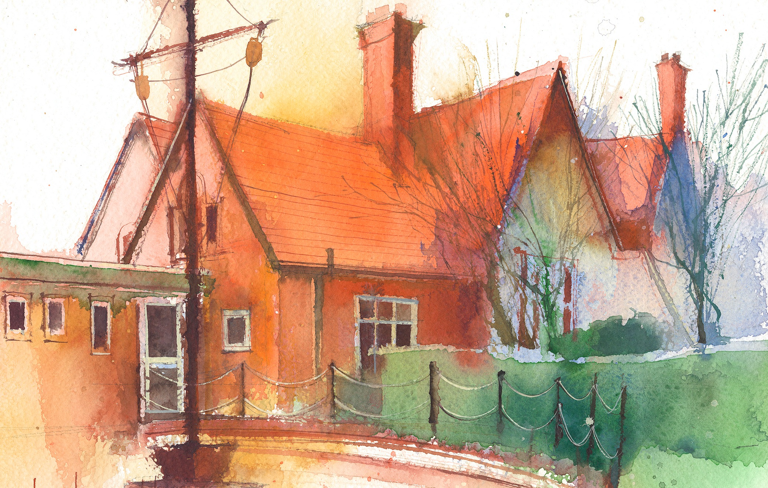

 | Lessons 09:00 – 10:30 |  | Lessons 10:45 – 12:15 |  | Lessons 13:15 – 15:30 (Incorporating 15-minute break) | Additional Tasks
Monday | Maths  Arithmetic- times tables  Collective Worship in classroom  10:10 |  | English –  Weekly spellings  Jemmy Button  To make predictions and inferences |  | Computing  Unpacking hardware and software  PSHE  Heart smart: Brilliant me | Useful Links / Other Recommended Activities  Oak National Academy  https://classroom.thenational.academy/  BBC Bitesize  https://www.bbc.co.uk/bitesize  Purple Mash  https://www.purplemash.com/sch/dawpool#/  Times table practise:  https://www.timestables.co.uk/multiplication-tables-check/  Hit the button  https://www.topmarks.co.uk/maths-games/hit-the-button
Tuesday | Class based worship  Maths  Multiply by ten |  | English  To use drama to explore the character and setting. |  | Science  I can describe the functions of the organs in the human digestive system  Picture News  .
Wednesday | .  Maths  Multiply by 100 |  | English-  To describe a setting using prepositions and noun phrases |  | Forest school
Thursday | Sing worship 9:10  Maths  Divide by 10 |  | Music- Ukulele  English-  I can improve sentences using subordinating conjunctions |  | English continued  RE  Why is light an important symbol in world faiths?
Friday | Maths  Divide by 100  Celebration worship 10:10 |  | English  Reading comprehension |  | Science  Roman Art- continued patterns  PE- 2:00-3:00pm  Cricket

