Year 5 Weekly Timetable Week Commencing 06.12.21
To contact your child’s class teacher, please email schooloffice@dawpool.wirral.sch.uk or phone 0151 648 3412
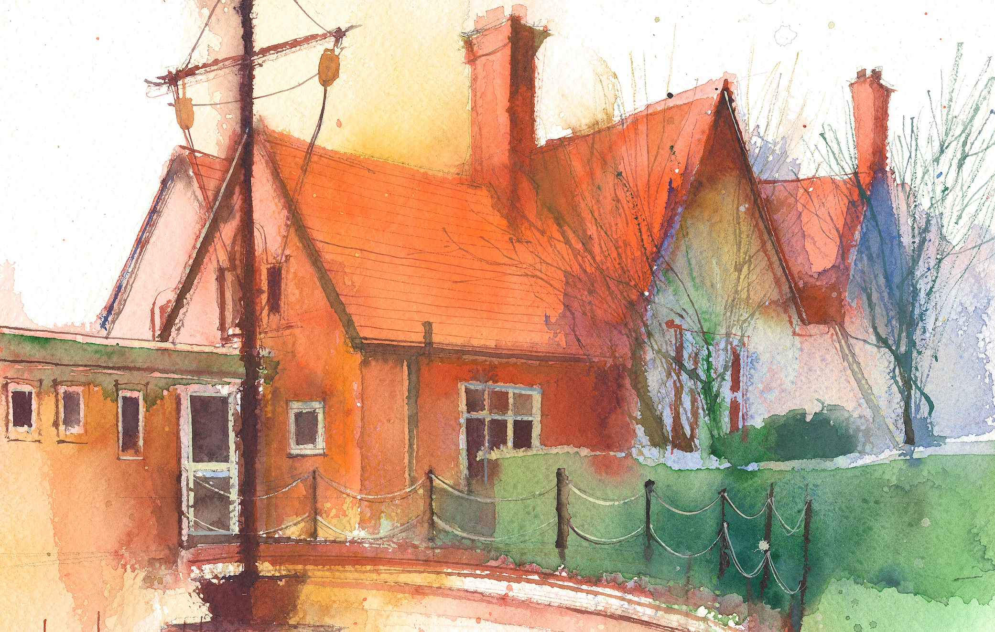

This timetable is available in the event that a Year 5 pupil is required to self-isolate at home, but the cohort remains open to other pupils.
Downloadable resources and activity sheets will be available when a child tests positive for Covid.

 | Session 1: 09:00-10:30 |  | Session 2: 10:45 – 12:15 |  | Session 3: 13:15 – 15:30 (Incorporating 15-minute break) | Additional Tasks
Monday  06.12.21 | MATHS  By the end of this lesson your child should be able to: To translate shapes in the first quadrant.  We recommend the following resources and activities to achieve this objective: Third Space slides and worksheets. |  | ENGLISH  By the end of this lesson your child should be able to: To answer non-fiction comprehension questions.  We recommend the following resources and activities to achieve this objective: Cracking comprehension resources: The Pebble in my Pocket. |  | ICT  By the end of this lesson your child should be able to: .To learn about the incarnation and its significance for Christians.  We recommend the following resources and activities to achieve this objective: PPT and Bible passages. | We also advise your child to complete the following tasks this week:  Read non-fiction books about Earth and Space and Ancient Greece. This will build up their knowledge about the topics we are studying in the Autumn term.  Use the Nrich Mathematics website for exploration and reasoning activities.
Tuesday  07.12.21 | CHRISTMAS POTTERY |  | CHRISTMAS POTTERY |  | CHRISTMAS ASSEMBLY PRACTICE
Wednesday  01.12.21 | CHRISTMAS ASSEMBLY  9.30am |  | ENGLISH  By the end of this lesson your child should be able to:  Use comprehension skills to learn the story of Arachne. Preparation for a long write.  We recommend the following resources and activities to achieve this objective:  Story and questions. |  | CHRISTMAS ASSEMBLY  2.00pm
Thursday  02.12.21 | ENGLISH  By the end of this lesson your child should be able to:  Use comprehension skills to learn the story of Arachne. Preparation for a long write.  We recommend the following resources and activities to achieve this objective:  Story and questions. |  | MATHS  By the end of this lesson your child should be able to:  Arithmetic and Key Skills.  Know how to read two-way tables.  We recommend the following resources and activities to achieve this objective:  Year 5 Arithmetic Full Test 1  Third Space Slides Lesson 5 |  | SCIENCE  By the end of this lesson your child should be able to:  Planning a Friction investigation  We recommend the following resources and activities to achieve this objective:  Purple Mash Planning Sheet
Friday  03.12.21 | MATHS  By the end of this lesson your child should be able to:  Know how to read and interpret timetables.  We recommend the following resources and activities to achieve this objective:  Third Space Slides Lesson 6 |  | CHRISTMAS CARDS AND CALENDARS |  | SPANISH  By the end of this lesson your child should be able to:  Colours in Spanish and Christmas  We recommend the following resources and activities to achieve this objective:  Lesson delivered by Senorita Wilson

