Foundation 2 Weekly Timetable Week Commencing 21.6.21
To contact your child’s class teacher, please email foundation2@dawpool.wirral.sch.uk
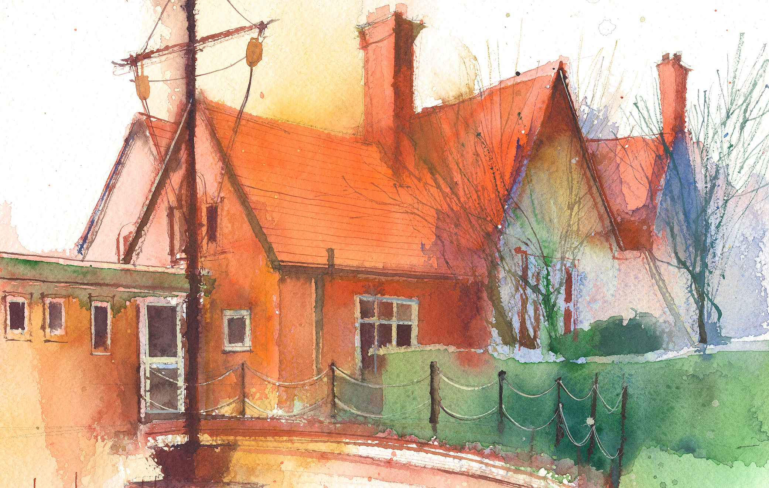

This timetable is available for pupils in Foundation 2 to require remote learning. Please visit the Foundation 2 Remote Learning Page to
access any downloadable resources and activity sheets. The assessed task should be submitted to the teacher at the end of each day via email/tapestry (setting up in progress)

 | Session 1 |  | Session 2 |  | Session 3
Monday  21.6.21 | Phonics  By the end of this lesson your child should be able to:  - Write recognisable letters, most of which are correctly formed;  - Spell words by identifying sounds in them and representing the sounds with a letter or letters;  - Write simple phrases and sentences that can be read by others.  We recommend the following resources and activities to achieve this objective:  Re-cap all taught sounds  s, a, t, p, i, n, m, d, g, o, c, k, ck, e, u, r, h, b, f, ff, l, ll, ss, j, v, w, x, y, z, zz, qu ch, sh, th, ng ai ee igh oa oo oo ar or ur ow oi ear air  Tricky words – no, go, I, the, to, me, she, we, be, me, was, my they  Re-cap all letters and sounds. Focus more on phase 3 digraphs. Show one, think of a word and write it.  Re-cap phase 2 and 3 tricky words.  Re-cap – j v w x powerpoint – complete activities as we go through  Split into phonics groups for activities |  | Maths  By the end of this lesson your child should be able to:  Talk about sharing and what we mean by this term in mathematics.  We recommend the following resources and activities to achieve this objective:  Quick fire – doubling numbers  Say the word ‘sharing’ what do I mean? Discuss and take ideas.  Talk about the main concepts – making it fair and making sure everybody ahs the same amount.  Model the dinosaur egg, playdough activity.  Adult led – using raisins to share equally between the dinosaurs – eat the raisins at the end. |  | Topic  By the end of this lesson your child should be able to:  Talk about fossils and who Mary Anning was.  We recommend the following resources and activities to achieve this objective:  What is a fossil?  Introduce a woman called Mary Anning – She a fossil hunter many years ago.  Mary Anning Powerpoint – take the quiz at the end to see if we can remember the facts.
Tuesday  22.6.21 | Phonics  By the end of this lesson your child should be able to:  - Write recognisable letters, most of which are correctly formed;  - Spell words by identifying sounds in them and representing the sounds with a letter or letters;  - Write simple phrases and sentences that can be read by others.  We recommend the following resources and activities to achieve this objective:  Re-cap all taught sounds  s, a, t, p, i, n, m, d, g, o, c, k, ck, e, u, r, h, b, f, ff, l, ll, ss, j, v, w, x, y, z, zz, qu ch, sh, th, ng ai ee igh oa oo oo ar or ur ow oi ear air ure  Tricky words – no, go, I, the, to, me, she, we, be, me, was, my they  Re-cap all letters and sounds. Focus more on phase 3 digraphs. Show one, think of a word and write it.  Re-cap phase 2 and 3 tricky words.  Re-cap – y z qu ch using powerpoint – complete activities as we go though  Split into phonics groups for activities |  | Maths  By the end of this lesson your child should be able to:  Talk about sharing in mathematics and how we can make sure it is fair.  We recommend the following resources and activities to achieve this objective:  Quick fire – one more and one less  Teaching pirates to be fair powerpoint  Use the toy dinosaurs and explain that we need to share them out equally between different children.  Select 2 children to come to front. I have 4 dinosaurs. How can I share them equally so it is fair? Talk about them both having the same at the end and how we can count to check. One for you, one for you, one for you approach until there are none left and then check they both have the same amount. |  | Topic  By the end of this lesson your child should be able to:  Talk about a selection of different dinosaurs.  We recommend the following resources and activities to achieve this objective:  What dinosaurs do we know? – make a list on the board.  Does anybody know any facts about any dinosaurs?  Dinosaur powerpoint to learn the names of different dinosaurs. Talk about some of the similarities and diffenreces just by looking at them.  Explain that we are going to have a vote to pick a dinosaur to learn some more information about. During continuous provision, explain that children need to write down the name of the dinosaur they want to learn more about and then put it in the voting box. At the end of the day we will count the votes and see what which dinosaur had the most votes.
Wednesday  23.6.21 | Phonics  By the end of this lesson your child should be able to:  - Write recognisable letters, most of which are correctly formed;  - Spell words by identifying sounds in them and representing the sounds with a letter or letters;  - Write simple phrases and sentences that can be read by others.  We recommend the following resources and activities to achieve this objective:  Re-cap all taught sounds  s, a, t, p, i, n, m, d, g, o, c, k, ck, e, u, r, h, b, f, ff, l, ll, ss, j, v, w, x, y, z, zz, qu ch, sh, th, ng ai ee igh oa oo oo ar or ur ow oi ear air ure  Tricky words – no, go, I, the, to, me, she, we, be, me, was, my, they  Re-cap all letters and sounds. Focus more on phase 3 digraphs. Show one, think of a word and write it.  Re-cap phase 2 and 3 tricky words.  Re-cap – sh th th ng using powerpoint – complete activities as we go along  Split into phonics groups for activities |  | Maths  By the end of this lesson your child should be able to:  Talk about sharing and what we mean by this term in mathematics.  We recommend the following resources and activities to achieve this objective:  Quick fire – rote counting as far as we can go in 1’s. Counting in 10’s to 100. Counting in 5’s.  Fairy tale sharing and reasoning powerpoint – complete and discuss. |  | Topic  By the end of this lesson your child should be able to:  Re-call some facts about a dinosaur we have researched.  We recommend the following resources and activities to achieve this objective:  Use the non-fiction books and the internet to find out lots of information about our chosen dinosaur.  Write the fact on a large piece of paper to be displayed.
Thursday  24.6.21 | Phonics  By the end of this lesson your child should be able to:  - Write recognisable letters, most of which are correctly formed;  - Spell words by identifying sounds in them and representing the sounds with a letter or letters;  - Write simple phrases and sentences that can be read by others.  We recommend the following resources and activities to achieve this objective:  Re-cap all taught sounds  s, a, t, p, i, n, m, d, g, o, c, k, ck, e, u, r, h, b, f, ff, l, ll, ss, j, v, w, x, y, z, zz, qu ch, sh, th, ng ai ee igh oa oo oo ar or ur ow oi ear air ure er  Tricky words – no, go, I, the, to, me, she, we, be, me, was, my, they  Re-cap all letters and sounds. Focus more on phase 3 digraphs. Show one, think of a word and write it.  Re-cap phase 2 and 3 tricky words.  Re-cap – ai ee igh oa using powerpoint – complete activities as we go along  Split into phonics groups for activities |  | Maths  By the end of this lesson your child should be able to:  Talk about sharing and what we mean by this term in mathematics.  We recommend the following resources and activities to achieve this objective:  https://www.youtube.com/watch?v=0b4beyJ4oG4 sharing video – watch and discuss.  What happens if there was an extra apple?  How do we know it is fair?  Sharing Max and monkey powerpoint – discuss concepts and ways of reasoning and working things out. |  | R.E.  By the end of this lesson your child should be able to:  - say what the Holy Spirit is  - explain that the Holy Spirit is a gift from God  - begin to think about how people talk about the Holy Spirit  We recommend the following resources and activities to achieve this objective:  Recap previous lesson, what story did we look at? (Pentecost) What can you remember about this story? (It was the start of the Church; God sent the Holy Spirit to the people as a gift)  Explain that someone has left us a present but we don’t know who it is from? I wonder if we look inside if we might be able to find out who it is from? Show large box, pull out each of the gifts (heart, Bible, family photo, torch), explain that this present shows us gifts that God gives to everyone who follows and believes in Jesus.  Heart - it is a gift to know that God loves and comforts His children  Bible - God’s word is a gift to His children because we find His promises and instructions inside - guidance  Family - it is a gift to be part of God’s family and be able to pray together and help each other as a Christian community  Torches - talk about what a torch does (lights up in the dark to show the way), explain that this is another gift that God gives us in the Holy Spirit. He comes and lives in our hearts to guide us and to show us how to lead a good life.  Reinforce that God sent the Holy Spirit to us as a gift  Provision: Decorate box templates to create into gift boxes  Activity: Children to work in small groups to cut out and construct their gift box (each children to be given a feather in next lesson to go in their gift box as a reminder that the Holy Spirit is like the wind / dove)
Friday  25.6.21 | P.E.  By the end of this lesson your child should be able to:  - develop the ability to move at speed  - safely play a running game  - successfully move in and out of objects at speed  We recommend the following resources and activities to achieve this objective:  Running on the spot  Start by running on the spot. A grown-up will shout out different commands e.g., ‘faster’ or ‘slower’. Listen to the command and change your speed  Catch me if you can  Find an area to play in and set up some safe spots e.g., a slide in the park or a tree in the woods. Try to run between the different safe spots without a grown-up catching up. How many safe spots can you get to?  Up and down running  Run around and listen to the instruction from a grown-up. When you hear the, shout ‘up’, jump up high. When you hear them shout ‘down’, bend down and try and touch the floor  Collect the coins  With a grown up, make some pretend pirate coins with numbers 1-10 written on them. Your grown-up will spread out the coins and use different objects as obstacles e.g., soft toys, pillows, old boxes. Next, run around the obstacle course, trying to collect the numbered coins on the correct order  Tips for running:  - make sure that your head is up and looking where you are running |  | R.S.E.  By the end of this lesson your child should be able to:  - explain that we need to keep trying when something is difficult  We recommend the following resources and activities to achieve this objective:  Remind the children that everyone finds things difficult sometimes. Revisit the ‘Boris the Robot’ story.  * What does Boris find difficult?  * What do you find difficult?  Ask the children to think of different strategies that they could use when they are stuck.  * What have you tried to do in the past?  * What could you try in the future? (e.g. keeping trying, ask a friend for help, ask a teacher to help)  Activity: What skill would you like to learn / try in the future?  Boris Says: Everyone needs help sometimes |  | Topic  OUTDOOR – Physical development  Field  Tyres  Bikes/scooters  Bats and balls  Hoops  Etc

