Year 1 Weekly Timetable Week Commencing 02.03.26
To contact your child’s class teacher, please email schooloffice@dawpool.wirral.sch.uk or phone 0151 648 3412
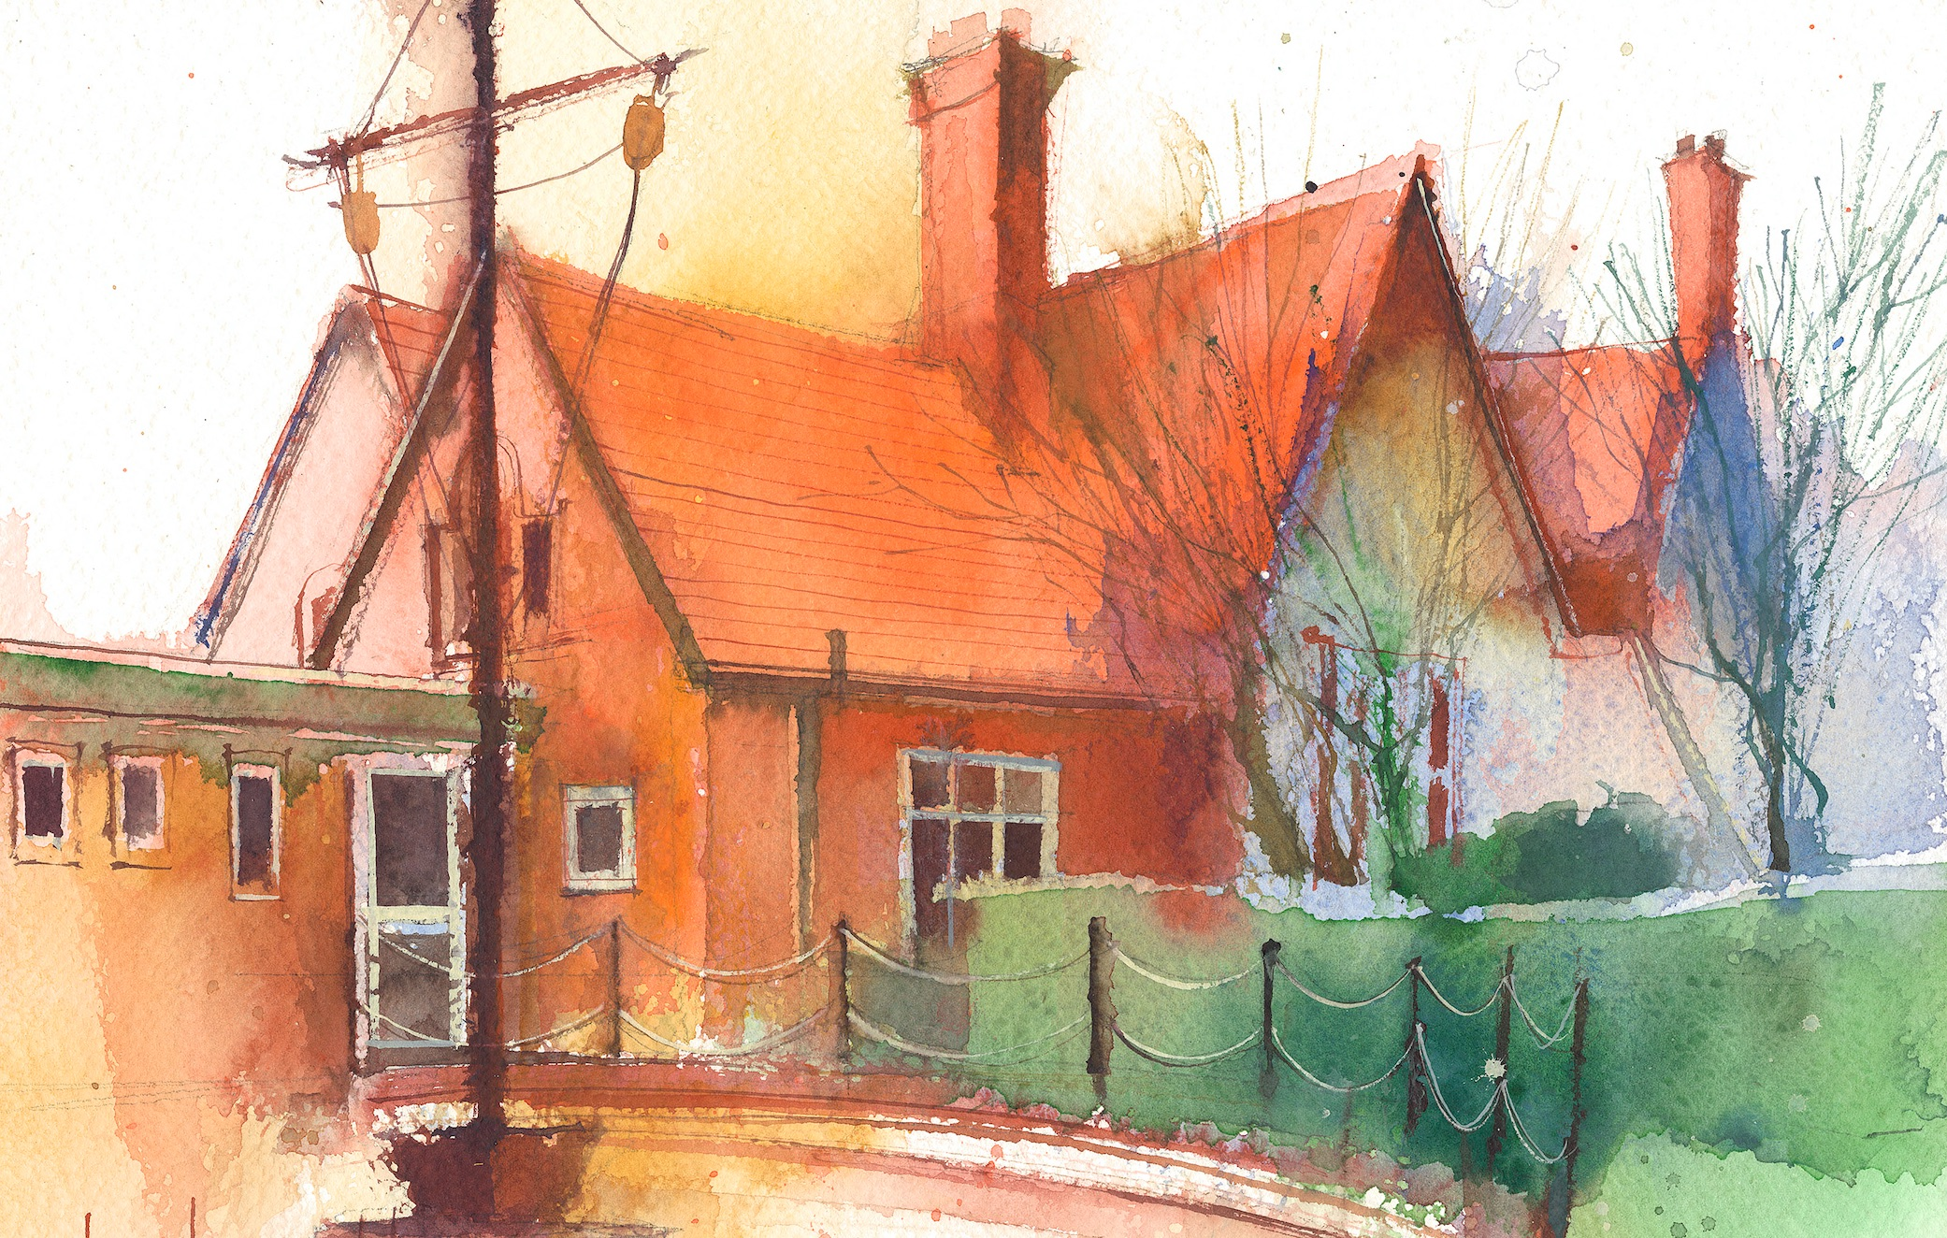

 | Lessons 09:00 – 10:30 |  |  | Lessons 10:45 – 12:15 |  | Lessons 13:15 – 15:30 (Incorporating 15-minute break) | Additional Tasks
Thursday | Phonics: k as ch (segmenting practise)  English: (SW, Lesson 4)  • To continue to learn to tell the Retell version of Oliver and Patch.  • To use ‘and’ to join two words (verbs) | Fashion  show! |  | Maths: (lesson 12) Order numbers to 20.  ERIC/ GR - Yellow, Blue |  | Fin5  Double PE:  •The focus of the learning is for pupils to create balances and movements that represent The Titanic.  •Pupils will create different movements that replicate the ship arriving at a port.  •Pupils will use their bodies to perform balances that represent the ship.  •The focus of learning is to create movements that represent the different social classes in 1912.  • Pupils will be able to use levels and characterisation to differentiate between each of the different social classes.
Friday | Phonics: Tricky words: Mr and Mrs  English: (lesson 3):  • Recall today’s section of Story Map in pairs  •Record Retell version in one/two sentences  •Write simple sentence/s using full stop and capital letter. | Celebration Assembly |  | Maths: (lesson 12) Numbers to 20 Assessment.  ERIC/ GR - Green, Orange |  | Fin5  RE/Forest School:  •I can reflect on the Easter story and notice signs of new life in the story.  •I can create an Easter Garden.  Golden Time!

