Year 4 Weekly Timetable Week Commencing: 19.01.26
To contact your child’s class teacher, please email schooloffice@dawpool.wirral.sch.uk or phone 0151 648 3412
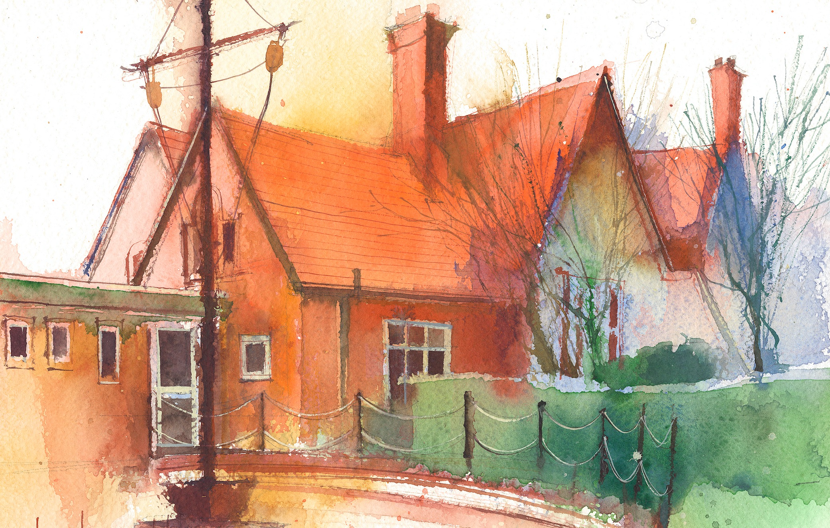

 | Lessons 09:00 – 10:30 |  | Lessons 10:45 – 12:15 |  | Lessons 13:15 – 15:30 (Incorporating 15-minute break) | Additional Tasks
Monday | Maths  To explore 12 times tables and division facts  Collective Worship 10:10 |  | English  Plan own story using boxing-up  Weekly spellings |  | Computing  Times table Rock Stars | Useful Links / Other Recommended Activities  Oak National Academy  https://classroom.thenational.academy/  BBC Bitesize  https://www.bbc.co.uk/bitesize  Purple Mash  https://www.purplemash.com/sch/dawpool#/  Times table practise:  https://www.timestables.co.uk/multiplication-tables-check/  Hit the button  https://www.topmarks.co.uk/maths-games/hit-the-button
Tuesday | Maths  To multiply by 1 and o |  | English  To write an introduction to a narrative  Class based worship: picture news |  | Comprehension  Heart Smart  What’s missing?
Wednesday | Maths  To divide by 1 and itself |  | Ukulele 11:00- 11:30  English  To continue my narrative |  | Science- Electricity  I can identify whether or not a lamp will light in a simple series circuit
Thursday | Sing worship 9:10  Maths  To multiply 3 numbers |  | English  To continue my narrative |  | Geography-  To identify the main volcanoes on a world map  Comprehension
Friday | Maths  Arithmetic  Celebration worship 10:10 |  | English  To edit and improve my narrative |  | Spelling Test 1:15-1:30  PE: 1:30-2:30  Gymnastics  Times Table Practise  Times tables Rock Stars

