Foundation 2 Weekly Timetable Week Commencing 05.01.26
To contact your child’s class teacher, please email schooloffice@dawpool.wirral.sch.uk or phone 0151 648 3412
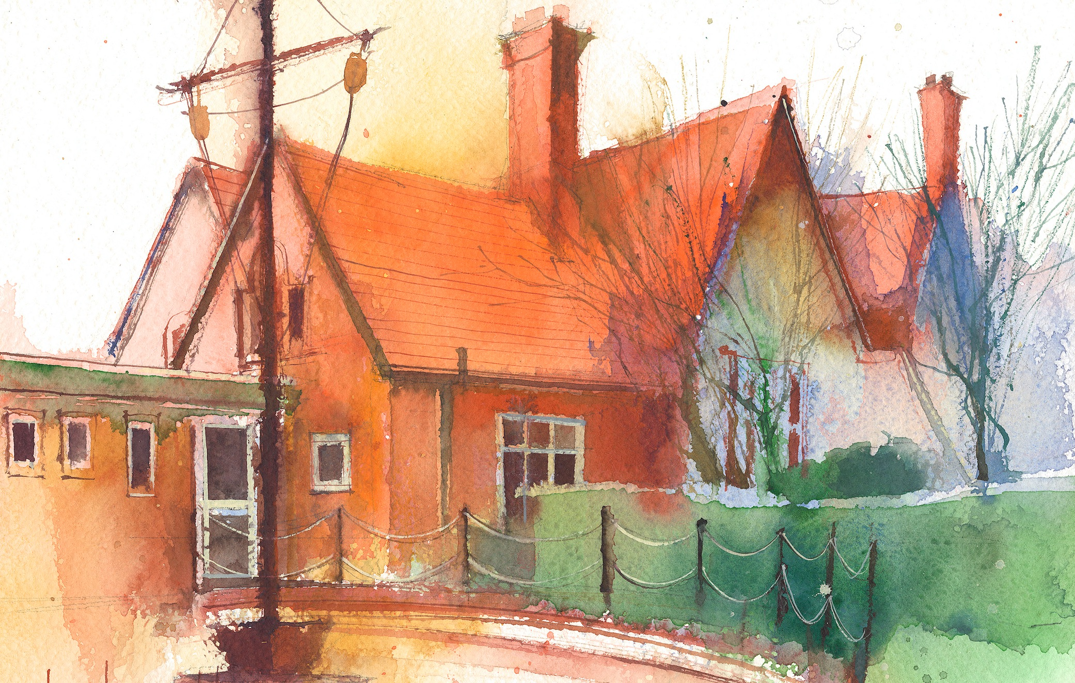

This timetable is available in the event that a Foundation 2 pupil is required to self-isolate at home, but the cohort remains open to other pupils.
Please visit the Foundation 2 Remote Learning Page on the school website to access any downloadable resources and activity sheets.

 | Session 1: 09:00-10:30 |  | Session 2: 10:50 – 12:00 |  | Session 3: 13:15 – 15:25
Monday | Phonics  By the end of this lesson your child should be able to:  Recognise and say the sound ‘j’  (Week 12)  We recommend the following resources and activities to achieve this objective:  Blending practice.  Children will complete activities in their individual rocket phonics workbooks. |  | Maths  By the end of this lesson your child should be able to:  To understand the composition of numbers  We recommend the following resources and activities to achieve this objective:  Watch Numberblocks 10. Pause it a regular points to discuss what they can see.  Use the language ‘10 is 1 more than 9’  Model writing  9+1=10  10-1=9  Discuss the fact that 10 is made up on 10 1s. However, it is also a stick of 10 on its own.  Sit the children in a circle and look at a stick of 10 cubes and 10 loose cubes. How many are in each pile?  Explain that there are 10 in each pile. They are the same, they just look different the stick of 10 is a set of ten. The single cubes are 10 individual cubes. |  | Topic  During the afternoons we will undertake activities linked to all areas of the Early Years Curriculum;  Prime Areas; Communication and Language;  Personal, Social and Emotional Development;  Physical Development.  Specific Areas; Literacy, Maths, Understanding the World and Expressive Arts and Design.  Afternoon sessions will also include RE, HeartSmart and Forest Schools.  Our current RE topic is ‘Special Times’. Planning for this can be found on the website.  Activities will be linked to our class topic which is ‘Where in the World’. We aim to use children’s books as a hook for learning to help us find out more about the world around us. Throughout the year we will select books that enable us to cover all requirements of the Early Years Curriculum.  We will talk about where the book is set and find out where this country is on a map. We will then use the theme of the book as a way of guiding our planning.  PLEASE NOTE  The very nature of the EYFS curriculum enables us to go with the interests of the children. The activities we plan are for a guide only.  Staff can use and adapt activities or add additional activities and not cover others. It is all dependent on how and where the children’s interests take us.  Activities are designed to cover several weeks, if needed.  A copy of the current topic plan is available to view on the class website page.
Tuesday | Phonics  By the end of this lesson your child should be able to:  Recognise and write the sound ‘j’  We recommend the following resources and activities to achieve this objective:  Segmenting practice.  Children will complete activities in their individual rocket phonics workbooks. |  | Maths  By the end of this lesson your child should be able to:  To understand the composition of numbers  We recommend the following resources and activities to achieve this objective:  Using number tiles 1-10 hand them out to some children. As a whole class can we order numbers 1-10? Which number to we start with? What number comes after 1 etc.  Play Musical Tens  (in the hall if possible)  Hand out some number cards 1-10 to the children. Can they dance around and move around to the music. When the music stops can they work together to get themselves in groups of 10.  Discuss the order as a whole class to re-cap.
Wednesday | Phonics  By the end of this lesson your child should be able to:  Recognise and say the sound ‘v’  We recommend the following resources and activities to achieve this objective:  Blending practice  Children will complete activities in their individual rocket phonics workbooks. |  | Maths  By the end of this lesson your child should be able to:  To understand the composition of numbers  We recommend the following resources and activities to achieve this objective:  Watch Numberblocks 10. Pause it a regular points to discuss what they can see.  Use the language ‘10 is 1 more than 9’  Model writing  9+1=10  10-1=9  Discuss the fact that 10 is made up on 10 1s. However, it is also a stick of 10 on its own.  Sit the children in a circle and look at a stick of 10 cubes and 10 loose cubes. How many are in each pile?  Explain that there are 10 in each pile. They are the same, they just look different the stick of 10 is a set of ten. The single cubes are 10 individual cubes.
Thursday | Phonics  By the end of this lesson your child should be able to:  Recognise and write the sound ‘v’  We recommend the following resources and activities to achieve this objective:  Segmenting practice  Children will complete activities in their individual rocket phonics workbooks. |  | Maths  By the end of this lesson your child should be able to:  To understand the composition of numbers  We recommend the following resources and activities to achieve this objective:  Using number tiles 1-10 hand them out to some children. As a whole class can we order numbers 1-10? Which number to we start with? What number comes after 1 etc.  Play Musical Tens  (in the hall if possible)  Hand out some number cards 1-10 to the children. Can they dance around and move around to the music. When the music stops can they work together to get themselves in groups of 10.  Discuss the order as a whole class to re-cap.
Friday | PE  By the end of this lesson your child should be able to:  Move in a variety of different ways around the room including High and Low. To sequence a series of moves.  We recommend the following resources and activities to achieve this objective:  During this half term the children will be learning ball skills. How to handle, control and pass balls carefully.  Skills will be taught using scarves, balloons, beachballs, footballs and smaller soft balls. |  | Phonics  By the end of this lesson your child should be able to:  To learn to read the Common Exception words ‘he she’  We recommend the following resources and activities to achieve this objective:  Children will complete activities in their individual rocket phonics workbooks.

