**Year 4 Weekly Timetable Week Commencing 28.04.25**

**To contact your child’s class teacher, please email** [**schooloffice@dawpool.wirral.sch.uk**](mailto:schooloffice@dawpool.wirral.sch.uk) **or phone 0151 648 3412**

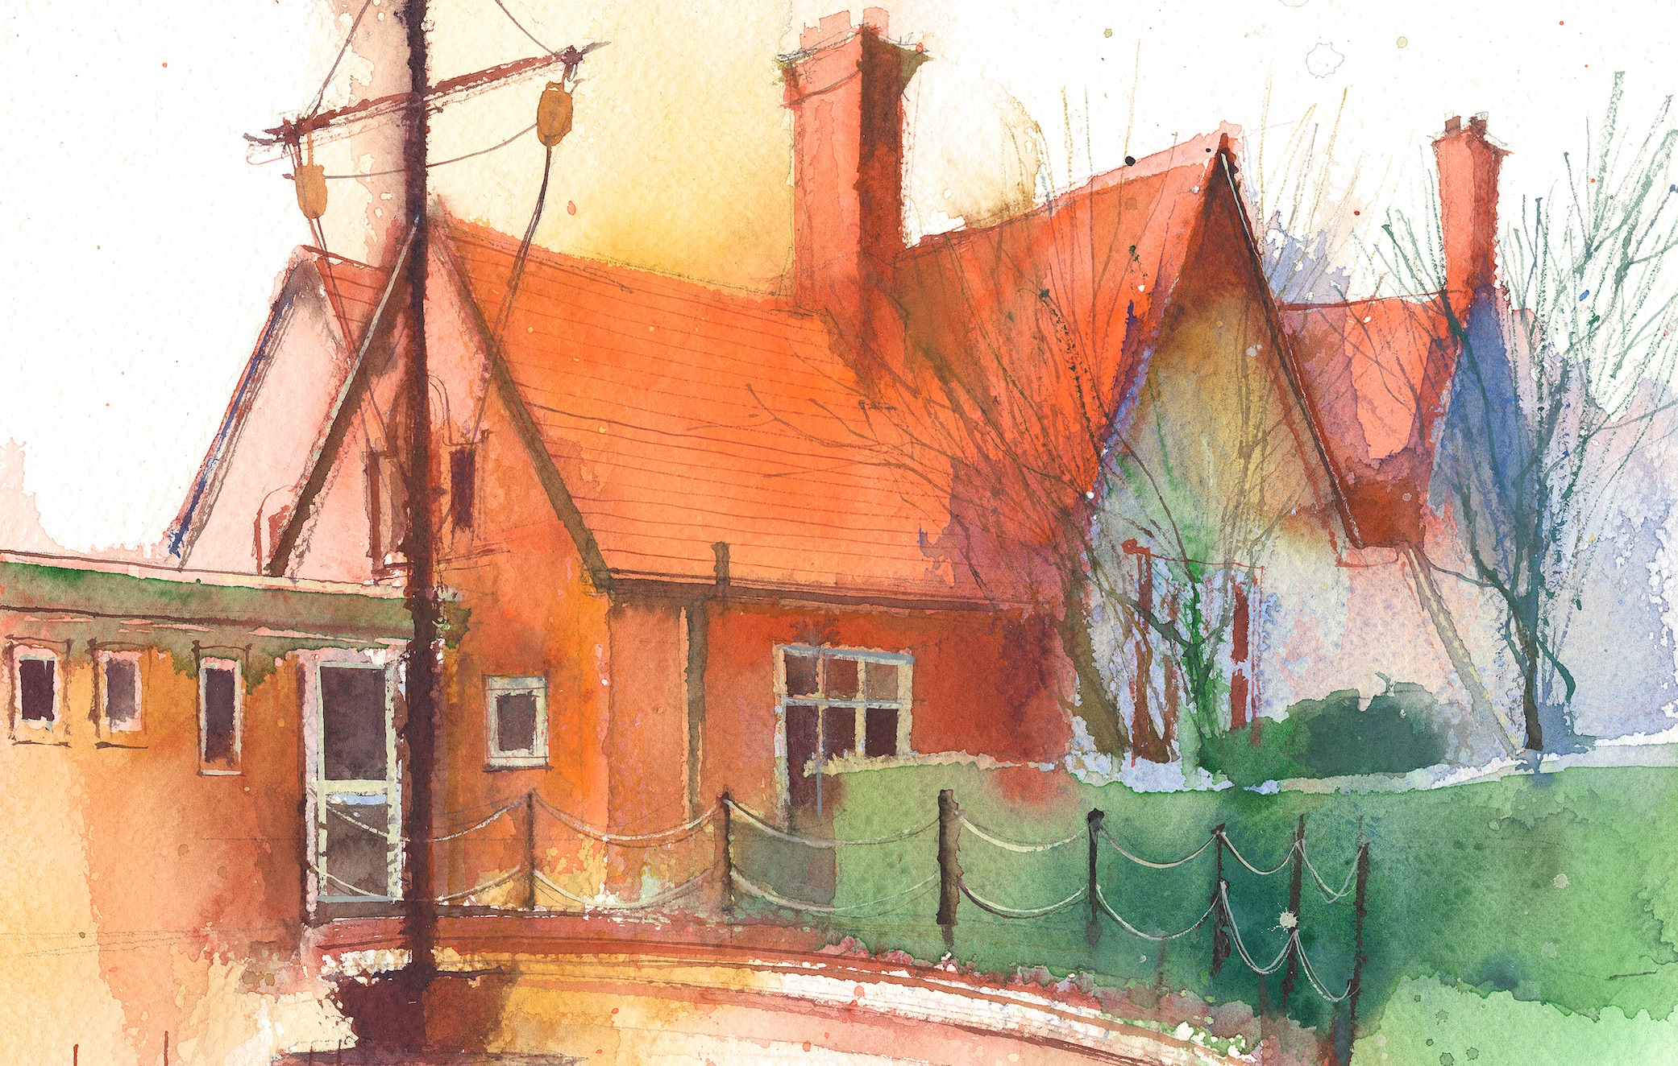

|  |  |  |  |  |  |  |
| --- | --- | --- | --- | --- | --- | --- |
|  | **Lessons 09:00 – 10:30** |  | **Lessons­­­­ 10:45 – 12:15** |  | **Lessons 13:15 – 15:30 (Incorporating 15-minute break)** | **Additional Tasks** |
| **Monday** |  |  |  | Useful Links / Other Recommended Activities  **Oak National Academy**  <https://classroom.thenational.academy/>  **BBC Bitesize**  <https://www.bbc.co.uk/bitesize>  **Purple Mash**  <https://www.purplemash.com/sch/dawpool#/>  **Recommended Reading List**  [See here](https://www.dawpool.wirral.sch.uk/website/recommended_reading_lists/577821) |
| **Tuesday** |  |  |  |
| **Wednesday** |  |  |  |
| **Thursday** | **Year 4 English Reading Comprehension**  By the end of this lesson your child should be able to:  **Understand and respond to the text and answer questions accurately.** | **Year 4 Maths**  By the end of this lesson your child should be able to:  **Know how to solve problems involving money.**  **Complete post-topic Money assessment** | **Year 4 Science - Sound**  By the end of this lesson your child should be able to:  **To be able to find patterns between the volume of a sound and the strength of the vibrations that produced it. Investigate -How does the height from which a tube is dropped affect the loudness of the sound produced?** |
| **Friday** | **INSET** |  |  |