**LB Weekly Timetable Week Commencing 25.09.23**

**To contact your child’s class teacher, please email** [**schooloffice@dawpool.wirral.sch.uk**](mailto:schooloffice@dawpool.wirral.sch.uk)

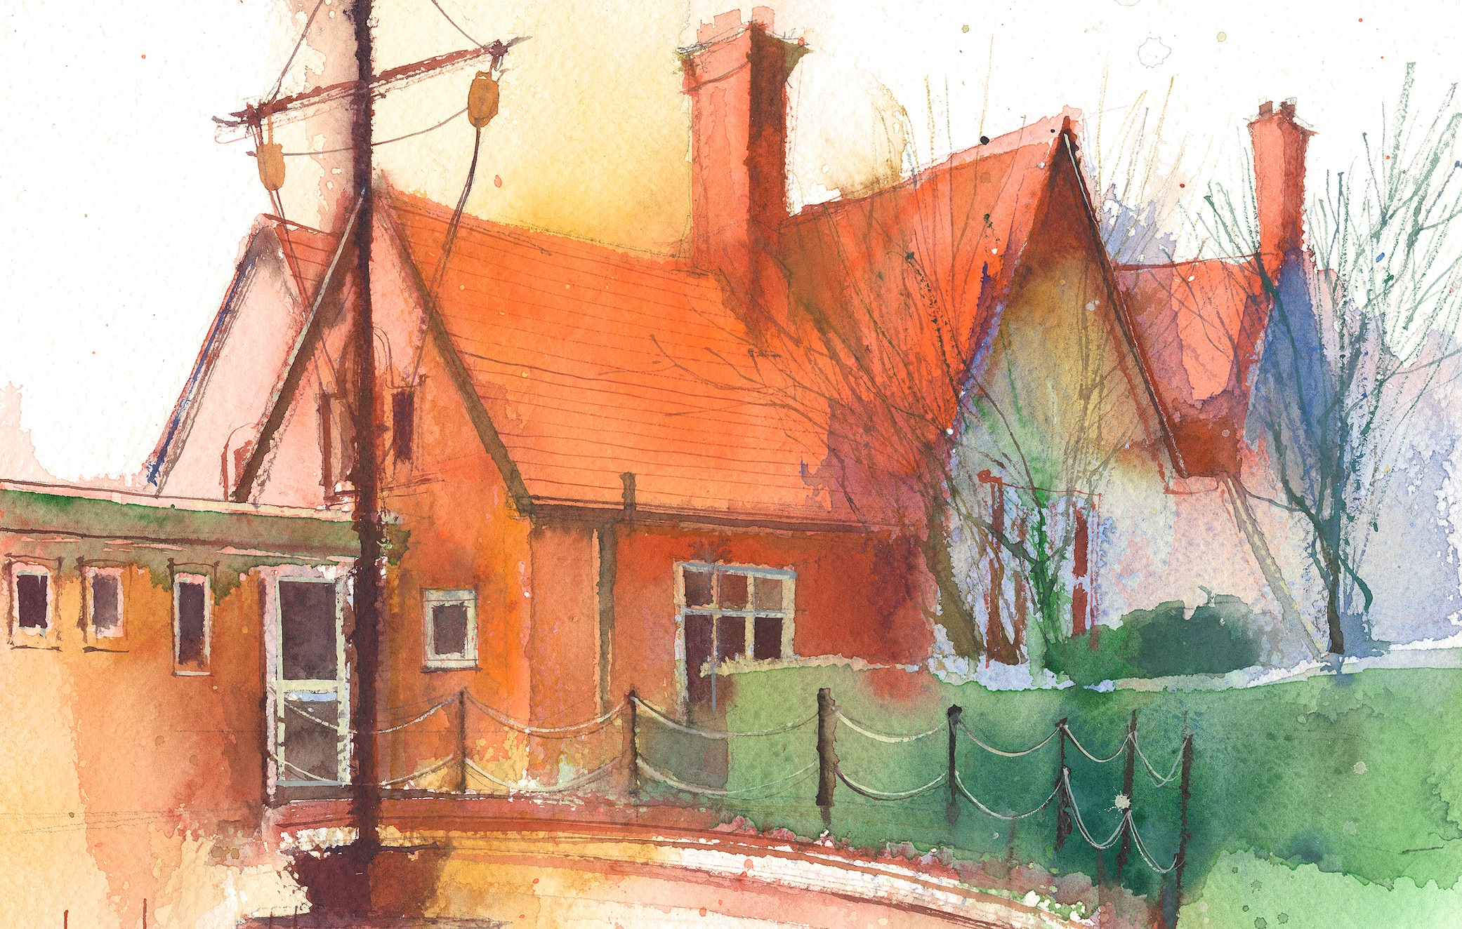

This timetable is available in the event that a Year 6 pupil is required to self-isolate at home, but the cohort remains open to other pupils.

Please visit the Year 6 **Remote Learning Page** on the school website to access any downloadable resources and activity sheets.

|  |  |  |  |  |  |  |
| --- | --- | --- | --- | --- | --- | --- |
|  | **Session 1: 09:00-10:30** |  | **Session 2: ­­­­ 10:45 – 12:15** |  | **Session 3: 13:15 – 15:30 (Incorporating 15-minute break)** | **Additional Tasks** |
| **Monday**  **25.09.23** | **Power of Reading**  By the end of this lesson your child should be able to:   * Develop skills of visualisation and use this to aid the exploration of descriptive language in writing. | **Maths**  By the end of this lesson your child should be able to:   * Understand how to count in thousands. | **Geography**  By the end of this lesson your child should be able to:   * Research to find when Mount Vesuvius erupted and create a fact file about this volcano. * Identify where Mount Vesuvius is on a map of Europe. |  |
| **Tuesday**  **25.09.23** | **Power of Reading**  By the end of this lesson your child should be able to:   * Write expanded noun phrases to create strong imagery. * Freeze frame in character role. | **Music**  .  By the end of this lesson your child should be able to:   * Learn the strings of the ukulele. | **Maths**  By the end of this lesson your child should be able to:   * Know how to represent numbers to 10,000   **Art**  By the end of this lesson your child should be able to:   * Experiment with creating lighter and darker tones on 2d images to add more dimension. |
| **Wednesday**  **26.09.23** | **Power of Reading**  By the end of this lesson your child should be able to:   * Write a diary entry in first person. * Proofread and check for spellings and punctuation. | **Maths**  By the end of this lesson your child should be able to:   * Understand how to partition numbers to 10,000 | **PE**  By the end of this lesson your child should be able to:   * Develop passing and receiving in mini game situations. |