Foundation 1 Weekly Timetable Week Commencing 13.12.21
To contact your child’s class teacher, please email foundation2@dawpool.wirral.sch.uk
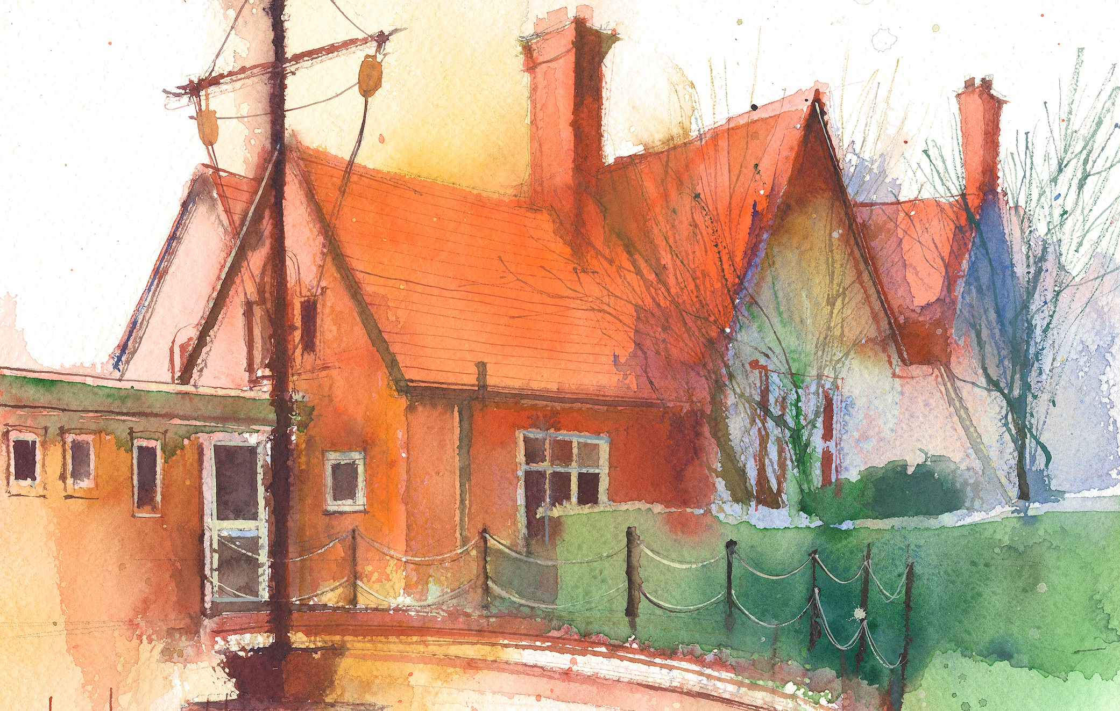

 | Session 1/registration |  | Session 2 |  | Session 3
Monday  13.12.21 | Maths  By the end of this lesson your child should be able to:  Recite numbers past 5. • Say one number for each item in order: 1,2,3,4,5. • Know that the last number reached when counting a small set of objects tells you how many there are in total (‘cardinal principle’)  We recommend the following resources and activities to achieve this objective:  Explain that need to find out how many children are in F1 today. How can we do this? – count all of the children.  Model counting the children by starting from the middle. Pretend to get muddled up and ask children of there is a better way so that I don’t get muddled up – starting with the children on the outside, pointing at each child as I count them.  Ask the helping hands to count the children to us to see how many are in school today. (Support if needed by modelling and walking around with them).  Write the total on the white board for children to see the numeral.  Can we count to that number?  Can we complete that many claps/jumps etc?  Maximise opportunities to count the children every time they are lining up throughout the day. |  | Literacy  By the end of this lesson your child should be able to:  - Engage in extended conversations about stories, learning new vocabulary  We recommend the following resources and activities to achieve this objective:  Read a Christmas story (children’s choice).  Talk about the front cover, author, make predictions before reading.  Before reaching the end of the story, can children predict what might happen?  Christmas production practice |  | Christmas production practice
Tuesday  14.12.21 | Maths  By the end of this lesson your child should be able to:  Recite numbers past 5. • Say one number for each item in order: 1,2,3,4,5. • Know that the last number reached when counting a small set of objects tells you how many there are in total (‘cardinal principle’)  We recommend the following resources and activities to achieve this objective:  Explain that need to find out how many children are in F1 today. How can we do this? – count all of the children.  Model counting the children by starting from the middle. Pretend to get muddled up and ask children of there is a better way so that I don’t get muddled up – starting with the children on the outside, pointing at each child as I count them.  Ask the helping hands to count the children to us to see how many are in school today. (Support if needed by modelling and walking around with them).  Write the total on the white board for children to see the numeral.  Can we count to that number?  Can we complete that many claps/jumps etc?  Maximise opportunities to count the children every time they are lining up throughout the day. |  | Christmas production/party |  | R.E.  By the end of this lesson your child should be able to:  I can retell the Christmas story.  We recommend the following resources and activities to achieve this objective:  Recall the story from the previous lesson. Show selected pictures of the story and work altogether to order them.  Imagine different scenes from the story eg the shepherds visited by an angel or the wise men following the star. Ask the class to show you an action or a facial expression of a character at certain points in the story. What might the character have been thinking about Jesus?  ACTIVITIES  Recreating the Christmas story through a range of props  - Nativity story map.  - Dress up in the role play  RESOURCES -  - nativity set  - Story sequencing cards.  - small world construction  costumes
Wednesday  15.12.21 | Maths  By the end of this lesson your child should be able to:  Recite numbers past 5. • Say one number for each item in order: 1,2,3,4,5. • Know that the last number reached when counting a small set of objects tells you how many there are in total (‘cardinal principle’)  We recommend the following resources and activities to achieve this objective:  Explain that need to find out how many children are in F1 today. How can we do this? – count all of the children.  Model counting the children by starting from the middle. Pretend to get muddled up and ask children of there is a better way so that I don’t get muddled up – starting with the children on the outside, pointing at each child as I count them.  Ask the helping hands to count the children to us to see how many are in school today. (Support if needed by modelling and walking around with them).  Write the total on the white board for children to see the numeral.  Can we count to that number?  Can we complete that many claps/jumps etc?  Maximise opportunities to count the children every time they are lining up throughout the day. |  | Communication and Language  By the end of this lesson your child should be able to:  - develop communication and listening skills  We recommend the following resources and activities to achieve this objective:  Circle time – pass the elf around the circle and children to talk about what they are asking Father Christmas for.  Challenge – can children draw a picture of what they would like for Christmas? |  | R.S.E.  By the end of this lesson your child should be able to:  We all have different talents and skills. We can accept praise and encouragement from others  We recommend the following resources and activities to achieve this objective:  Tell the children you are going to have a talent show so the children can demonstrate their special talents and skills. Explain that everyone has a talent or special skill. It may be a performing skill such as reciting a nursery rhyme, singing a song or telling a joke or it may be something as simple as giving great hugs or sharing something kind they did to help someone else and so on.  Boris says, ‘We all have different talents and skills.’
Thursday  16.12.21 | Maths  By the end of this lesson your child should be able to:  Recite numbers past 5. • Say one number for each item in order: 1,2,3,4,5. • Know that the last number reached when counting a small set of objects tells you how many there are in total (‘cardinal principle’)  We recommend the following resources and activities to achieve this objective:  Explain that need to find out how many children are in F1 today. How can we do this? – count all of the children.  Model counting the children by starting from the middle. Pretend to get muddled up and ask children of there is a better way so that I don’t get muddled up – starting with the children on the outside, pointing at each child as I count them.  Ask the helping hands to count the children to us to see how many are in school today. (Support if needed by modelling and walking around with them).  Write the total on the white board for children to see the numeral.  Can we count to that number?  Can we complete that many claps/jumps etc?  Maximise opportunities to count the children every time they are lining up throughout the day. |  | Phase 1 phonics  By the end of this lesson your child should be able to:  Have an awareness of alliteration and recognise some initial sounds.  We recommend the following resources and activities to achieve this objective:  Phase 1 phonics - alliteration and initial sounds  https://www.twinkl.co.uk/resource/phase-1-phonics-lesson-5-alliteration-and-initial-sounds-t-p-1642  Challenge children to think of some initial sounds for objects around the classroom. |  | Maths  By the end of this lesson your child should be able to:  Talk about and identifies the patterns around them. For example: stripes on clothes, designs on rugs and wallpaper. Use informal language like ‘pointy’, ‘spotty’, ‘blobs’ etc.  We recommend the following resources and activities to achieve this objective:  Say the word pattern – what does it mean? Explain that it can be anything around us.  Model talking about the patterns on some objects found in the classroom –  Pattern on the advent calendar-squares etc.  Stripy hat  Ask children if they can spot any patterns in the classroom?  Leave patten activity in provision.
Friday  17.12.21 | Maths  By the end of this lesson your child should be able to:  Recite numbers past 5. • Say one number for each item in order: 1,2,3,4,5. • Know that the last number reached when counting a small set of objects tells you how many there are in total (‘cardinal principle’)  We recommend the following resources and activities to achieve this objective:  Explain that need to find out how many children are in F1 today. How can we do this? – count all of the children.  Model counting the children by starting from the middle. Pretend to get muddled up and ask children of there is a better way so that I don’t get muddled up – starting with the children on the outside, pointing at each child as I count them.  Ask the helping hands to count the children to us to see how many are in school today. (Support if needed by modelling and walking around with them).  Write the total on the white board for children to see the numeral.  Can we count to that number?  Can we complete that many claps/jumps etc?  Maximise opportunities to count the children every time they are lining up throughout the day. |  | Forest School/outdoor  By the end of this lesson your child should be able to:  - Use all their senses in hands-on exploration of natural materials.  - Explore collections of materials with similar and/or different properties.  - Talk about what they see, using a wide vocabulary  - Begin to understand the need to respect and care for the natural environment and all living things.  We recommend the following resources and activities to achieve this objective:  Go into the forest school area.  Allow children time to explore.  Encourage vocabulary the natural environment and surrounding.  Encourage team work between peers to build friendships  OR  Use bikes and scooters  Trim trail  Playground  Field |  | Literacy  By the end of this lesson your child should be able to:  - Engage in extended conversations about stories, learning new vocabulary  We recommend the following resources and activities to achieve this objective:  Sing a selection of songs and rhymes of children choice.  Story sack/what’s in the bag linked to current topic this week.

