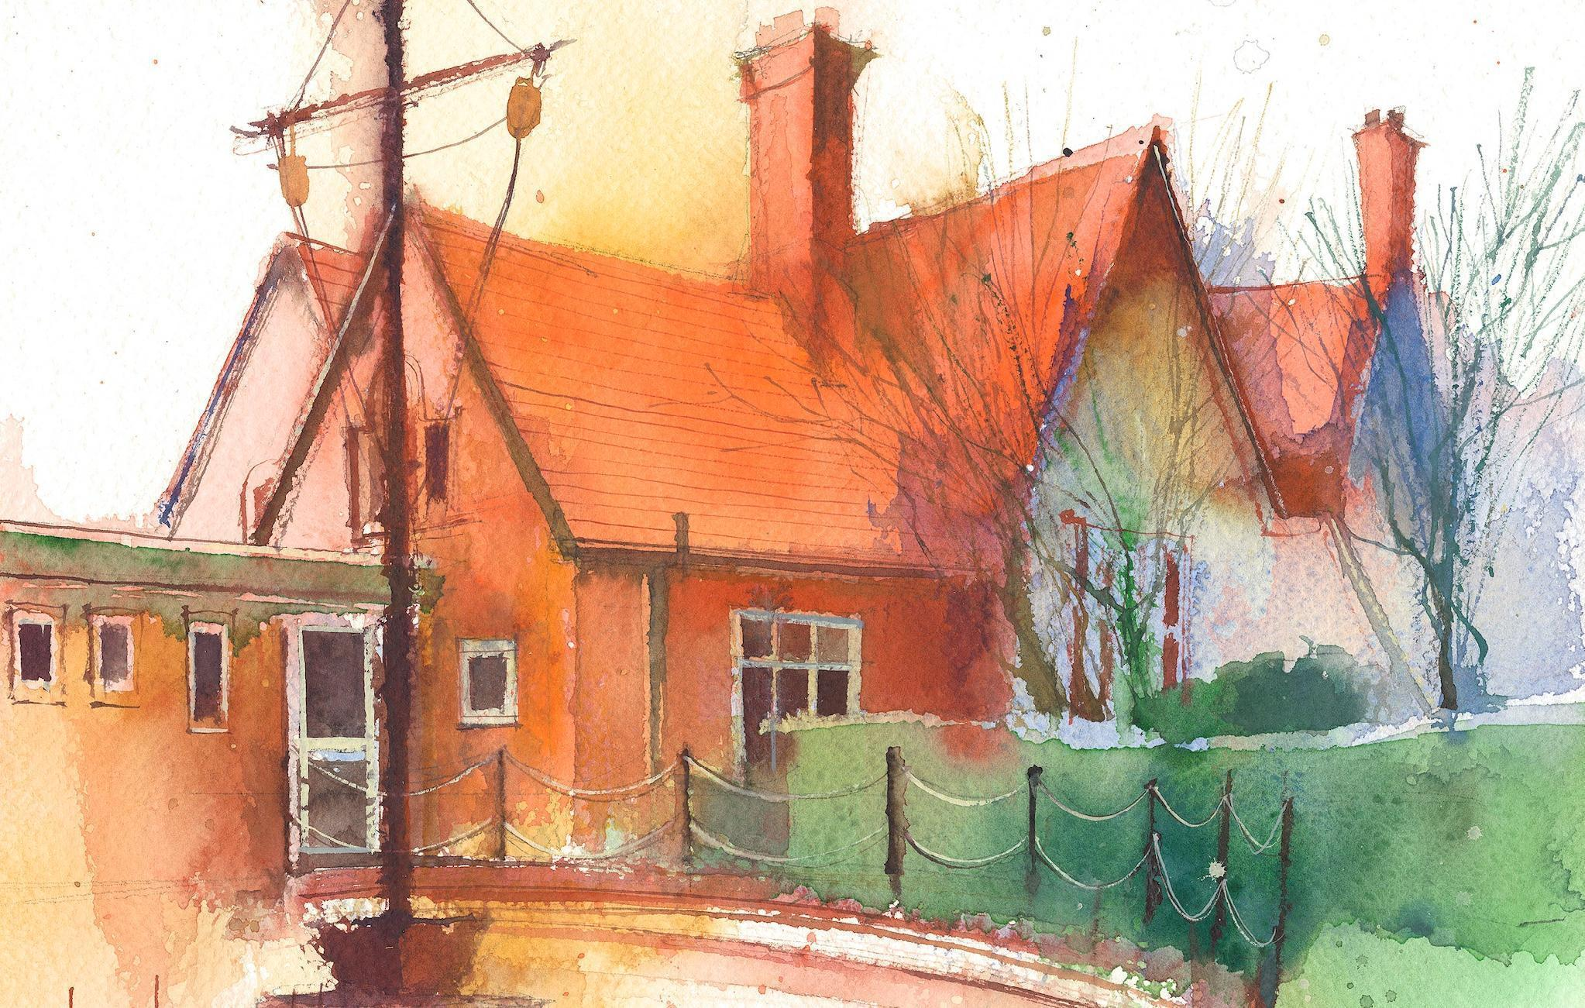
Year 1 Weekly Timetable Week Commencing 08.07.26
To contact your child’s class teacher, please email schooloffice@dawpool.wirral.sch.uk or phone 0151 648 3412

 | Lessons 09:00 – 10:30 |  |  | Lessons 10:45 – 12:15 |  | Lessons 13:15 – 15:30 (Incorporating 15-minute break) | Additional Tasks
Thursday | Phonics:  ch as tch (x2)  S, si, ge (x2) | Singing  Assembly |  | Maths: (lesson 5) To know how to find 1 more and 1 less than a number up to 100.  ERIC/ GR |  | Fin5  Forest School | PE - Mondays  Forest School - Thursdays
Friday | Phonics: Tricky Words:  Mr, Mrs, looked, called | Celebration  Assembly |  | Maths: (lesson 6) To know how to compare numbers with the same number of tens.  ERIC/ GR |  | Fin5  Computing (Coding lesson 3):  • I can complete codes to make sea creatures move. .  .  Golden Time | PE - Mondays  Forest School - Thursdays

