Year 2 Weekly Timetable Commencing: 19.10.26
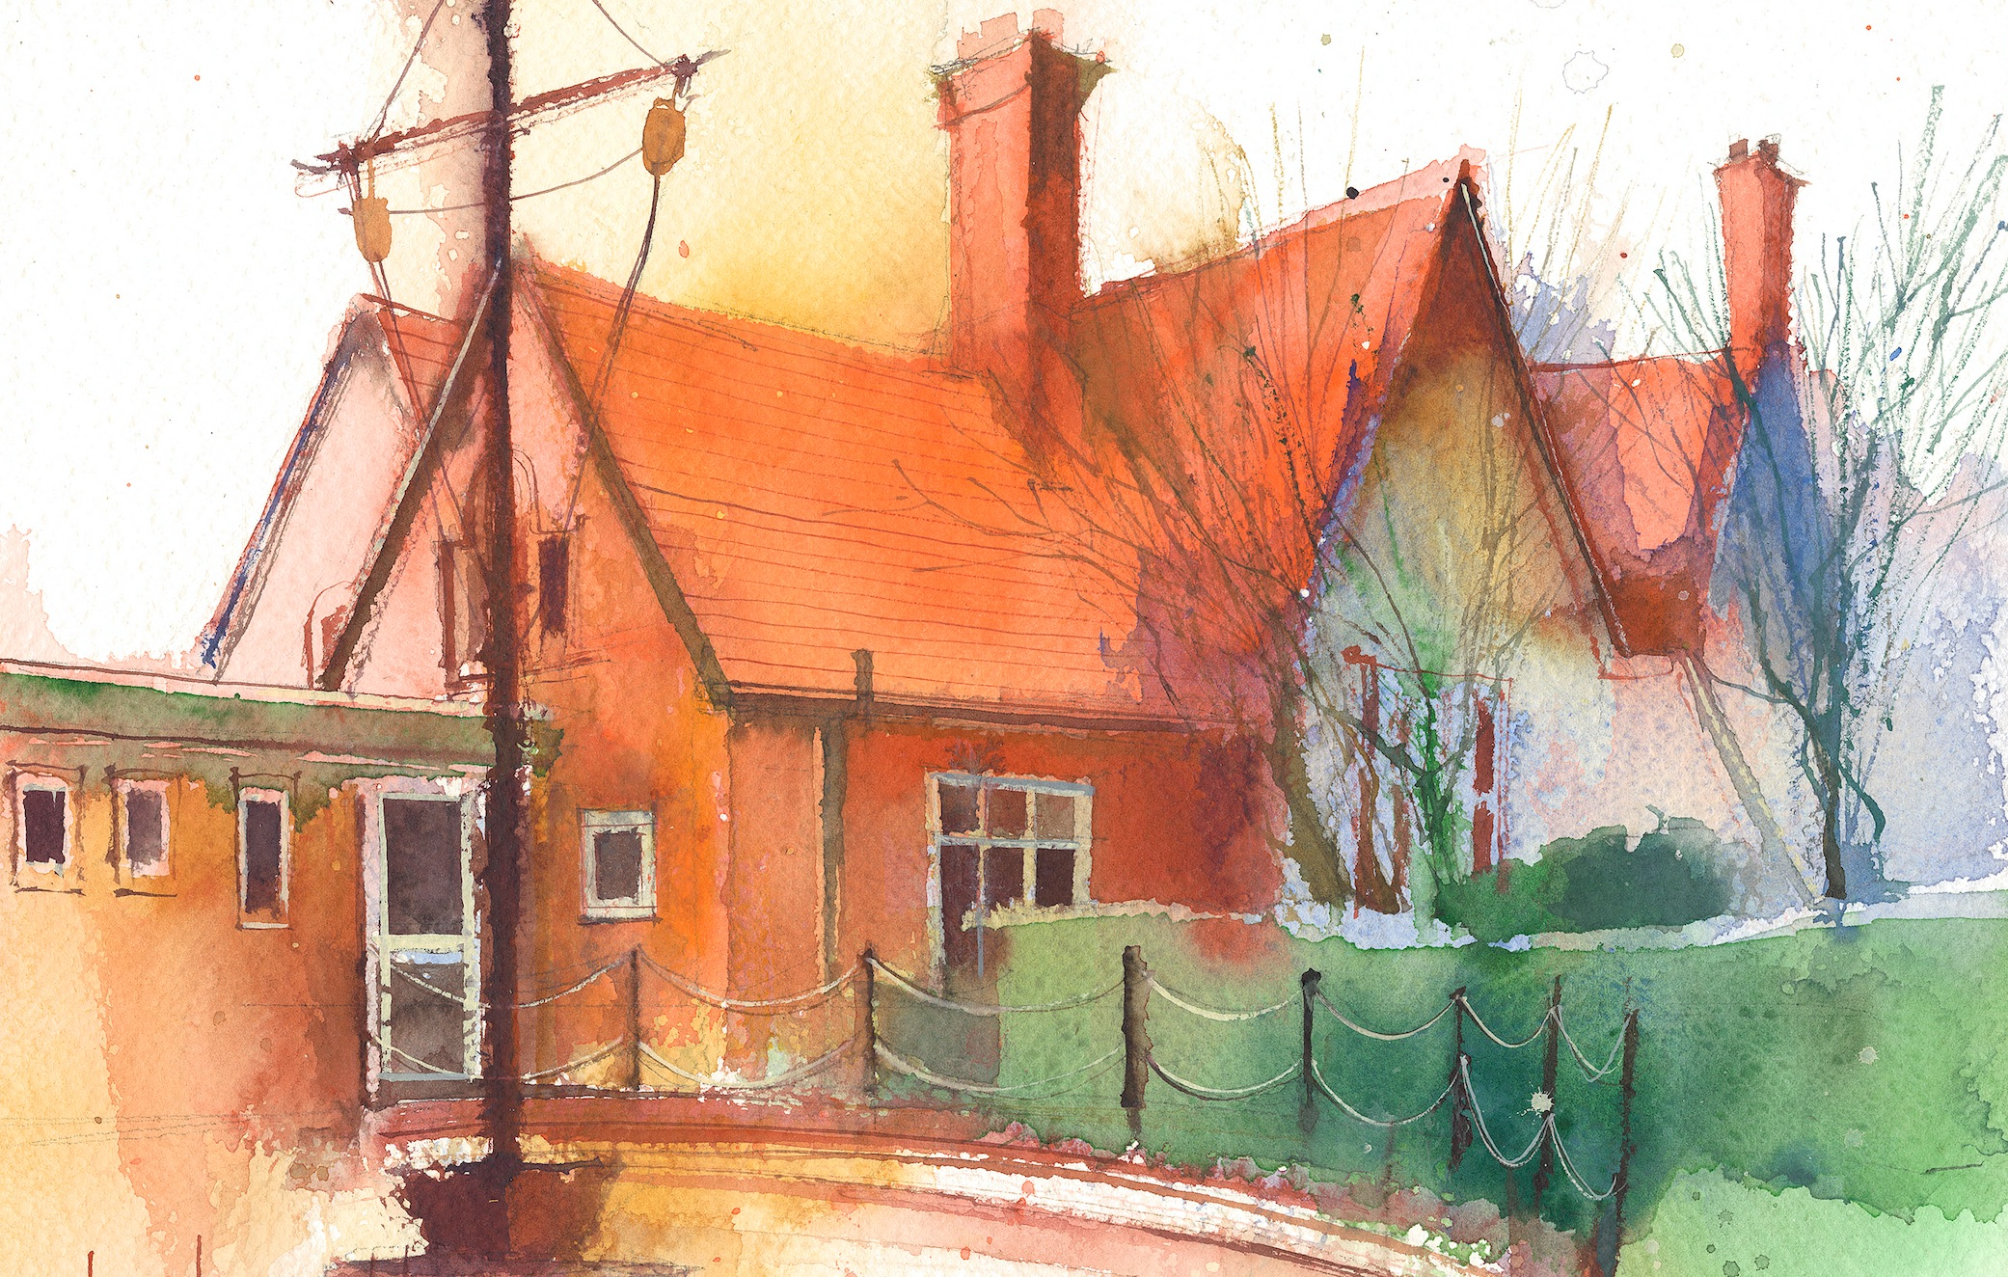
To contact your child’s class teacher, please email schooloffice@dawpool.wirral.sch.uk or phone 0151 648 3412

 | Lessons 09:00 – 10:30 |  | Lessons 10:45 – 12:15 |  | Lessons 13:15 – 15:30 (Incorporating 15-minute break) | Additional Tasks
Monday | Maths  To subtract across 10  Collective Worship |  | Phonics  /igh/ as igh, i  RE  To understand that the Bible is made of 66 books |  | RE  To share favourite old and new testament  .  PE  To use dodging and tagging with increasing skill. | Useful Links / Other Recommended Activities  Oak National Academy  https://classroom.thenational.academy/  BBC Bitesize  https://www.bbc.co.uk/bitesize  Purple Mash  https://www.purplemash.com/sch/dawpool#/  Times table practise:  https://www.timestables.co.uk/multiplication-tables-check/  Hit the button  https://www.topmarks.co.uk/maths-games/hit-the-button
Tuesday | Maths  To subtract from a 10  Class worship  Picture news |  | Phonics  /igh/ as i–e  RE  To read the story of Mary Jones and her bible - impact |  | History  To explain how London changed after The Great Fire of London
Wednesday | Maths  To subtract 1 digit from a 2 digit crossing 10  Class worship |  | Phonics  /igh/ as ie  RE  To explore the sacred book of Judaisim |  | Art  Torah Art
Thursday | Sing worship 9:10  Maths  To explore 10 more or 10 less |  | Phonics  /igh/ as y  RE  To explore how The Quran is treated with respect |  | Comprehension
Friday | Maths  To add and subtract 10s  Celebration worship 10:10 |  | Phonics  Consolidation and spellings  RE  To explore The Guru Granth Sahib- Sikhi  Heart Smart |  | Computing  Create a portfolio of artwork  Spellings  Common exception words

