Year 6 Weekly Timetable Week Commencing 15.06.26
To contact your child’s class teacher, please email schooloffice@dawpool.wirral.sch.uk or phone 0151 648 3412
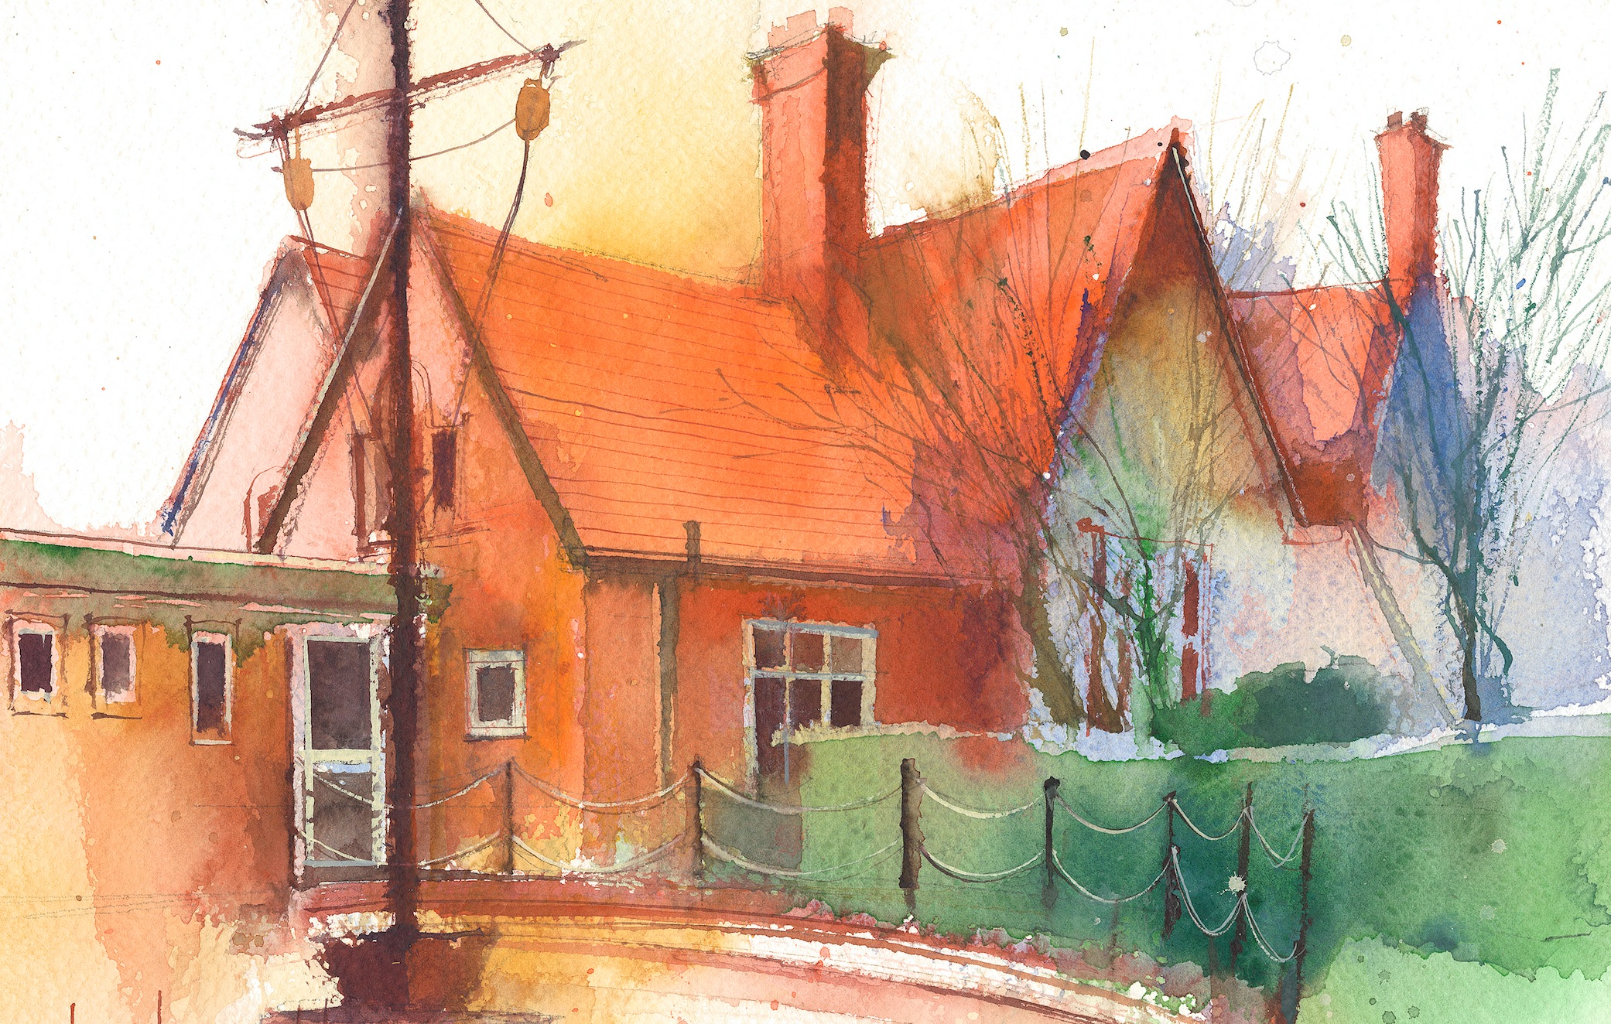

Mrs Croft Monday – Friday

 | Lessons 09:00 – 10:30 |  | Lessons 10:45 – 12:15 |  | Lessons 13:15 – 15:30  (Incorporating 15-minute break) | Additional Tasks
Monday | Fluent in Five/Rapid Reasoning and Arithmetic  Objective:  - To improve mental and written arithmetic strategies and algorithms within a timed period.  Maths  Objective:  - I can explore dual bar charts. |  | English:  Objectives:  - I can write my narrative.  - I can check the non-negotiables of spelling, punctuation and Capital letters. |  | Spiritual Learning/Art:  Objective:  - I can explore racism and religion.  - I can explore spiritual learning through Art. | - Create a fact file on a country in North America of your choice.  - Write a postcard from New York home.  - Draw your own New York skyline
Tuesday | Fluent in Five/Rapid Reasoning and Arithmetic  Objective:  1To improve mental and written arithmetic strategies and algorithms within a timed period.  Maths  Objective:  - I can explore pie charts. |  | English: Narrative  Objectives:  - I can write a narrative.  - I can check the non-negotiables of spelling, punctuation and Capital letters. |  | Geography:  Objective:  - I can explore how locality is affected by tourism and research the state of New York.
Wednesday | Floral Dance Festival |  | Floral Dance Festival |  | Floral Dance Festival
Thursday | Fluent in Five/Rapid Reasoning and Arithmetic  Objective:  - To improve mental and written arithmetic strategies and algorithms within a timed period.  Maths  Objective:  I can explore pie charts with percentages. |  | English: Narrative  Objectives:  - I can write a narrative.  - I can check the non-negotiables of spelling, punctuation and Capital letters. |  | PE:  Led by Claremount
Friday | Fluent in Five/Rapid Reasoning and Arithmetic  Objective:  1.To improve mental and written arithmetic strategies and algorithms within a timed period.  Maths  Objective:  - I can draw pie charts. |  | English – Non-fiction  Objectives:  - I can write a narrative  - I can use embedded relative clauses. |  | Spanish:  Objective:  I can identify parts of the verb ‘to play’.  Heartsmart:  I can explore the theme of ‘the bridge to not yet’

