LB Weekly Timetable Week 5 Commencing 02.02.26
To contact your child’s class teacher, please email schooloffice@dawpool.wirral.sch.uk
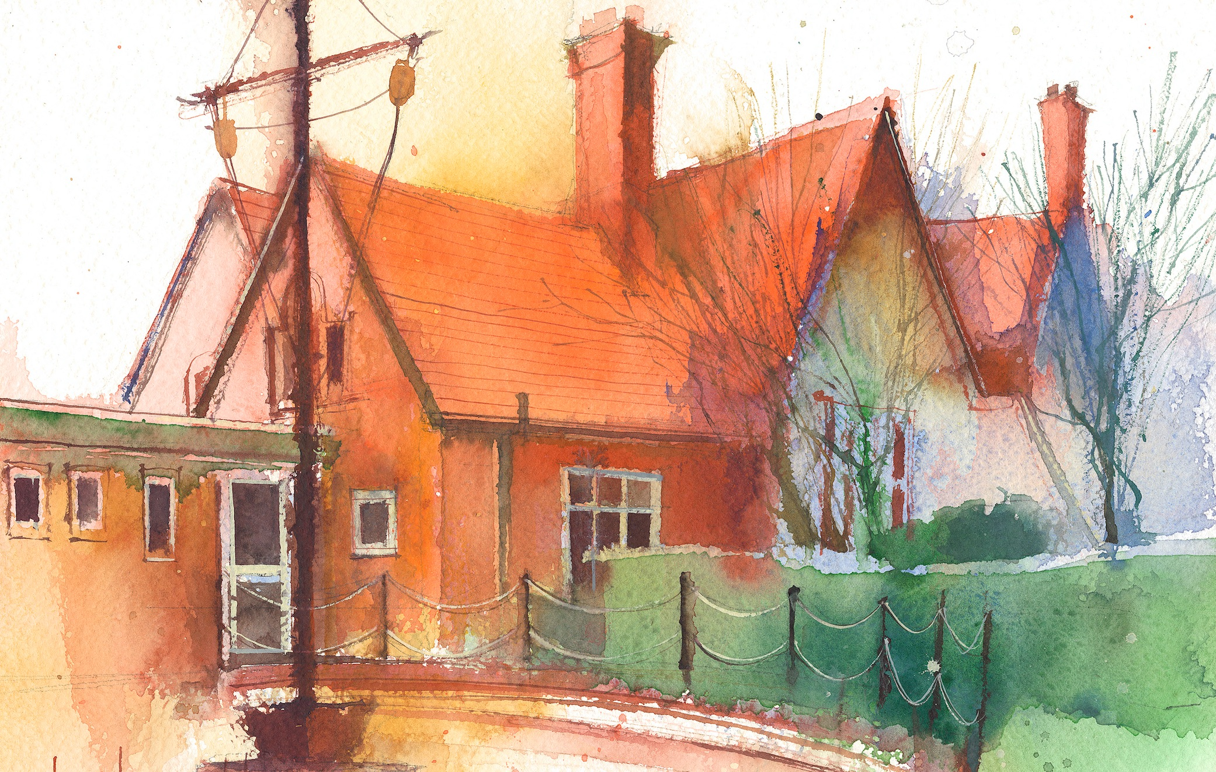

This timetable is available in the event that a Year 1 pupil is required to self-isolate at home, but the cohort remains open to other pupils.
Please visit the Year 1 Remote Learning Page on the school website to access any downloadable resources and activity sheets.

 | Session 1: 09:00-10:30 |  | Session 2: 10:45 – 12:15 |  | Session 3: 13:15 – 15:30 (Incorporating 15-minute break) | Additional Tasks
Monday  02.02.26 | Check phonics folder for tab.  Phonics  By the end of this lesson your child should be able to:  - Revisit and read.  Non Fiction Reading Lesson 3  English Star in a Jar  By the end of this lesson your child should be able to:  - Write two clauses using ‘and’ about the sun. |  | Lesson 6 Question 1  Maths  Mass and Volume  By the end of this lesson your child should be able to:  - Investigate how many small containers it takes to fill 1 large container |  | Lesson 5  History  Toys from the past.  By the end of this lesson your child should be able to:  - Use words relating to the passing of time.  No outsiders | PPA
Tuesday  03.02.26 | Check phonics folder for tab.  Phonics  By the end of this lesson your child should be able to:  Revisit and record. Creating interest Lesson 2  English  Star  By the end of this lesson your child should be able to:  - Take part in a star party. |  | Lesson 6 Question 2&3  Maths  Mass and Volume  By the end of this lesson your child should be able to:  - Investigate how many small containers it takes to fill 1 large container.  Guided Reading |  | Lesson 3a  Science  Animals including humans  By the end of this lesson your child should be able to:  - Identify and name a variety of common animals that are fish or amphibians.  Picture News | PPA
Wednesday  04.02.26 | Check phonics folder for tab.  Phonics  By the end of this lesson your child should be able to:  - Revisit and read.  Creating interest Lesson 1  English  By the end of this lesson your child should be able to:  - Order events.  - Innovate a map. |  | Forrest school  By the end of this lesson your child should be able to:  Guided Reading |  | Lesson 4  Art  Animal Art  By the end of this lesson your child should be able to:  - Create animal art in the style of Aboriginal dot art.  My Happy Mind | PPA

