Year 1 Weekly Timetable Week Commencing 8.12.25
To contact your child’s class teacher, please email schooloffice@dawpool.wirral.sch.uk or phone 0151 648 3412
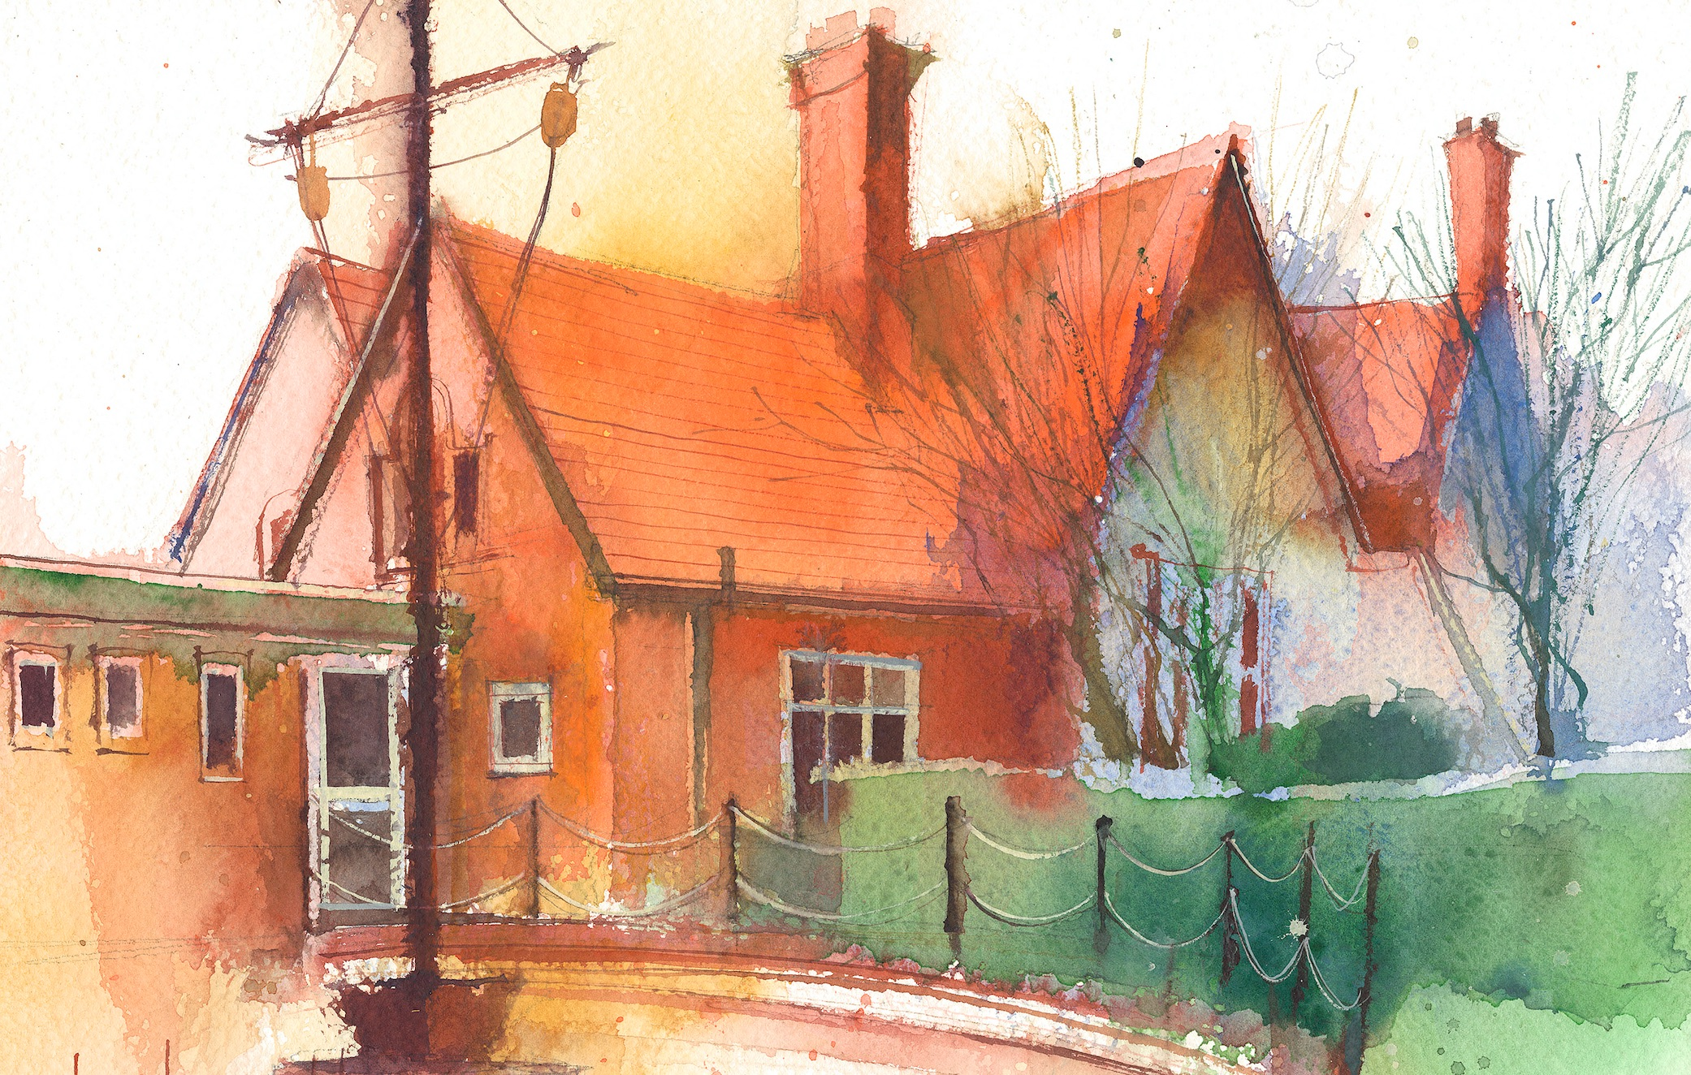

 | Lessons 09:00 – 10:30 |  |  | Lessons 10:45 – 12:15 |  | Lessons 13:15 – 15:30 (Incorporating 15-minute break) | Additional Tasks
Wednesday | Story house theatre trip |  |  | Story house theatre trip |  | Heartsmart: Children can learn different ways that they can take care of themselves daily. | Remember that you can come onto the school grounds early on Friday. Come for festive drinks at 3.15pm.  If you haven’t booked onto the Santa dash already, please make sure you do so.
Thursday | Phonics: or as aw (blending practise)  Phonics: or as aw (segmenting practise) | Singing Assembly |  | Maths: To know addition means add together.  ERIC/ GR |  | Forest School: I can wait my turn.
Friday | Phonics: Tricky words: who, again  Maths: To know addition means more. | Celebration  Assembly |  | Maths: To know how to solve problems with addition.  ERIC/ GR |  | Santa Dash!  RE: I can order events from the Christmas story.

