**Year 4 Weekly Timetable Week Commencing 09.06.25**

**To contact your child’s class teacher, please email** [**schooloffice@dawpool.wirral.sch.uk**](mailto:schooloffice@dawpool.wirral.sch.uk) **or phone 0151 648 3412**

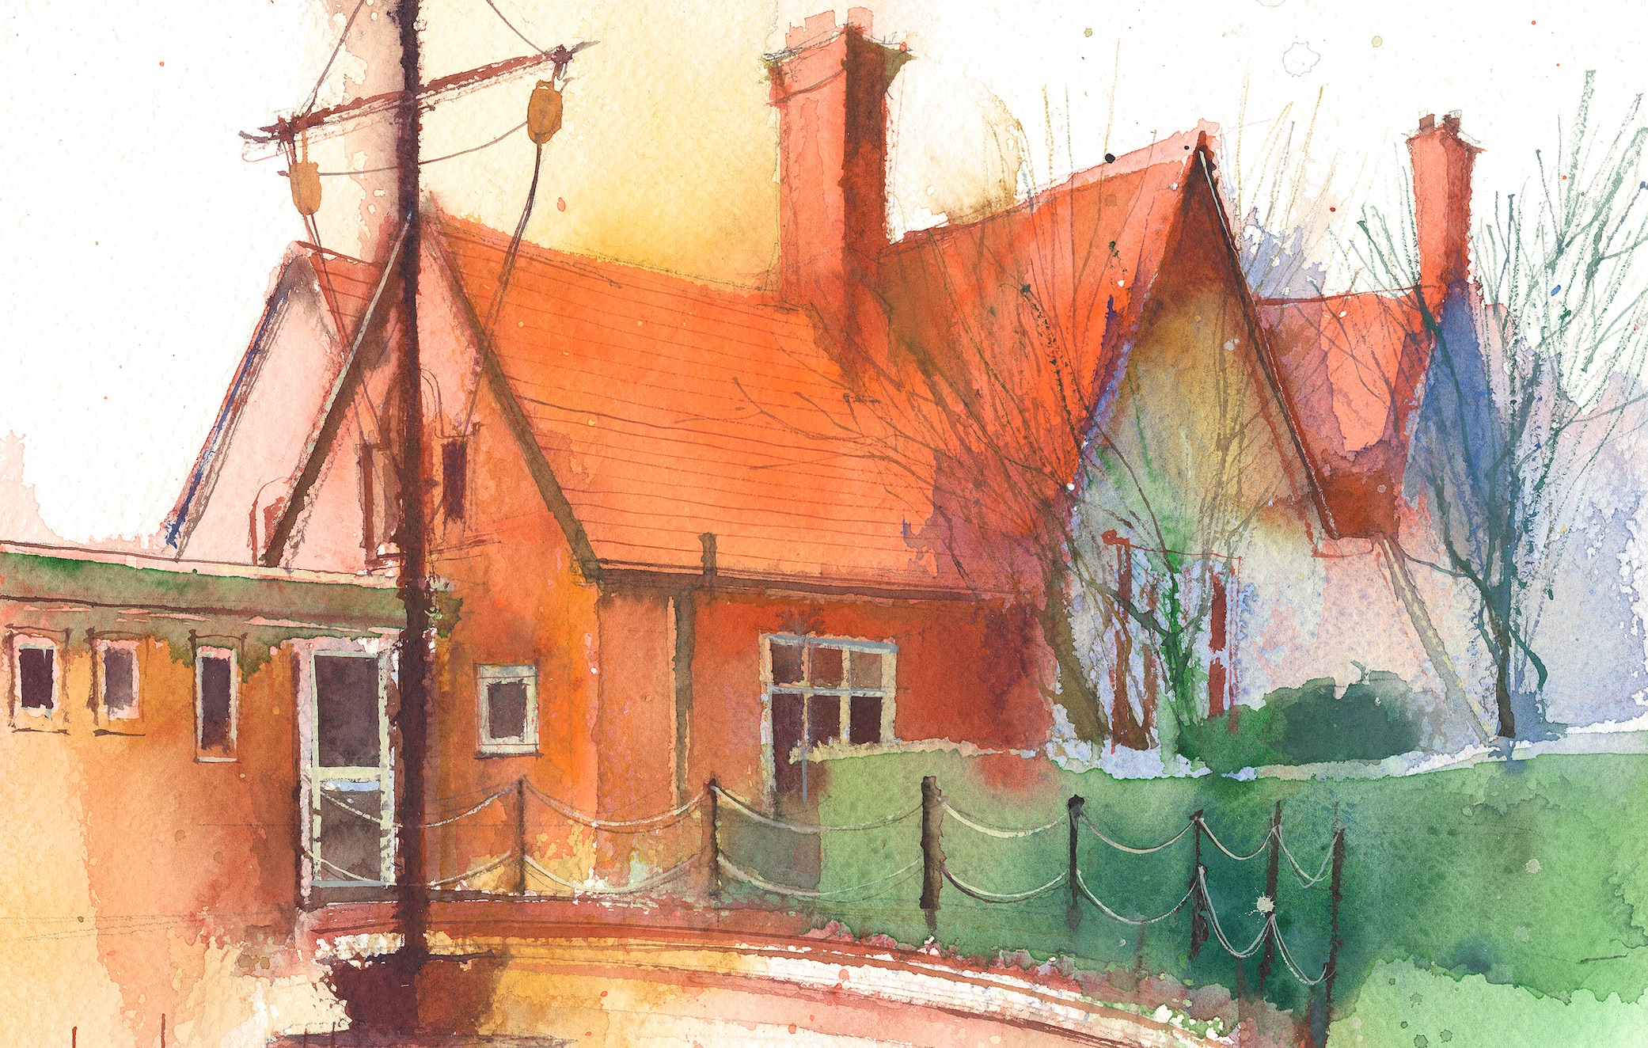

|  |  |  |  |  |  |  |
| --- | --- | --- | --- | --- | --- | --- |
|  | **Lessons 09:00 – 10:30** |  | **Lessons­­­­ 10:45 – 12:15** |  | **Lessons 13:15 – 15:30 (Incorporating 15-minute break)** | **Additional Tasks** |
| **Monday** |  |  |  | Useful Links / Other Recommended Activities  **Oak National Academy**  <https://classroom.thenational.academy/>  **BBC Bitesize**  <https://www.bbc.co.uk/bitesize>  **Purple Mash**  <https://www.purplemash.com/sch/dawpool#/>  **Recommended Reading List**  [See here](https://www.dawpool.wirral.sch.uk/website/recommended_reading_lists/577821) |
| **Tuesday** |  |  |  |
| **Wednesday** |  |  |  |
| **Thursday** | **Year 4 English Reading Comprehension**  By the end of this lesson your child should be able to:  **Understand and respond to the text and answer questions about the story.** | **End of year Reading Assessment.** | **Year 4 Science - Electricity**  By the end of this lesson your child should be able to:  **be able to construct a simple series electrical circuit, identifying and naming its basic parts, including cells, wires, bulbs, switches and buzzers.**  **To be able to identify whether or not a lamp will light in a simple series circuit, based on whether or not the lamp is part of a complete loop with a battery.** |
| **Friday** | **Year 4 Maths**  By the end of this lesson your child should be able to:  **Know how to draw line graphs.** | **Year 4 English**  By the end of this lesson your child should be able to:  **Words that begin noun phrases are called determiners.** | **Year 4 RE Unit 4:6Prayer**  By the end of this lesson your child should be able to:  **Read traditional Christian prayers which include the Prayer of St. Francis and the Covenant Prayer of John Wesley What do these prayers reveal to us about God and Christian belief? Children highlight words and phrases in the prayers that reveal Christian belief**. |