Foundation 2 Weekly Timetable Week Commencing 01.12.25
To contact your child’s class teacher, please email schooloffice@dawpool.wirral.sch.uk or phone 0151 648 3412
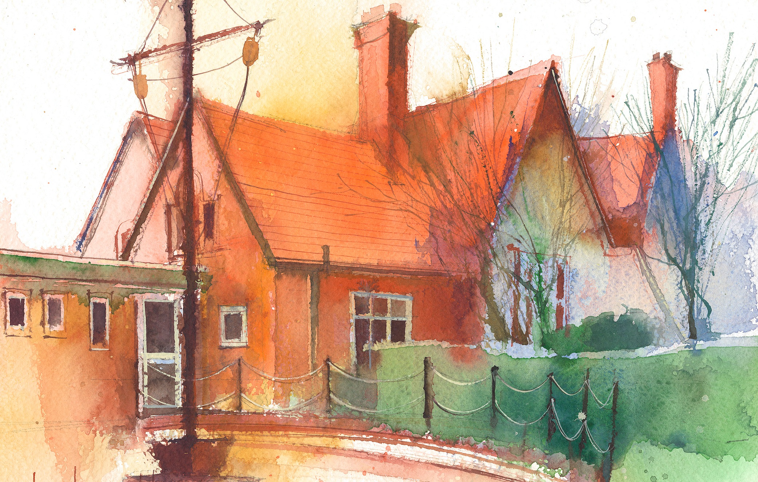

This timetable is available in the event that a Foundation 2 pupil is required to self-isolate at home, but the cohort remains open to other pupils.
Please visit the Foundation 2 Remote Learning Page on the school website to access any downloadable resources and activity sheets.

 | Session 1: 09:00-10:30 |  | Session 2: 10:50 – 12:00 |  | Session 3: 13:15 – 15:25
Monday | Phonics  By the end of this lesson your child should be able to:  Recognise and say the sound ‘ll’  We recommend the following resources and activities to achieve this objective:  Blending practice.  Children will complete activities in their individual rocket phonics workbooks. |  | Maths  By the end of this lesson your child should be able to:  To understand the composition of numbers up to 9  We recommend the following resources and activities to achieve this objective:  Watch Numberblocks – Number 9  Discuss the episode together and encourage the children to talk in Perfect Partners (PP) about what they have seen.  Go back to different parts of the episode and model writing the number sentences.  Re-cap on previous learning of the part-part-whole method and write each part of the number sentence as a part, part whole. |  | Topic  During the afternoons we will undertake activities linked to all areas of the Early Years Curriculum;  Prime Areas; Communication and Language;  Personal, Social and Emotional Development;  Physical Development.  Specific Areas; Literacy, Maths, Understanding the World and Expressive Arts and Design.  Afternoon sessions will also include RE, HeartSmart and Forest Schools.  Our current RE topic is ‘Special Times’. Planning for this can be found on the website.  Activities will be linked to our class topic which is ‘Where in the World’. We aim to use children’s books as a hook for learning to help us find out more about the world around us. Throughout the year we will select books that enable us to cover all requirements of the Early Years Curriculum.  We will talk about where the book is set and find out where this country is on a map. We will then use the theme of the book as a way of guiding our planning.  PLEASE NOTE  The very nature of the EYFS curriculum enables us to go with the interests of the children. The activities we plan are for a guide only.  Staff can use and adapt activities or add additional activities and not cover others. It is all dependent on how and where the children’s interests take us.  Activities are designed to cover several weeks, if needed.  A copy of the current topic plan is available to view on the class website page.
Tuesday | Phonics  By the end of this lesson your child should be able to:  Recognise and write the sound ‘ll’  We recommend the following resources and activities to achieve this objective:  Segmenting practice.  Children will complete activities in their individual rocket phonics workbooks. |  | Maths  By the end of this lesson your child should be able to:  To partition numbers and recombine them to make the whole number.  We recommend the following resources and activities to achieve this objective:  Have two children stand up can they play ‘Christmas Crackers’ with two cubes. Pull them apart saying 1 is a part, 1 is a part and together they make 2.  I will now draw up a part whole frame on the board.  I will demonstrate how to fill this in using the number 2.  Repeat this with up to 9 cubes.  Put children in partners with 9 cubes, pull them apart and see what each has saying;  e.g. if the whole is 9 then 1 is a part and 8 is a part.
Wednesday | Phonics  By the end of this lesson your child should be able to:  Recognise and say the sound ‘ss’  We recommend the following resources and activities to achieve this objective:  Blending practice  Children will complete activities in their individual rocket phonics workbooks. |  | Maths  By the end of this lesson your child should be able to:  Recognise and begin to use the part-part whole method.  We recommend the following resources and activities to achieve this objective:  I will ask 9 children stand up. As a class we will count them to check we have the right amount.I will stand 3 children to each side of me saying “3 is a part, 6 is a part and together they make 9”.  I will now draw up a part whole frame on the board.  I will demonstrate how to fill this in using the number 6.  Repeat several times for different numbers.
Thursday | Phonics  By the end of this lesson your child should be able to:  Recognise and write the sound ‘ss’  We recommend the following resources and activities to achieve this objective:  Segmenting practice  Children will complete activities in their individual rocket phonics workbooks. |  | Maths  By the end of this lesson your child should be able to:  To partition numbers and recombine them to make the whole number.  We recommend the following resources and activities to achieve this objective:  Have two children stand up can they play ‘Christmas Crackers’ with two cubes. Pull them apart saying 1 is a part, 1 is a part and together they make 2.  I will now draw up a part whole frame on the board.  I will demonstrate how to fill this in using the number 2.  Repeat this with up to 9 cubes.  Put children in partners with 9 cubes, pull them apart and see what each has saying;  e.g. if the whole is 9 then 1 is a part and 8 is a part.
Friday | PE  By the end of this lesson your child should be able to:  Move in a variety of different ways around the room including High and Low. To sequence a series of moves.  We recommend the following resources and activities to achieve this objective:  During this half term the children will use the hall space to undertake games and activities that require them to roll, crawl, walk, jump, run, hop, skip and climb.  Ho can you make yourself as high/low as possible?  Can you put together a sequence of different moves?  Can you use apparatus and equipment to move in different ways?  Children will also learn to stop and change directions safely. |  | Phonics  By the end of this lesson your child should be able to:  To learn to write the Common Exception word ‘go’  We recommend the following resources and activities to achieve this objective:  Children will complete activities in their individual rocket phonics workbooks.

