Mrs Hall Weekly Timetable Y5 Week Commencing 22.04.24
To contact your child’s class teacher, please email schooloffice@dawpool.wirral.sch.uk or phone 0151 648 3412
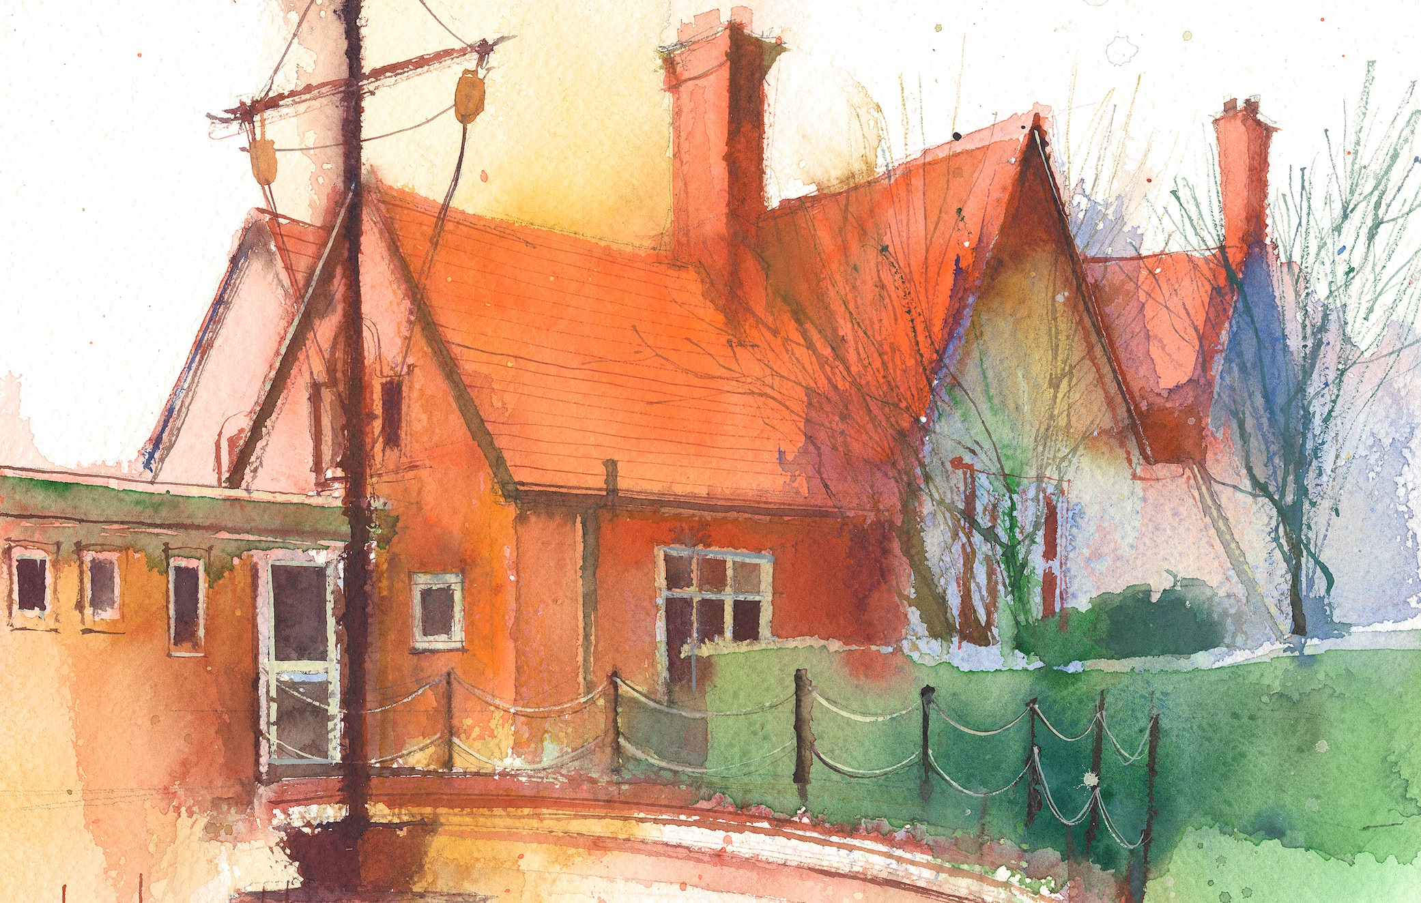

 | Lessons 09:00 – 10:30 |  | Lessons 10:45 – 12:15 |  | Lessons 13:15 – 15:30 (Incorporating 15-minute break) | Additional Tasks
Monday |  |  |  |  |  | Useful Links / Other Recommended Activities  Oak National Academy  https://classroom.thenational.academy/  BBC Bitesize  https://www.bbc.co.uk/bitesize  Purple Mash  https://www.purplemash.com/sch/dawpool#/  Recommended Reading List  See here
Tuesday

Wednesday | Year 5 Grammar  By the end of this lesson your child should be able to:  Know that using pronouns in sentences helps to avoid repetition. |  | Year 5 Maths  By the end of this lesson your child should be able to:  Know how to reason about 3D shapes. |  | Year 5 RE  Daniel, did he make the right choice?  By the end of this lesson your child should be able to:  In Daniel Chapter 3 Shadrach, Meshach and Abednego are thrown into the fiery furnace. They refuse to bow and worship the image of gold set up by King Nebuchadnezzar. Why? Daniel 3: 16-18.  Children complete a storyboard to retell the events of this story.  Year 5 Music  Liverpool Philharmonic- Going For Gold- The Orchestral Olympics  By the end of this lesson your child should be able to:  Lesson 1 – Ancient Dramatics.  1. Explore the Ancient Olympic Games.  2. Recognise and respond to different dynamics.  3. Create a graphic score inspired by Vivaldi’s composition.
Thursday

Friday

