Year 6 Weekly Timetable Week Commencing 28.09.26
To contact your child’s class teacher, please email schooloffice@dawpool.wirral.sch.uk or phone 0151 648 3412
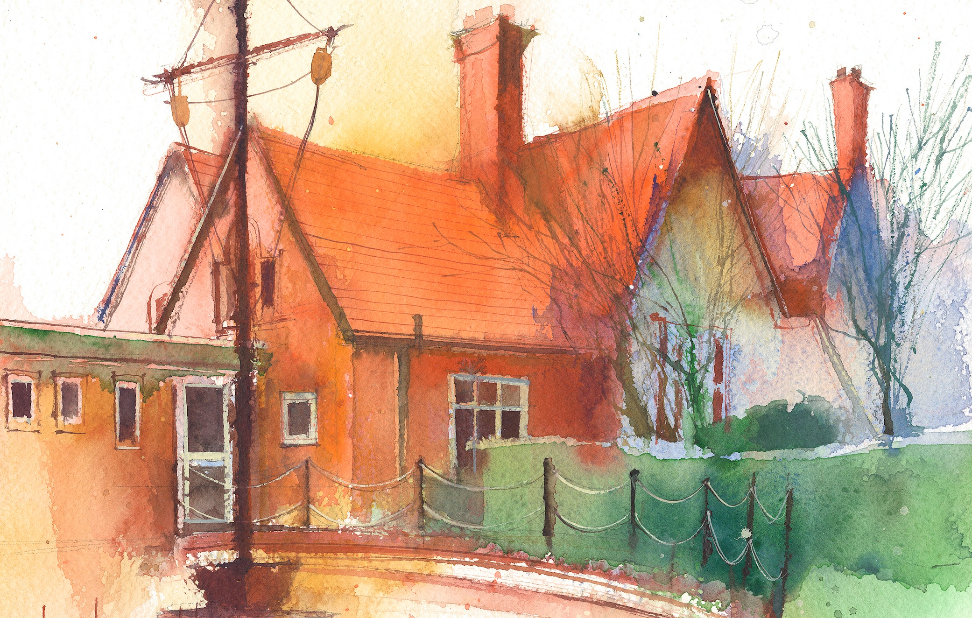

Mrs Croft Monday – Friday

 | Lessons 09:00 – 10:30 |  | Lessons 10:45 – 12:15 |  | Lessons 13:15 – 15:30  (Incorporating 15-minute break) | Additional Tasks
Monday | Fluent in Five/Rapid Reasoning and Arithmetic  Objective:  - To improve mental and written arithmetic strategies and algorithms within a timed period.  Maths  Objective:  - I can use common multiples. |  | English: Narrative  Objectives:  - I can use subordinating conjunctions for time.  - I can check the non-negotiables of spelling, punctuation and Capital letters. |  | History  Objectives:  1. I can explain what the Blitz was and how it affected life in Britain. | - Create an Anderson shelter  - Explore life as an evacuee during WW2  - Research into your own family history during the war
Tuesday | Fluent in Five/Rapid Reasoning and Arithmetic  Objective:  - To improve mental and written arithmetic strategies and algorithms within a timed period.  Maths  Objective:  - I can use the rules of divisibility. |  | English: Narrative  Objectives:  - I can answer comprehension questions on Jack and the baked beanstalk.  - I can check the non-negotiables of spelling, punctuation and Capital letters. |  | PE  Objectives:  - I can take part in Forest schools.
Wednesday | Fluent in Five/Rapid Reasoning and Arithmetic  Objective:  - To improve mental and written arithmetic strategies and algorithms within a timed period.  Maths  Objective:  - I can identify prime numbers to 100. |  | English: Narrative  Objectives:  - I can use figurative language.  - I can check the non-negotiables of spelling, punctuation and Capital letters. |  | Art  Objectives:  - I can understand atmospheric perspective and use it in a piece of art.
Thursday | Fluent in Five/Rapid Reasoning and Arithmetic  Objective:  - To improve mental and written arithmetic strategies and algorithms within a timed period.  Maths  Objective:  I can explore square and cubed numbers. |  | English: Narrative  Objectives:  - I can use hyphens for compound words.  - I can check the non-negotiables of spelling, punctuation and Capital letters. |  | Science  Objective:  - I can explain the ways in which water and nutrients are transported around the body.  Music:  Objectives:  - I can listen and appraise.
Friday | Fluent in Five/Rapid Reasoning and Arithmetic  Objective:  1.To improve mental and written arithmetic strategies and algorithms within a timed period.  Maths  Objective:  - I can multiply up to 4digit numbers by 2digit numbers. |  | English – Non-fiction  Objectives:  - I can use brackets for relative clauses.  - I can use the non-negotiables. |  | Spanish  Objectives:  - I can read and write about my personality.  Computing:  Objective:  - I can write and style a blog post.

