**Foundation 2 Weekly Timetable Week Commencing 09.06.25**

**To contact your child’s class teacher, please email** [**schooloffice@dawpool.wirral.sch.uk**](mailto:schooloffice@dawpool.wirral.sch.uk) **or phone 0151 648 3412**

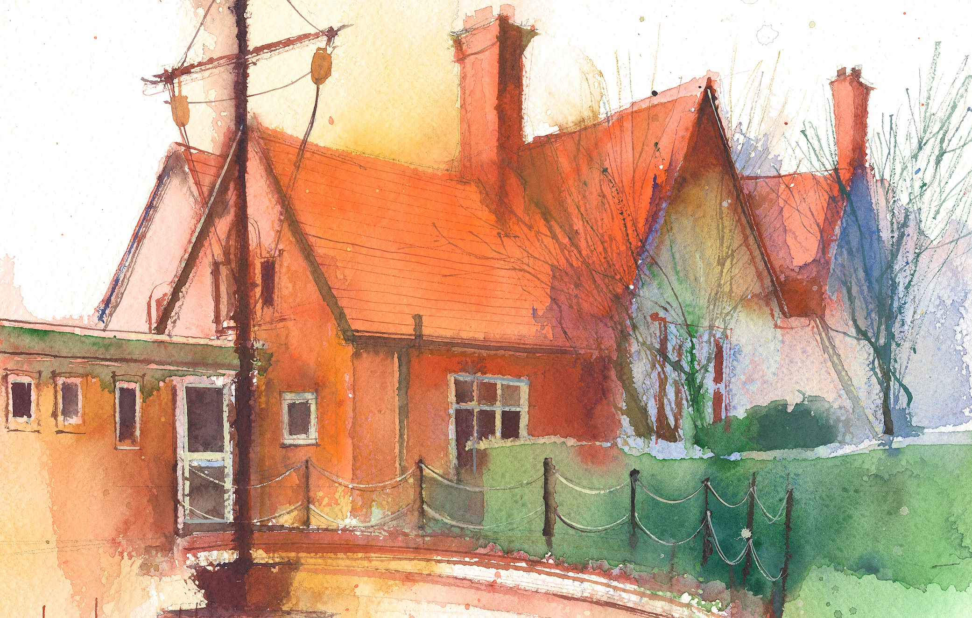

This timetable is available in the event that a Foundation 2 pupil is required to self-isolate at home, but the cohort remains open to other pupils.

Please visit the Foundation 2 **Remote Learning Page** on the school website to access any downloadable resources and activity sheets.

|  |  |  |  |  |  |
| --- | --- | --- | --- | --- | --- |
|  | **Session 1: 09:00-10:30** |  | **Session 2: ­­­­ 10:50 – 12:00** |  | **Session 3: 13:15 – 15:25** |
| **Monday** | **Phonics**  **By the end of this lesson your child should be able to:**  To recognise and say the sound ‘wh’  (Week 31)  **We recommend the following resources and activities to achieve this objective:**  Blending practice.  Children will complete activities in their individual rocket phonics workbooks. | **Maths**  **LO:** To count beyond 10 and understand the 1 more relationship between consecutive numbers.  **Teaching:**  Watch Numberblocks 13.  Discuss the concept of a ‘teen’ number.  Look at ways of making 13 using the cubes.  How would 13 look on a tens frame? | **Topic**  During the afternoons we will undertake activities linked to all areas of the Early Years Curriculum;  **Prime Areas**; Communication and Language;  Personal, Social and Emotional Development;  Physical Development.  **Specific Areas**; Literacy, Maths, Understanding the World and Expressive Arts and Design.  Afternoon sessions will also include RE, HeartSmart and Forest Schools.  Our current RE topic is ‘Special Times’. Planning for this can be found on the website.  Activities will be linked to our class topic which is ‘Where in the World’. We aim to use children’s books as a hook for learning to help us find out more about the world around us. Throughout the year we will select books that enable us to cover all requirements of the Early Years Curriculum.  We will talk about where the book is set and find out where this country is on a map. We will then use the theme of the book as a way of guiding our planning.  **PLEASE NOTE**  The very nature of the EYFS curriculum enables us to go with the interests of the children. The activities we plan are for a guide only.  Staff can use and adapt activities or add additional activities and not cover others. It is all dependent on how and where the children’s interests take us.  Activities are designed to cover several weeks, if needed.  A copy of the current topic plan is available to view on the class website page. |
| **Tuesday** | **Phonics**  **By the end of this lesson your child should be able to:**  Recognise and write the sound ‘wh’  **We recommend the following resources and activities to achieve this objective:**  Blending practice.  Children will complete activities in their individual rocket phonics workbooks. | **Maths**  **LO:** To count beyond 10 and understand the 1 more relationship between consecutive numbers.  **Teaching:**  Watch Numberblocks 14. Discuss that 14 is a teen number as well.  Can they see that 14 is an even number, this means it can be shared equally between two groups. Each group would be the same so it is a double.  Look at doubling facts up to 14. |
| **Wednesday** | **Phonics**  **By the end of this lesson your child should be able to:**  The recognise and say the sound ‘ph’  **We recommend the following resources and activities to achieve this objective:**  Segmenting practice.  Children will complete activities in their individual rocket phonics workbooks. | **Maths**  **LO:** To count beyond 10 and understand the 1 more relationship between consecutive numbers.  **Teaching:**  Watch Numberblocks 15. Discuss the concepts seen.  Can they see that adding consecutive numbers together makes the number blocks step one bigger. Discuss the concept of ‘triangular’ numbers. |
| **Thursday** | **Phonics**  **By the end of this lesson your child should be able to:**  To recognise and write the sound ‘ph’  **We recommend the following resources and activities to achieve this objective:**  Blending practice  Children will complete activities in their individual rocket phonics workbooks. | **Maths**  **LO:** To count beyond 10 and understand the 1 more relationship between consecutive numbers..  **Teaching:**  Watch Numberblocks tween numbers episode.  Discuss the numbers 11-15.  Look at them all using a atens frame and model writing it as a number sentence. |
| **Friday** | **Phonics**  By the end of this lesson your child should be able to:  To consolidate learning of the Common Exception words ‘some’ ‘one’ ‘said’  We recommend the following resources and activities to achieve this objective:  Segmenting practice  Children will complete activities in their individual rocket phonics workbooks. | **PE**  **By the end of this lesson your child should be able to:**  *Revise and refine fundamental movement skills already acquired.*  **We recommend the following resources and activities to achieve this objective:**  During this half term the children will use the hall space to undertake games and activities that require them to roll, crawl, walk, jump, run, hop, skip and climb. Children will also learn to stop and change directions safely. |