It has been a busy week at school as children have been settling into their new classrooms and routines. The children have been hard at work using their ‘No Outsiders’ books and the corridors are now showcasing their beautiful work and thoughtful comments.

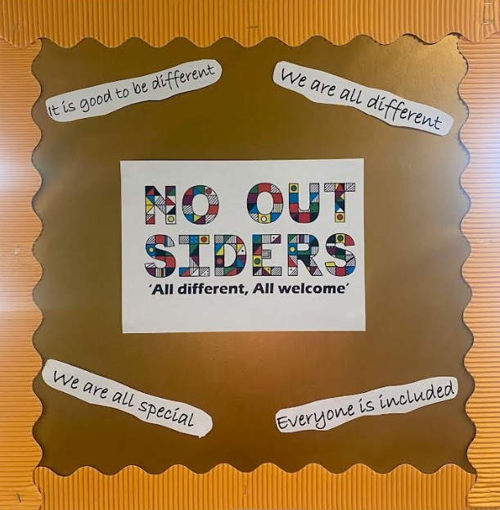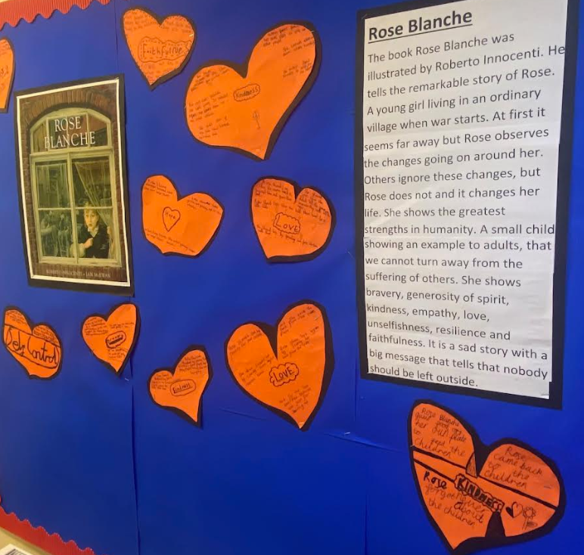

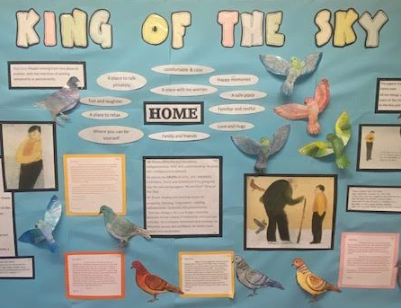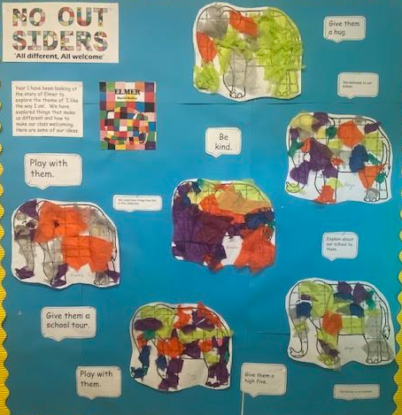

The children have kept their promise and are greeting me daily with a big smile which is helping me get to know them. I’ve spent some time at lunchtime with them both in the hall and outside and I have to say I’m very impressed with their ideas and dreams for Dawpool.

We had our first lockdown drill this morning and I was amazed by all of the children. They were remarkably sensible and calm and I felt so proud of

them all. By carrying out the drill, we have been able to improve our plan and procedures. I think a lot of the children had fun during this practice.

“It made me feel safe.” Rhys

“It was exciting trying something we haven’t done before.” Imogen

“It made me feel protected.” Phoebe

“It surprised me in a fun way.” Thapelo

Thank you to those of you who have introduced yourselves to me, I’m really enjoying getting to put faces to names. Having met with FoDS and discussing lots of exciting plans for this next academic year, I am hoping many of you can join us at the FoDS AGM on 25th September at 7pm in the school hall.

Wishing you all a wonderful weekend.

Kindest regards,

Mrs Helen Griffiths

Paper copies of permission letters have been sent home today. Please complete and return to school before Friday 19th September. I would like our Dawpool News to include photographs so we can celebrate the children and what they have been doing, however we need parental consent for this.

***NEXT WEEK***

**Monday 15th September**

Cross Country Race at Arrowe Park

**Tuesday 16th September**

**Wednesday 17th September**

Forest School for Year 6

3.30-4.30 pm Chess Club

**Thursday 18th September**

**Friday 19th September**

Lunchtime Violin Club

**Meet the Teacher Meetings**

The dates and times of the meetings are:

**Year 1:** Wednesday 24th September at 5.00-5.30pm

**Year 2**: Tuesday 23rd September at 5:30-6:00pm

**Year 3**: Tuesday 23rd September at 4:30-5:00pm

**Year 4**: Wednesday 24th September at 4:30-5:00pm

**Year 5**: Tuesday 23rd September at 5:00-5.30pm

**Year 6**: Wednesday 24th September at 5:30-6:00pm

Information shared during the meetings will be uploaded to the class webpages afterwards for handy reference during the year.

Parents’ Evenings for **Foundation 1 and Foundation 2** children will take place on **Tuesday 30th September and Wednesday 1st October between 3:30-6:00pm.** Details about how to book an appointment will be sent to parents shortly. Parents’ Evenings for Years 1-6 will take place before half term and more details will follow soon.

.

Year 4 had a fantastic time on Wednesday during Forest School.

“We did loads of activities like a fire circle and building dens. We even made a really big one that we could fit the whole entire class in.” Bentham

“I built a massive den and we had to hide under it from the rain.” Freddie

“We could climb higher now that we're older and that was really fun.” Edie

“We had a fire circle which was good so we knew what we could do. Some of us made soup and cupcakes out of mud, sticks and leaves and we gave them to the teachers.” Matilde

Next week, it is Year 6’s turn for Forest School.



It's that time of year again when the option for children in Years 4, 5 and 6 to enter some cross-country races is offered.

The dates of this season’s races are:

15/09/25 – Arrowe Park (field behind hospital)

29/09/25 – Birkenhead Park (Upper Park)

13/10/25 – Arrowe Park (field behind hospital)

A letter with full details has been sent home with pupils in these year groups.

**School Photographs Thursday 2nd October**

Our school photographer will be visiting school on the morning of **Thursday 2nd October. We request** that all children **wear** **their winter** **uniform** for their photograph with shirts and ties.



We are committed to ensuring that your child has 30-minutes of physical activity each day. Please therefore provide your child with a coat to ensure that outdoor activities can continue during rainy weather. They should have a light raincoat with them every day, no matter how the day looks in the morning

Additionally, as the weather gets colder, please ensure your child has a school jumper/cardigan.

Thank you.

**School Admissions**

Applications for Foundation 2 and Year 7 school places in September 2026

If your child is due to move up to Foundation 2 in primary school or Year 7 in secondary school in September 2026, and you are a Wirral resident, the online application process opened on 1 September 2025.

For Year 7 in September 2026 the deadline for applying is 31 October 2025, and for Foundation 2 the deadline is 15 January 2026.

For more information about the application process go to: http://www.wirral.gov.uk/schooladmissions

or phone 0151 666 4600.

Please contact schools directly for information about open events and admissions arrangements.



Wednesday - KS2 chess club.

Friday-Cross-country lunchtime clubY4 5 & 6.

Friday-Violin Club Y3-6

**Wraparound Care Payments/Pre-school / Lunchtime payments & School dinners**

Payment for this month's invoices have now been requested.Please endeavour to pay by the ‘due by’ date quoted in the request.

Any problems please contact Mandy Parr at the School Office on option 4 or by email at [mparr@dawpool.wirral.sch.uk](mailto:mparr@dawpool.wirral.sch.uk).

If any parents wish to pay by the government’s tax-free childcare payments scheme, please contact Mandy Parr about how this works.

**11+ Examination**

Good luck to our Year 6 children who will be sitting the 11+ examination on **Monday 15th September**. Remember, you can do it and we are very proud of you!

Just a reminder that your child must take the Test Day Identity Form with them to the test centre on the day.

We’re looking forward to hearing all about it on Monday afternoon when you come back to school.

**FoDS AGM Meeting Thursday 25th September**

You're Invited to FoDS Annual Catch Up (AGM)

Thursday, 25th September

7:00 PM

School Hall

We’d love to see as many of you as possible at our Meeting! It’s a great opportunity to:

- Take a look at the highlights of last year’s fantastic fundraising efforts

- Elect this year’s committee

- Share ideas and discuss plans for the year ahead.

If you're interested in joining the committee, getting more involved, or simply want to hear more about what we do, please come along — everyone is welcome!

To read more about FoDS and the committee roles, please use the link below.

<https://www.dawpool.wirral.sch.uk/website/friends_of_dawpool_fods_pta/255158>

**Little Actors**

If your child is interested in performing arts there are workshops for children aged from 2 ½ and a youth theatre for ages 13+ held in Neston.

Little Actors is a Registered Charity and as such promote inclusive access to the arts and offer a 50% discount for low-income families.

All of the workshops are led by professional theatre practitioners.



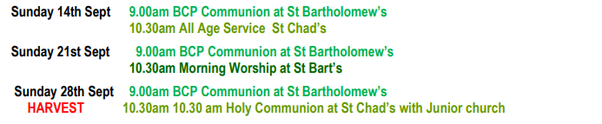

For more information about Services and events at St Bartholomew’s Thurstaston and St Chad’s Irby, please visit:

[**https://www.thurstaston.org.uk/**](https://www.thurstaston.org.uk/)

**Email:**

[**office@thurstaston.org.uk**](mailto:office@thurstaston.org.uk)

**Facebook:**

[**https://www.facebook.com/stchadsstbarts/**](https://www.facebook.com/stchadsstbarts/)

**Twitter:**

[**https://twitter.com/StBartsStChads**](https://twitter.com/StBartsStChads)