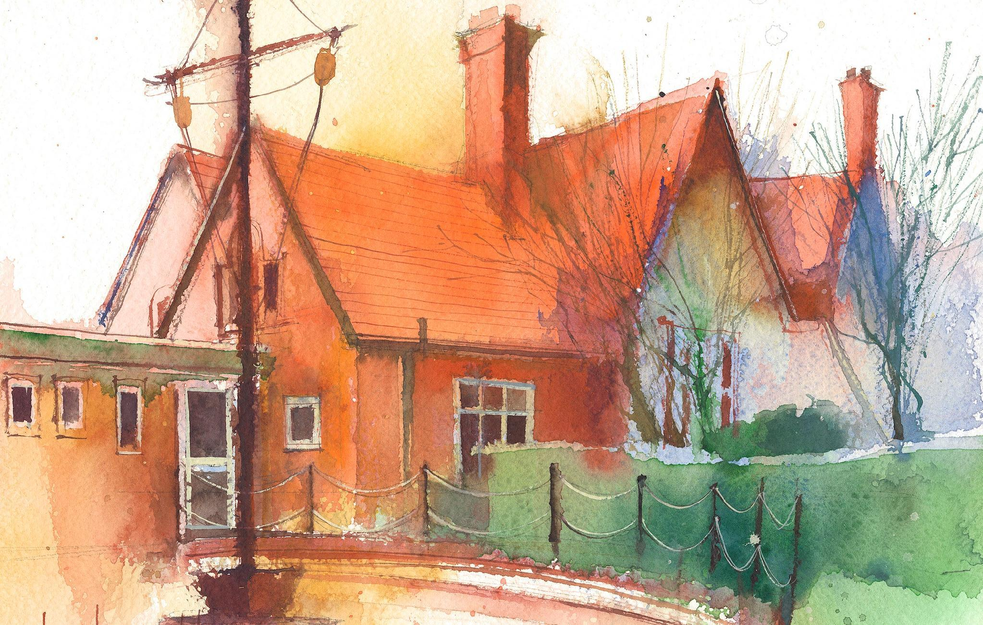
Year 1 Weekly Timetable Week Commencing 8.6.26
To contact your child’s class teacher, please email schooloffice@dawpool.wirral.sch.uk or phone 0151 648 3412

 | Lessons 09:00 – 10:30 |  |  | Lessons 10:45 – 12:15 |  | Lessons 13:15 – 15:30 (Incorporating 15-minute break) | Additional Tasks
Wednesday | Phonics: Alien Phonics practise  English: Mrs B | O  P  A  L  Assembly |  | Maths - Mrs B  ERIC/ GR |  | Forest School/RE: Can you make flat roof houses/dens like Jesus lived in? | FOREST SCHOOL IS ON WEDNESDAY THIS WEEK.  Thursday we have a special golf tournament with Yr2.
Thursday | Phonics: Alien Phonics practise  English: (SW Day 3)  • I can learn how to box up my story. | Singing  Assembly |  | Maths: (lesson 4) To know how to find half of a quantity.  ERIC/ GR |  | Fin5  PE: Golf Tournament
Friday | Phonics: Alien Phonics practise  English: (SW Day 4):  • I can use a wide range of familiar verbs in the simple past tense (‘-ed’ suffix). | Celebration  Assembly |  | Maths: (lesson 5) To know how to recognise a quarter of a shape or an object.  ERIC/ GR |  | Fin5  Computing (Coding lesson 3):  • I can debug a code. .  RE: I can look and compare houses when Jesus was a boy to now. I can make a flat roof house out of paper.  Golden Time

