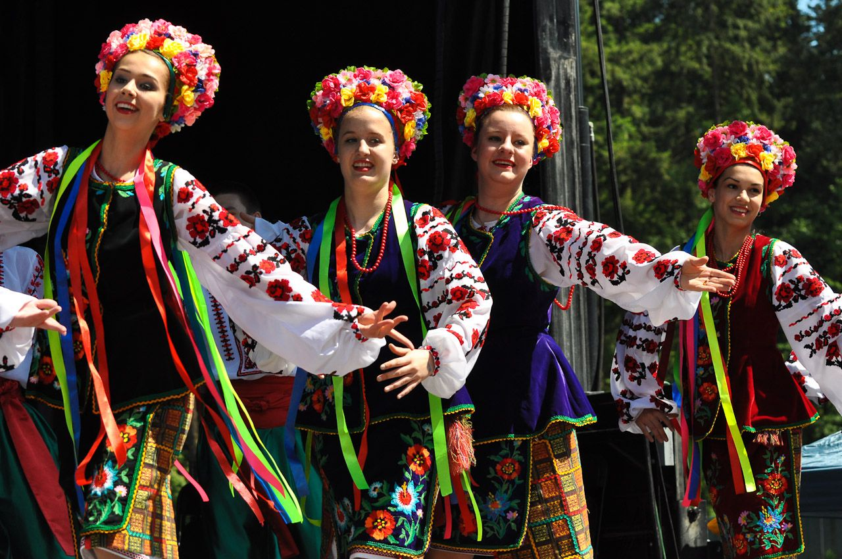

Tuesday 27th May
Warm Hub Guests

Ukrainian dancers

We are thrilled to welcome dancers from Ukraine.
They will be dancing in national costumes to traditional Ukrainian music.
The event, including refreshments, is entirely free,
but donations for the dancers themselves will be welcome.

The Warm Hub at St. Chad’s Church, Irby is open from 9.30 a.m.,
with tea, coffee and biscuits available.
The Ukrainian Dancers’ performance will start at 11.00 a.m.
Everyone is welcome for what promises to be a really lovely and entertaining session.

We are thrilled to welcome dancers from Ukranian. They will be dancing in national costumes to traditional Ukranian music.
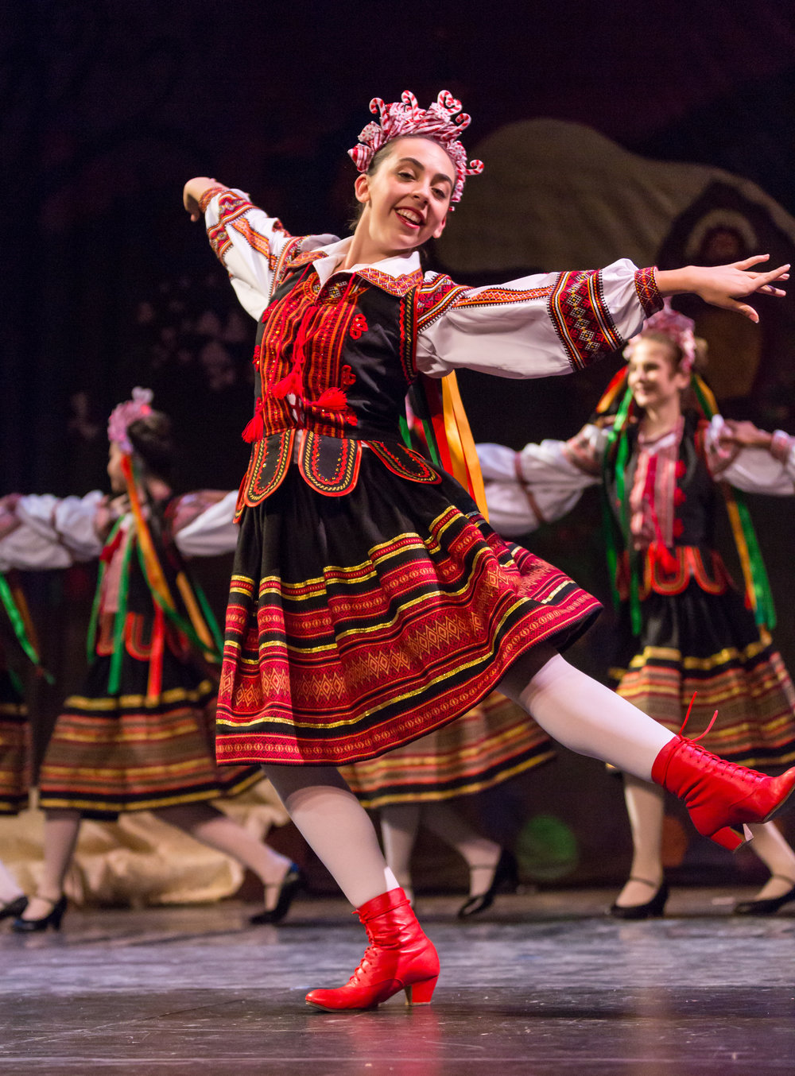
Whilst the event, including refreshments, is entirely free

The Warm Hub at St. Chad’s Church, Irby opens at 9.30 a.m.
The Ukranian Dancers’ performance, which is free, will start at 11.00 a.m. Do join us earlier than that for refreshments.
Everyone is welcome for what promises to be an interesting and entertaining session.

