Foundation 2 Weekly Timetable Week Commencing 10.11.24
To contact your child’s class teacher, please email schooloffice@dawpool.wirral.sch.uk or phone 0151 648 3412
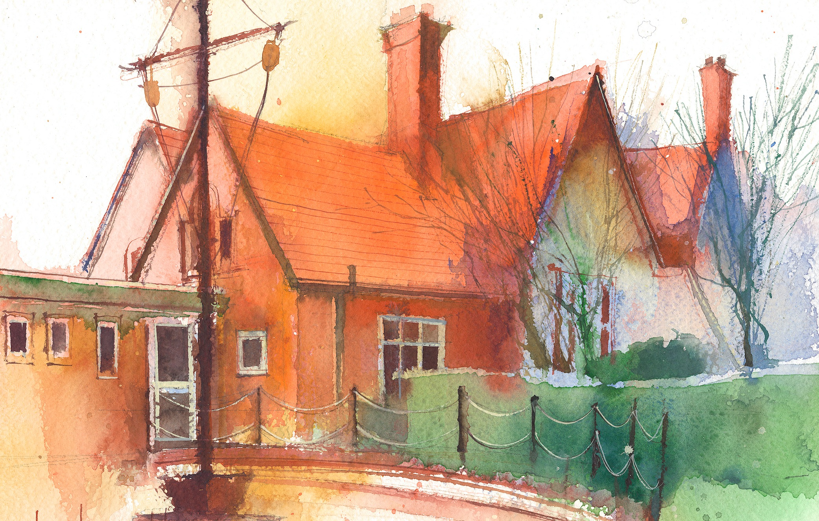

This timetable is available in the event that a Foundation 2 pupil is required to self-isolate at home, but the cohort remains open to other pupils.
Please visit the Foundation 2 Remote Learning Page on the school website to access any downloadable resources and activity sheets.

 | Session 1: 09:00-10:30 |  | Session 2: 10:50 – 12:00 |  | Session 3: 13:15 – 15:25
Monday | Phonics  By the end of this lesson your child should be able to:  Recognise and say the sound ‘u’  We recommend the following resources and activities to achieve this objective:  Blending practice.  Children will complete activities in their individual rocket phonics workbooks. |  | Maths  By the end of this lesson your child should be able to:  To understand the composition of the number 6  We recommend the following resources and activities to achieve this objective:  Watch Numberblocks – Six.  Pause the episode at different points and discuss the things they see.  Focus on what Number 6 looks like, what images you can see in each scene and how they make number 6. |  | Topic  By the end of this lesson your child should be able to:  To understand why we are having anti-bullying week  We recommend the following resources and activities to achieve this objective:  Focus on ‘Power for Good’ theme.  Use random acts of kindness tickets to think about how we can help and support others
Tuesday | Phonics  By the end of this lesson your child should be able to:  Recognise and write the sound ‘u’  We recommend the following resources and activities to achieve this objective:  Segmenting practice.  Children will complete activities in their individual rocket phonics workbooks. |  | Maths  By the end of this lesson your child should be able to:  Addition - To see that a number increases when you add one more  We recommend the following resources and activities to achieve this objective:  In numberblocks number 5 and number 1 joined together to make 6. 5+1=6  Are there any other ways of making 6?  Give all children sets of 6 cubes. Can they break up the cubes to find new ways of making 6? |  | Topic  By the end of this lesson your child should be able to:  To understand why we wear poppies in November  We recommend the following resources and activities to achieve this objective:  Discuss the meaning of Remembrance Day  Listen to the last post for a minutes reflection  Make a poppy wreath for the classroom door.  Watch ‘My First Festival’ on Cbeebies  Watch ‘Poppies’ on Cbeebies
Wednesday | Phonics  By the end of this lesson your child should be able to:  Recognise and say the sound ‘r’  We recommend the following resources and activities to achieve this objective:  Blending practice  Children will complete activities in their individual rocket phonics workbooks. |  | Maths  By the end of this lesson your child should be able to:  Subitise - To recognise quantities without counting.  We recommend the following resources and activities to achieve this objective:  In Numberblocks, Number 6 is made up of different parts of a dice.  Look at a picture of Number 6, do they know which number each part of him represents? How do they know?  Sit the children in a large circle and in the middle I will roll the jumbo dice. What number is represented? Can they do that many jumps/claps/hops?  Repeat several times |  | Topic  By the end of this lesson your child should be able to:  To discuss superheroes and how they help people  We recommend the following resources and activities to achieve this objective:  Re-cap on ‘Power for Good’ theme.  Superheroes fight for good and justice.  Think of other superheroes who have superpowers.  Discuss with friends as many superheroes as they can think of – what superpowers do they have to defeat the unkind villans?
Thursday | Phonics  By the end of this lesson your child should be able to:  Recognise and write the sound ‘r’  We recommend the following resources and activities to achieve this objective:  Segmenting practice  Children will complete activities in their individual rocket phonics workbooks. |  | Maths  By the end of this lesson your child should be able to:  Addition – To see that a number increases when you add one more.  We recommend the following resources and activities to achieve this objective:  Re-cap on Tuesdays lesson  In numberblocks number 5 and number 1 joined together to make 6. 5+1=6  Are there any other ways of making 6?  Give all children sets of 6 cubes. Can they break up the cubes to find new ways of making 6? |  | Topic  By the end of this lesson your child should be able to:  What makes us special  We recommend the following resources and activities to achieve this objective:  We can all help others and make school a happier place.  What superpower do they have?  PP discussion to find out how special we all are.  Create a superhero cape picture to show our super power.
Friday | PE  By the end of this lesson your child should be able to:  Revise and refine fundamental movement skills already acquired.  We recommend the following resources and activities to achieve this objective:  During this half term our focus will be on collaborative playground games. |  | Phonics  By the end of this lesson your child should be able to:  To learn to write the Common Exception word ‘I’  We recommend the following resources and activities to achieve this objective:  Children will complete activities in their individual rocket phonics workbooks. |  | Forest School  By the end of this lesson your child should be able to:  Collaborate with others  We recommend the following resources and activities to achieve this objective:  Work together to create minibeast hotels, art in nature, build dens, support each other getting in and out of the swinging hammock

