Year 1 Weekly Timetable Week Commencing 19.10.26
To contact your child’s class teacher, please email schooloffice@dawpool.wirral.sch.uk or phone 0151 648 3412
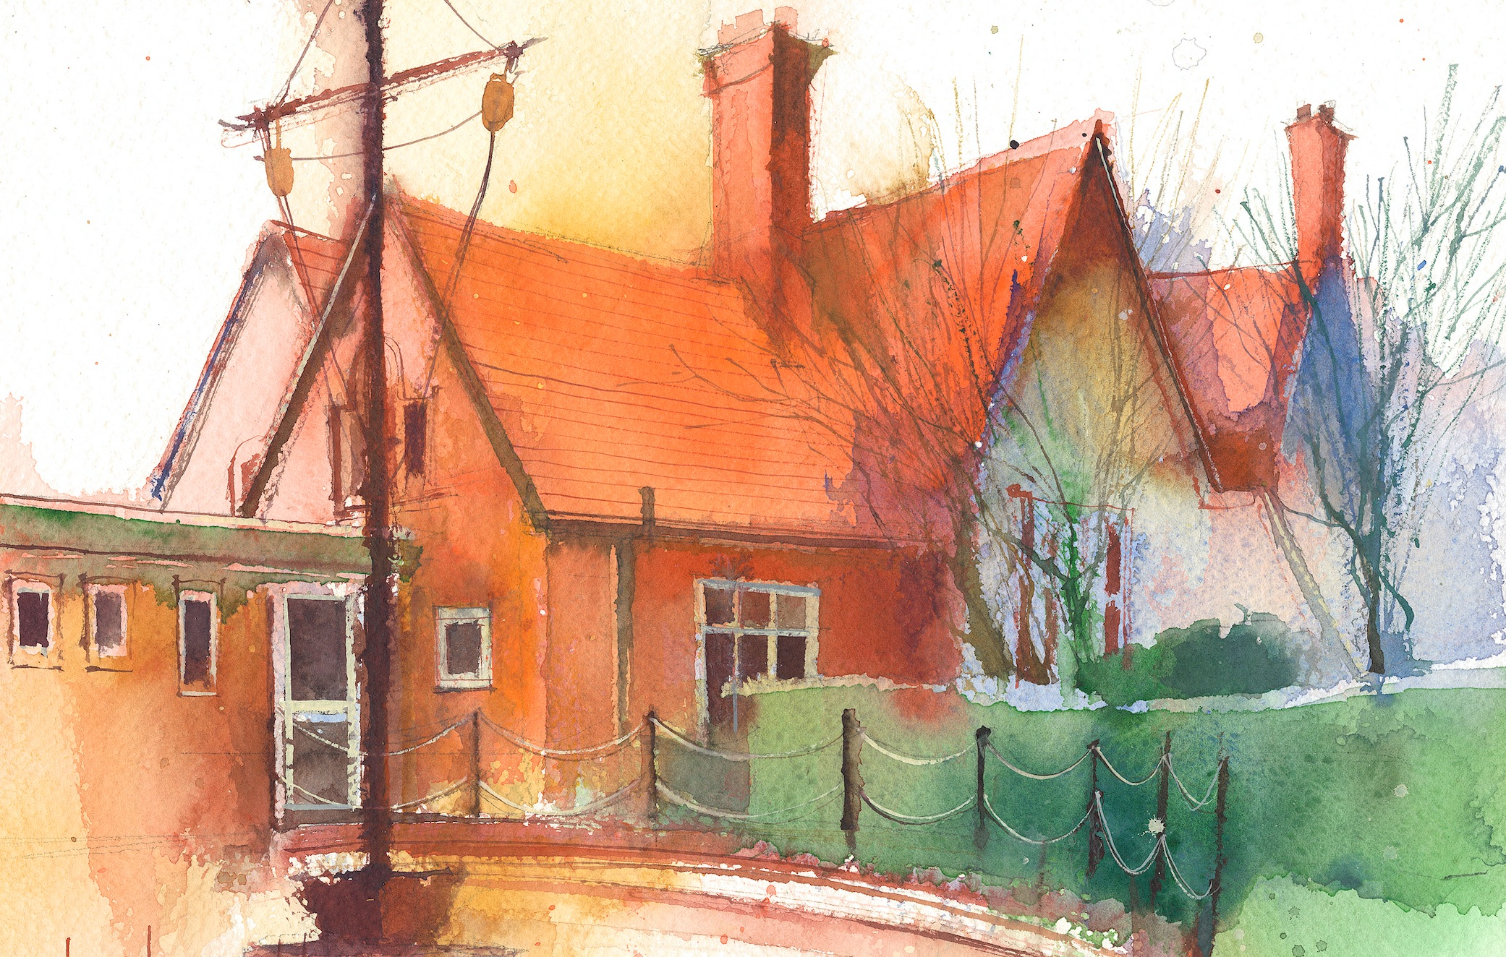

 | Lessons 09:00 – 10:30 |  | Lessons 10:45 – 12:15 |  | Lessons 13:15 – 15:30  (Incorporating 15-minute break) | Additional Tasks
Monday | Phonics: oe  English  To use capital letters..  Busy Learning  Whole School Worship |  | Maths  To know how to write addition fact families.  Busy Learning |  | Geography  To compare how The Wirral and Cape Town are similar and different.  Busy Learning  Music | Useful Links / Other Recommended Activities  Oak National Academy  https://classroom.thenational.academy/  BBC Bitesize  https://www.bbc.co.uk/bitesize  Purple Mash  https://www.purplemash.com/sch/dawpool#/  Hit the button  https://www.topmarks.co.uk/maths-games/hit-the button
Tuesday | Phonics:oe  English  To use full stops.  Busy Learning |  | Maths  To know how to find number bonds to 10  Busy Learning |  | Art  To create art based on the artist Kandinsky.  Busy Learning  Picture News
Wednesday | Phonics: o  English  To orally say my sentence before writing.  Busy Learning |  | Maths  To know how to find all number bonds within 10  Busy Learning |  | RE  To understand the festival of Pongal.  Busy Learning  Heartsmart
Thursday | Phonics: o  English  To use full stops. .  Busy Learning |  | The Wirral Mental Health Support Team  Connect: Learning how to connect with others through kindness, sharing,  listening and playing together to support build positive relationships |  | Forest School/RE  Tools work  . Maths  To know what number bonds to 10 are.
Friday | Phonics: Tricky Word: have, there  English  To use capital letters.  Celebration worship |  | Maths  To know how to find number bonds to 10  Busy Learning |  | PE  To create hand-eye coordination circuits.  Computing  Introduction to Purple Mash

