Year 3 Weekly Timetable Week Commencing 18.01.21
To contact your child’s class teacher, please email year3@dawpool.wirral.sch.uk
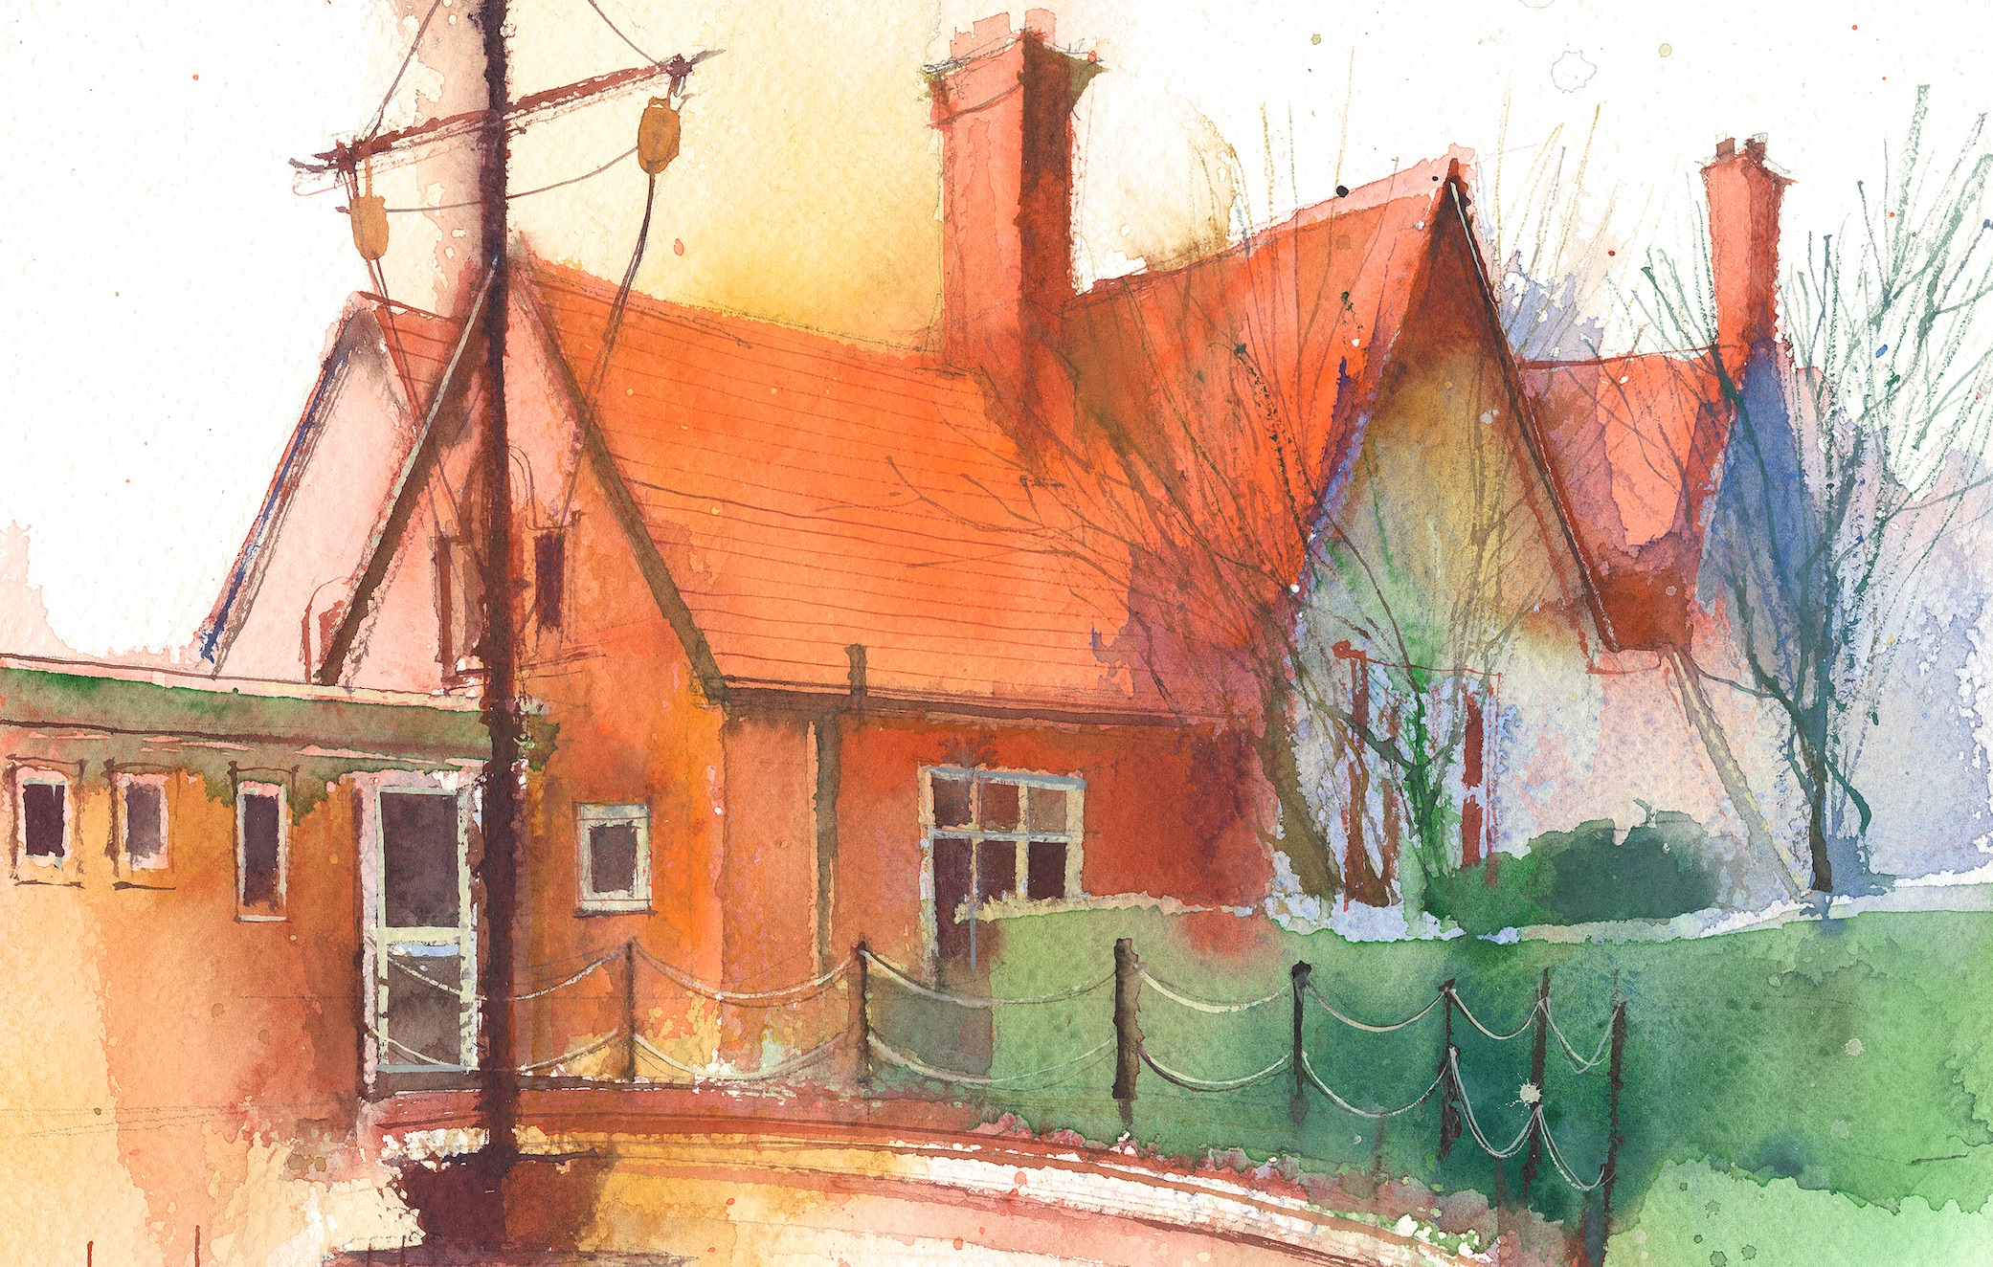

This timetable is available in the event that all Year 3 pupils are required to self-isolate at home. Please visit the Year 3 Remote Learning Page to
access any downloadable resources and activity sheets. The assessed task should be submitted to the teacher at the end of each day via Purple Mash.

 | Session 1: 09:00-10:30 |  | Session 2:10:45 – 12:15 |  | Session 3: 13:15 – 15:30 (Incorporating 15-minute break) | Assessed Task
Monday  11.01.21 | Maths  By the end of this lesson your child should be able to: calculate how many possible combinations can be made from 2 groups of objects (Lesson 9)  We recommend the following resources and activities to achieve this objective:  Slides  Worksheet |  | ICT  By the end of this lesson your child should be able to: Look at what an email is and how we safely send and receive them  We recommend the following resources and activities to achieve this objective:  2x Worksheet (differentiated by stars)  Handy hints  PPT |  | Europe  By the end of this lesson your child should be able to: Investigate rivers and mountains of Europe  We recommend the following resources and activities to achieve this objective:  https://classroom.thenational.academy/lessons/what-are-the-physical-features-of-europe-74wp6r  Worksheet:  - World map rivers  - Mountain ranges of Europe | Login to Purple Mash to submit today’s assessed task:  On Purple Mash, using the blank page set, tell me about some rivers and mountains in Europe.
Tuesday  12.01.21 | Maths  By the end of this lesson your child should be able to: Recap their knowledge from this topic- Assessment  We recommend the following resources and activities to achieve this objective:  Assessment worksheet  - Children should also take their time to recap times table knowledge (see further worksheets) |  | English  By the end of this lesson your child should be able to: Plan our email  We recommend the following resources and activities to achieve this objective:  WAGOLL  Worksheet- when planning, write in bullet points. This is not your actual email!  Could we write an email to the dad begging him to come back? What will make him want to come back?  Children to put themselves in the role of the boy. Children to plan email, persuading dad to come back by focussing on their feelings and fears. Tell dad what is like at home and what the boy has been doing. |  | R.E  By the end of this lesson your child should be able to: Listen to Christian songs and explain what they say about Jesus  We recommend the following resources and activities to achieve this objective:  Listen to and examine the content of the following hymns:  ‘Shine Jesus Shine’ Graham Kendrick  https://www.youtube.com/watch?v=gi1Ubff5XoY  ‘The Servant King’ Christians at Glastonbury Abbey 1996  https://www.youtube.com/watch?v=7VeQrWmvCms  Watch the videos: sing the songs and look at the words.  Mark & annotate lyrics. Identify especially what the hymns say about Jesus. – write your thoughts down on lyric sheet with your annotations.  - Worksheet with lyrics of both songs. | On Purple Mash, using the blank page set, let me know your scores for the maths assessment today.
Wednesday  13.01.21 | Maths  By the end of this lesson your child should be able to: Recap measuring and comparing mass  We recommend the following resources and activities to achieve this objective:  https://www.bbc.co.uk/bitesize/articles/zndy6g8  https://www.bbc.co.uk/bitesize/articles/zgx4ydm  (Websites to help provide a learning summary and activity too! I would read through the website pages first before completing the worksheets)  Worksheets |  | English (Comprehension)  By the end of this lesson your child should be able to: Read and understand a given text. Answer questions using literal retrieval and give opinions justified by the text.  We recommend the following resources and activities to achieve this objective:  ’Utterly me’ text, and written task.  Read a book of your own choice for 20 minutes after completing this task. |  | Science  By the end of this lesson your child should be able to:  -know that animals, including humans, need the right amounts and types of food.  -report on findings from enquiries.  We recommend the following resources and activities to achieve this objective:  Please refer to the lesson guide. | Answer the question that has been set on the Science Blog (on Purple Mash)
Thursday  14.01.21 | Maths  By the end of this lesson your child should be able to: Find and compare different combination of coins (Lesson 1)  We recommend the following resources and activities to achieve this objective:  Slides  Worksheet |  | English  By the end of this lesson your child should be able to: Write our email to dad  We recommend the following resources and activities to achieve this objective:  - WAGOLL  - Email template to write on or type on Purple Mash  - Success Criteria- what I am looking for  - Plans from Tuesday to help them |  | P.E  By the end of this lesson your child should be able to: Be active.  We recommend the following resources and activities to achieve this objective:  Choose one of the activities from the attached sheet.  AND  Music  By the end of this lesson your child should be able to: Understand pulse and rhythm  We recommend the following resources and activities to achieve this objective:  https://classroom.thenational.academy/lessons/understanding-pulse-and-rhythm-chj3cr | Send me your email to dad!  Option 1: Type your email into Purple Mash on the blank page set  Option 2: Write your email on the template given, take a picture and send it to my email:  year3@dawpool.wirral.sch.uk
Friday  15.01.21 | Maths  By the end of this lesson your child should be able to: Add amounts of money (Lesson 2)  We recommend the following resources and activities to achieve this objective:  Slides  Worksheet |  | English (Grammar & Punctuation)  By the end of this lesson your child should be able to: Identify and use prepositions correctly  We recommend the following resources and activities to achieve this objective:  https://classroom.thenational.academy/lessons/to-explore-prepositions-74t66r?activity=video&step=1  Worksheet (uploaded)- Send me your answers via Purple Mash |  | French  By the end of this lesson your child should be able to: demonstrate their understanding of instructions in French.  We recommend the following resources and activities to achieve this objective:  Worksheet  PPT  Word Mat  Word Search | On Purple Mash, using the blank page set, send me your answers to the worksheet on prepositions
Additional Tasks

We also advise your child to complete the following tasks this week:

Fluent in Five Week 16- Complete one each day.

Rapid Reasoning Week 16- Complete one each day.

Handwriting (uploaded each week)

Times tables- https://www.bbc.co.uk/teach/supermovers/times-table-collection/z4vv6v4

Reading- book chapter and quiz set on Purple Mash this week.

Spellings 3 (uploaded)

