LB Weekly Timetable Week Commencing 12.3.24
To contact your child’s class teacher, please email schooloffice@dawpool.wirral.sch.uk
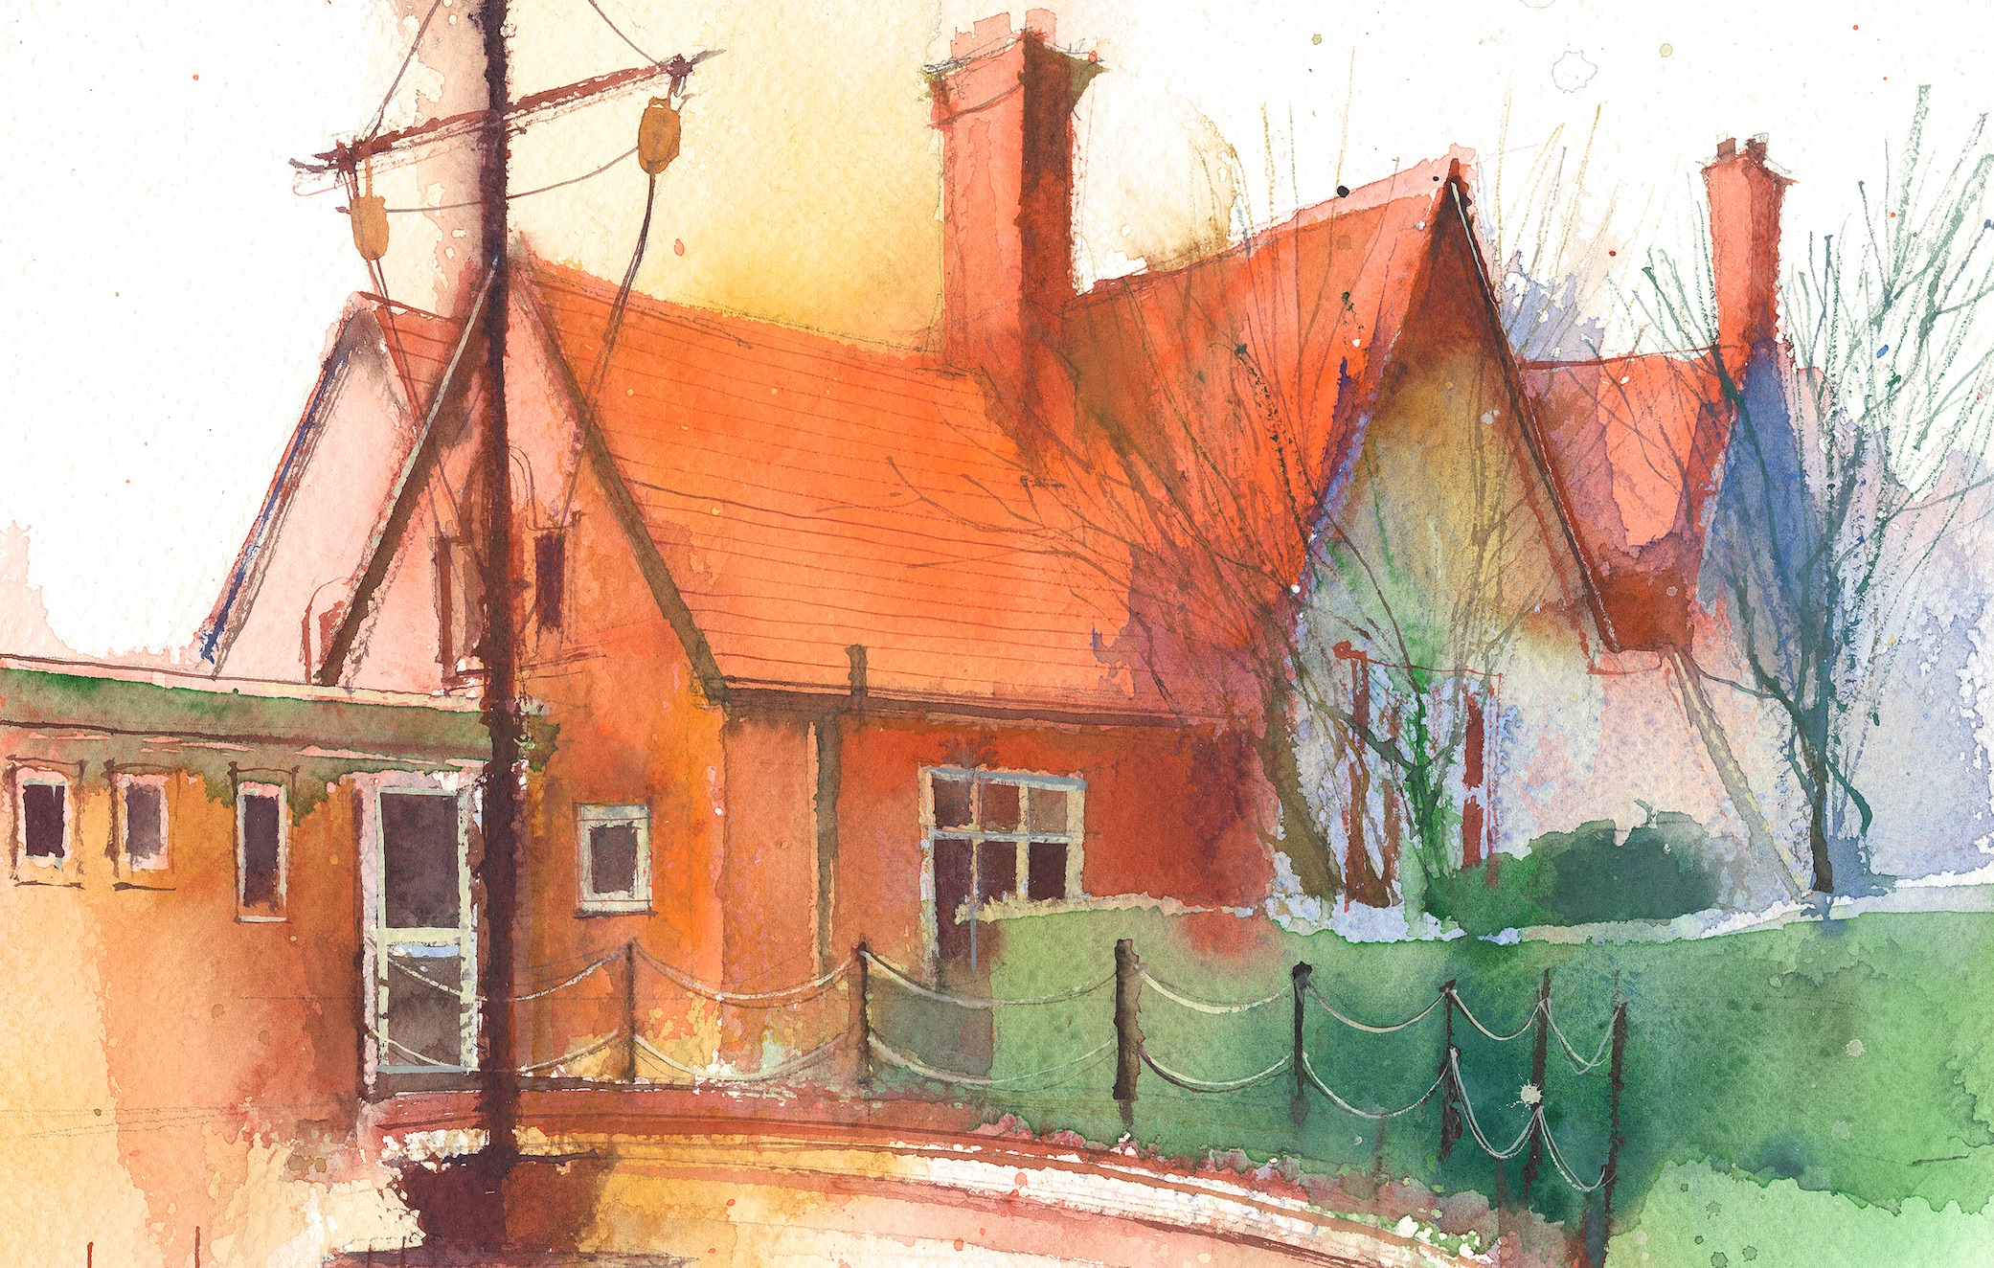

This timetable is available in the event that a Year 6 pupil is required to self-isolate at home, but the cohort remains open to other pupils.
Please visit the Year 6 Remote Learning Page on the school website to access any downloadable resources and activity sheets.

 | Session 1: 09:00-10:30 |  | Session 2: 10:45 – 12:15 |  | Session 3: 13:15 – 15:30 (Incorporating 15-minute break) | Additional Tasks
Monday  12.3.24 | Power of Reading  By the end of this lesson your child should be able to:  - Write a letter offering advice to a character.  - Edit to improve work. |  | Maths  By the end of this lesson your child should be able to:  - Know how to identify equivalent fractions. |  | History  By the end of this lesson your child should be able to:  - Know who resisted the Roman invasion and the consequences of this resistance.  - Present my findings to an audience.
Tuesday  13.3.24 | Power of reading  By the end of this lesson your child should be able to:  - Explore the slave trade and what happened to slaves.  - Reflect and share my opinion on the slave trade. |  | Music  By the end of this lesson your child should be able to:  - Delivered by a music teacher.  Heart Smart  - Suggest ways to fix a broken friendship |  | PE  Delivered by a sports coach.  Times table Test  My Happy mind
Wednesday  14.3.24 | Power of Reading  By the end of this lesson your child should be able to:  - Write a response to the scene of Jemmy's family being given a button for Jemmy.  - Consider the value of a button compared to a human life. |  | Maths  By the end of this lesson your child should be able to:  - Know how to add two or more fractions. |  | DT  By the end of this lesson your child should be able to:  - Understand why vegetables form an important part of a healthy and varied diet.  - Know and understand the term “hygiene.”  - Know now how to prepare food safely.  - Know the difference between fruit and vegetables.  - Know which foods are good for us.

