**Year 1 Weekly Timetable Week Commencing 19.5.25**

**To contact your child’s class teacher, please email** [**schooloffice@dawpool.wirral.sch.uk**](mailto:schooloffice@dawpool.wirral.sch.uk) **or phone 0151 648 3412**

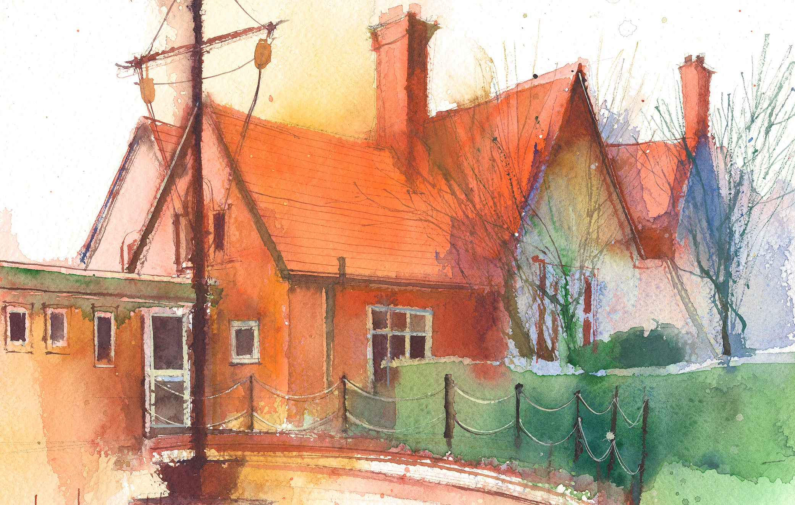

|  |  |  |  |  |  |  |
| --- | --- | --- | --- | --- | --- | --- |
|  | **Lessons 09:00 – 10:30** |  | **Lessons­­­­ 10:45 – 12:15** |  | **Lessons 13:15 – 15:30 (Incorporating 15-minute break)** | **Additional Tasks** |
| **Monday** | **Phonics:** consolidate gn  **English:** I can write my own version of the secret of the black rock. | **Maths:** To know how to make equal groups by sharing.  **ERIC / GR** | **Fluent in 5**  **Topic/Art:** Learning how to mix primary colours to make secondary  colours.  **My Happy Mind:** Relate | Useful Links / Other Recommended Activities  **Oak National Academy**  <https://classroom.thenational.academy/>  **BBC Bitesize**  <https://www.bbc.co.uk/bitesize>  **Purple Mash**  <https://www.purplemash.com/sch/dawpool#/>  **Recommended Reading List**  [See here](https://www.dawpool.wirral.sch.uk/website/recommended_reading_lists/577821) |
| **Tuesday** | **SPORTS** | **DAY** | **Fluent in 5**  **Science:**To be able to record data in a table.  **Picture News** |
| **Wednesday** | **Phonics:** consolidate tch and wr  **Spag** | **Forest School**  **ERIC / GR** | **Fluent in 5**  **Computing:**  • To add a sound effect to a picture.  • To add a voice recording to the picture.  • To add created music to the picture.  • To add a background to the story.  • To demonstrate a good understanding of all the tools they have used in 2Create a Story and use these successfully to create their own story.  **Maths:** To know how to make equal groups by sharing. |
| **Thursday** | **Phonics:** consolidate s, si, ge  **English:** I can write my own version of the secret of the black rock. | **Maths:** To know how to use a number line to 20.  **ERIC / GR** | **Fluent in 5**  **Heartsmart:** Fake is a mistake.  **PE:** Use knowledge of attack and defence in simple games rules.  **No Outsiders:** Errol’s Garden. |
| **Friday** |  | **See Mrs Clark’s Planning** |  |