Year 3 Weekly Timetable Week Commencing 21.06.21
To contact your child’s class teacher, please email schooloffice@dawpool.wirral.sch.uk or phone 0151 648 3412

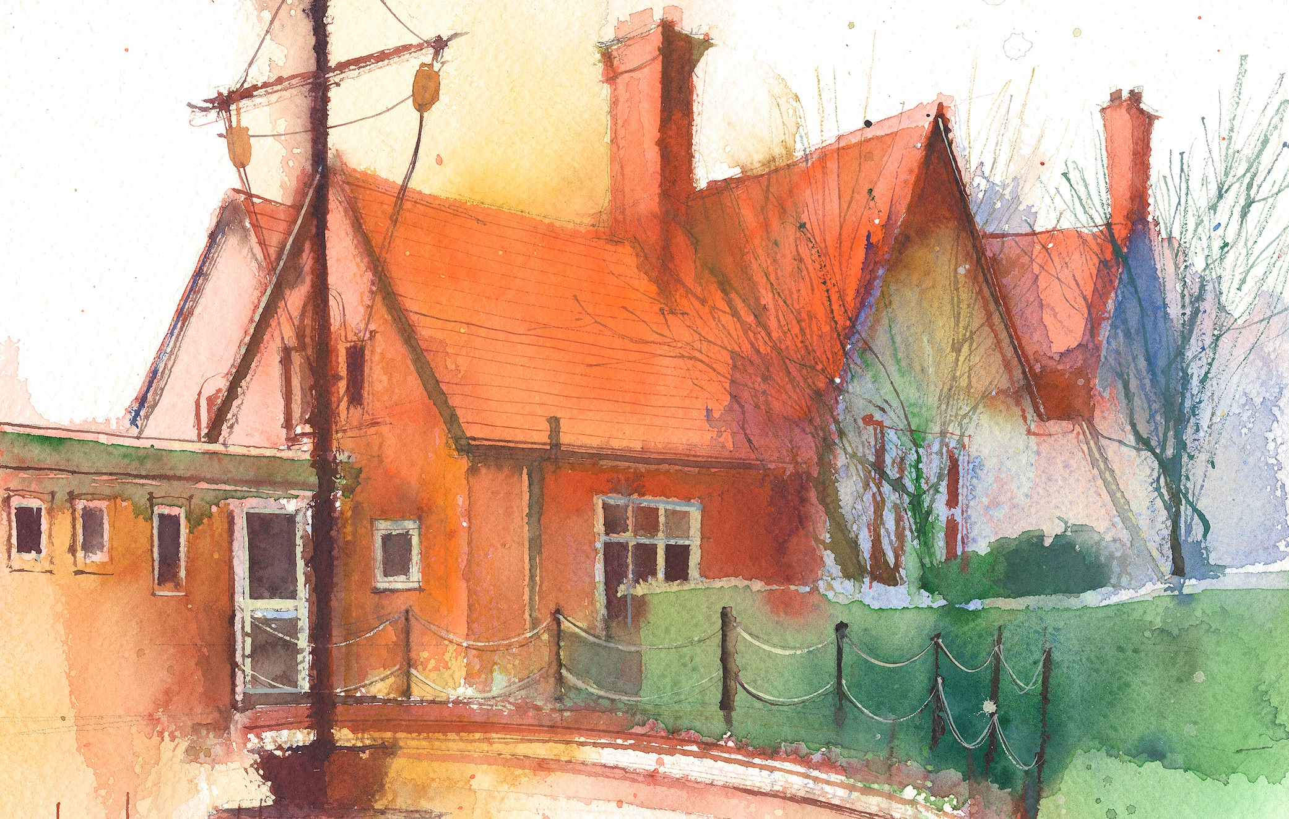

This timetable is available in the event that a Year 3 pupil is required to self-isolate at home, but the cohort remains open to other pupils.
Please visit the Year 3 Remote Learning Page on the school website to access any downloadable resources and activity sheets.

 | Session 1: 09:00-10:30 |  | Session 2:10:45 – 12:15 |  | Session 3: 13:15 – 15:30 (Incorporating 15-minute break)
Monday | Maths  By the end of this lesson your child should be able to: Know how to read scales to measure mass in grams or kilograms  (RECAP)  We recommend the following resources and activities to achieve this objective:  PPT  Worksheet |  | English  By the end of this lesson your child should be able to:  Plan our letter to the boy  We recommend the following resources and activities to achieve this objective:  Planning sheet  WAGOLL  Task- Recap what has just happened to the boy- tough decision. What do you think the boy should do? How could we try and persuade him that your idea is the right idea?  Read the pages again and think about what life would be like with the polar bears or with the human family. Children to read through their reasons they have come up with in their books.  Children to put themselves in the role of a friend of the boy. Children to plan letter, writing to persuade the boy to either stay or go with the humans- children make their own choice. |  | History- Stone Age  By the end of this lesson your child should be able to: Explore and research Skara Brae  We recommend the following resources and activities to achieve this objective:  WAGOLL  PPT  Task- We are going to be exploring a Stone Age village called Skara Brae. We are going to find out what this discovery tells us about people who lived in the Stone Ages.  Show the YouTube clip of skara brae, watch it through .  https://www.youtube.com/watch?v=FFqqZn0ZuxY  Activity  Using iPads children to research more about Skara Brae and note take on A4 lined paper.  Our aim is to inform others who have not heard of Skara Brae before.  What subheadings could we use? Which information could we use for the general introduction? Use the WAGOLL for guidance.
Tuesday | English  By the end of this lesson your child should be able to: Write their letter of persuasion to the boy thinking about grammar and punctuation  We recommend the following resources and activities to achieve this objective:  WAGOLL  Planning sheets (Monday’s lesson)  Success Criteria |  | English  By the end of this lesson your child should be able to:  Write their letter of persuasion to the boy thinking about grammar and punctuation  We recommend the following resources and activities to achieve this objective:  WAGOLL  Planning sheets (Monday’s lesson)  Success Criteria |  | R.E  By the end of this lesson your child should be able to: Recognise main symbol associated with Islam  We recommend the following resources and activities to achieve this objective:  PPT  Worksheet
Wednesday | SUBJECT – READING COMPREHENSION  Allan Ahlberg  (Poetry)  By the end of this lesson your child should be able to:  - read and understand a given text. Answer questions using literal retrieval and give opinions justified by the text.  We recommend the following resources and activities to achieve this objective:  Lesson resources provided by email if a pupil is isolating. |  | Maths  By the end of this lesson your child should be able to:  Measure mass and record it as a mixed measurement in kilograms and grams  (RECAP)  We recommend the following resources and activities to achieve this objective:  PPT  Worksheet |  | SUBJECT - SCIENCE  Plants – Lesson 5  By the end of this lesson your child should be able to:  - To be able to identify and describe the function of the flower.  - To be able to use straightforward scientific evidence to answer questions or to support their findings.  We recommend the following resources and activities to achieve this objective:  Lesson resources provided if a pupil is isolating.
Thursday | Art  By the end of this lesson your child should be able to: Create a background sunset wash and painted elephants  We recommend the following resources and activities to achieve this objective:  PPT x2  Image examples  Elephant template |  | Art  By the end of this lesson your child should be able to:  Create a background sunset wash and painted elephants  We recommend the following resources and activities to achieve this objective:  PPT x2  Image examples  Elephant template |  | P.E  By the end of this lesson your child should be able to: Be active.  We recommend the following resources and activities to achieve this objective:  We will be practising our rounders skills in school. Could you practise some of these skills needed for rounders at home? Or, try and be active some other way e.g. find a dance routine to follow, Joe Wicks YouTube sessions.
Friday | Maths  By the end of this lesson your child should be able to: Practise arithmetic skills  We recommend the following resources and activities to achieve this objective:  Worksheets (3 & 4) |  | English (Grammar)  By the end of this lesson your child should be able to:  Recap grammar learnt  We recommend the following resources and activities to achieve this objective:  Worksheet |  | French  By the end of this lesson your child should be able to: Talk About What They Like To Do  We recommend the following resources and activities to achieve this objective:  PPT  Worksheets
Additional Tasks

We also advise your child to complete the following tasks this week:

Fluent in Five Week 34- Complete one each day.

Rapid Reasoning Week 34- Complete one each day.

Handwriting (use your spellings to practise your handwriting)

Times tables- https://www.bbc.co.uk/teach/supermovers/times-table-collection/z4vv6v4

Spellings

