Foundation 2 Weekly Timetable Week Commencing 8.12.25
To contact your child’s class teacher, please email schooloffice@dawpool.wirral.sch.uk or phone 0151 648 3412
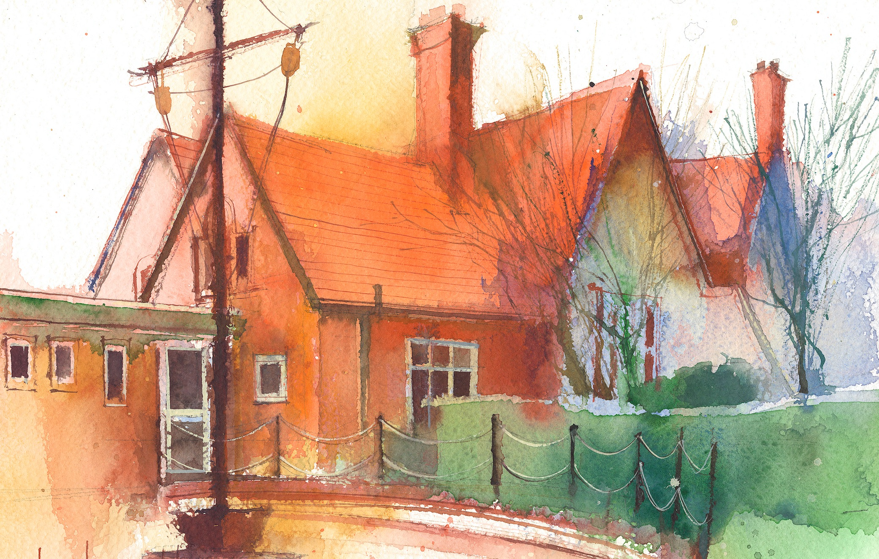

This timetable is available in the event that a Foundation 2 pupil is required to self-isolate at home, but the cohort remains open to other pupils.
Please visit the Foundation 2 Remote Learning Page on the school website to access any downloadable resources and activity sheets.

 | Session 1: 09:00-10:30 |  | Session 2: 10:50 – 12:00 |  | Session 3: 13:15 – 15:25
Monday | Phonics  By the end of this lesson your child should be able to:  Know that we sound out double consonant letters once e.g. rabbit  We recommend the following resources and activities to achieve this objective:  Blending practice.  Children will complete activities in their individual rocket phonics workbooks. |  | Maths  By the end of this lesson your child should be able to:  To be able to recognise and name shapes and their properties  We recommend the following resources and activities to achieve this objective:  Play What’s in the Bag.  Put hand in a bag and describe a shape to the children “It has 4 sides and 4 corners.” Can they name it? Is there any other shape it could be? Repeat for all shapes covered so far. |  | Topic  During the afternoons we will undertake activities linked to all areas of the Early Years Curriculum;  Prime Areas; Communication and Language;  Personal, Social and Emotional Development;  Physical Development.  Specific Areas; Literacy, Maths, Understanding the World and Expressive Arts and Design.  Afternoon sessions will also include RE, HeartSmart and Forest Schools.  Our current RE topic is ‘Special Times’. Planning for this can be found on the website.  Activities will be linked to our class topic which is ‘Where in the World’. We aim to use children’s books as a hook for learning to help us find out more about the world around us. Throughout the year we will select books that enable us to cover all requirements of the Early Years Curriculum.  We will talk about where the book is set and find out where this country is on a map. We will then use the theme of the book as a way of guiding our planning.  PLEASE NOTE  The very nature of the EYFS curriculum enables us to go with the interests of the children. The activities we plan are for a guide only.  Staff can use and adapt activities or add additional activities and not cover others. It is all dependent on how and where the children’s interests take us.  Activities are designed to cover several weeks, if needed.  A copy of the current topic plan is available to view on the class website page.
Tuesday | Phonics  By the end of this lesson your child should be able to:  Know that double consonant sounds are written with two letters e.g. puppet  We recommend the following resources and activities to achieve this objective:  Segmenting practice.  Children will complete activities in their individual rocket phonics workbooks. |  | Maths  By the end of this lesson your child should be able to:  To develop a basic understanding of time  We recommend the following resources and activities to achieve this objective:  Show the yellow teaching clock. Explain that when the big hand is pointing at the twelve it tells us it is “o’clock”. When the little hand is pointing at a number it tells us what time it is.  Demonstrate 1 o’clock and talk about things they may be doing at 1 o’clock in the day and night.  Move the hands and talk about time passing. Show 2, 3 etc. Can they say what time it is as we move the hands around.  Talk about things they might be doing at that time of the day and act them out.  Put children in partners with 6 cubes, pull them apart and see what each has saying;  e.g. if the whole is 4 then 1 is a part and 3 is a part.
Wednesday | Phonics  By the end of this lesson your child should be able to:  Know that longer words are broken down into syllables e.g. sunset  We recommend the following resources and activities to achieve this objective:  Blending practice  Children will complete activities in their individual rocket phonics workbooks. |  | Maths  By the end of this lesson your child should be able to:  Select and rotate shapes for a purpose, to develop spatial reasoning skills  We recommend the following resources and activities to achieve this objective:  Show a selection of different sized circles, squares and triangles. We need to put them in order, starting with the smallest.  Encourage the children to work in small groups to order the shapes. Whilst they are ordering keep talking about the properties of shapes to support their vocabulary.  Go around each group and talk about the orders they have done. Do they all agree? Why?  Talk about small, smaller, smallest. Big, bigger, biggest.
Thursday | Phonics  By the end of this lesson your child should be able to:  Practice segmenting words that contain two syllables e.g. picnic  We recommend the following resources and activities to achieve this objective:  Segmenting practice  Children will complete activities in their individual rocket phonics workbooks. |  | Maths  By the end of this lesson your child should be able to:  To develop a basic understanding of time  We recommend the following resources and activities to achieve this objective:  Show the 1 minute sand timer. Explain that this timer lasts for 1 minute which is 60 seconds. Is 60 seconds a long time? What things can you do in 60 second?  Using the 60 second countdown on YouTube, complete some challenges. Star jumps/the plank/jog on the spot. Can they take their shoes off and put them back on? How many times can they write their name in 1 minute?  Keep talking about time and saying 1 minute is 60 seconds whilst doing the activities.
Friday | PE  By the end of this lesson your child should be able to:  Move in a variety of different ways around the room including High and Low. To sequence a series of moves.  We recommend the following resources and activities to achieve this objective:  During this half term the children will use the hall space to undertake games and activities that require them to roll, crawl, walk, jump, run, hop, skip and climb.  Ho can you make yourself as high/low as possible?  Can you put together a sequence of different moves?  Can you use apparatus and equipment to move in different ways?  Children will also learn to stop and change directions safely. |  | Phonics  By the end of this lesson your child should be able to:  To learn to write the Common Exception word ‘into’  We recommend the following resources and activities to achieve this objective:  Children will complete activities in their individual rocket phonics workbooks.

