Year 1 Weekly Timetable Week Commencing 07.06.21
To contact your child’s class teacher, please email schooloffice@dawpool.wirral.sch.uk or phone 0151 648 3412
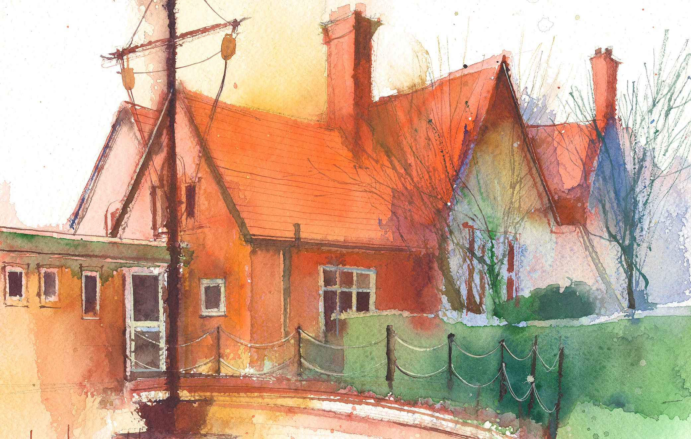

This timetable is available in the event that a Year 1 pupil is required to self-isolate at home, but the cohort remains open to other pupils.
Please visit the Year 1 Remote Learning Page on the school website to access any downloadable resources and activity sheets.

 | Session 1: 09:00-10.00 | Session 2: 10.00 – 10.30 | Session 3:10:45 – 12:15 | Session 4: 13:15 – 15:10
Monday  07.06.21 | Phonics  By the end of this lesson your child should be able to:  * I can match all 40+ graphemes to their phonemes  We recommend the following resources and activities to achieve this objective:  *Begin with re-capping all sounds taught. Main focus being vowel sounds.  *Practice Tricky words  *MTYT on a_e. Discuss the concept of a split digraph. How the sounds are still friends, even if they have been split up. Also discuss the vowel sound and how the magic e makes it go from its sound to its name.  *Think of words with these sounds and write them together in a list.  Group 1: Tricky word and handwriting intervention  Group 2: Read and Roll, a_e word focus.  Group 3: a_e spelling activity. Look at the picture and write the word. Can they put the words into sentences?  Group 4: Word and picture match  Group 5: Titanic Character study. Pick a name card of someone from The Titanic.  Can they draw a picture of them and write | SPAG  This is a daily intervention. The repetition is aimed at helping children practice their spelling, punctuation, grammar and handwriting skills. Specific attention will be given to letter formation, sentence structure and use of punctuation.  Each activity is designed to support the children at their own, current level.  This week we will focus on comprehension. Breaking down a story into each of the sections and really thinking about characters, settings and themes of stories. Our story focus is The Lighthouse Keeper’s Lunch.  Interventions start with teaching input and handwriting practice before moving into the Literacy carousel of activities. | Maths  By the end of this lesson your child should be able to:  * Add together two numbers within 20.  We recommend the following resources and activities to achieve this objective:  *Start by counting to 100. Can we pick a number on the 100 grid and start counting from there?  *Next we will re-cap on all addition methods taught.  *I will model some sentences, can they use the different methods to solve the problems?  *Using dice, can they roll them twice and come up with their own number sentences?  *Partner work first them working independently. | Topic - Lighthouses  By the end of this lesson your child should be able to:  *I can explain how people have helped us have better lives  *I can recognise that some objects belong in the past.  *I can spot old and new things in a picture  We recommend the following resources and activities to achieve this objective:  * Today we are going to travel back in time to 1815, 100 years before the Titanic.  *In the Time Machine will be a lighthouse.  *In PP discuss the lighthouse and talk about what it is, where you find them and what they are for.  *Share ideas and discuss together as a whole class.  *Has anyone seen a lighthouse before? Talk about where they can be found.  *Go through the lighthouse PowerPoint and discuss the facts.  *We will draw and collage our own lighthouse and fill it with facts about lighthouses.
Tuesday  08.06.21 | Phonics  By the end of this lesson your child should be able to:  * I can match all 40+ graphemes to their phonemes  We recommend the following resources and activities to achieve this objective:  *Begin with re-capping all sounds taught. Main focus being vowel sounds.  *Practice Tricky words  *MTYT on a_e. Discuss the concept of a split digraph. How the sounds are still friends, even if they have been split up. Also discuss the vowel sound and how the magic e makes it go from its sound to its name.  *Think of words with these sounds and write them together in a list.  Group 1: Tricky word and handwriting intervention  Group 2: Read and Roll, a_e word focus.  Group 3: a_e spelling activity. Look at the picture and write the word. Can they put the words into sentences?  Group 4: Popping Punctuation sheet  Group 5: Titanic Character study. Pick a name card of someone from The Titanic.  Can they draw a picture of them and write | SPAG  This is a daily intervention. The repetition is aimed at helping children practice their spelling, punctuation, grammar and handwriting skills. Specific attention will be given to letter formation, sentence structure and use of punctuation.  Each activity is designed to support the children at their own, current level.  This week we will focus on comprehension. Breaking down a story into each of the sections and really thinking about characters, settings and themes of stories. Our story focus is The Lighthouse Keeper’s Lunch.  Interventions start with teaching input and handwriting practice before moving into the Literacy carousel of activities. | Maths  By the end of this lesson your child should be able to:  * Subtract together two numbers within 20.  We recommend the following resources and activities to achieve this objective:  *Start by discussing the difference in odds and evens. Next can we count 24 in 2s? Forwards and backwards.  *Next we will re-cap on all subtraction methods taught.  *I will model some sentences, can they use the different methods to solve the problems?  *Using dice, can they roll them twice and come up with their own number sentences? Ensure they use the largest number first.  *Partner work first them working independently. | Topic - Lighthouses  By the end of this lesson your child should be able to:  *I can explain how people have helped us have better lives  *I can recognise that some objects belong in the past.  *I can spot old and new things in a picture  We recommend the following resources and activities to achieve this objective:  * Today we are going to travel back in time to 1815,100 years before the Titanic.  *Today we will talk about someone very famous who worked at a lighthouse. Her name is Grace Darling.  *We will watch the video of Grace Darling and find out about why she is so special.  *Together go through the timeline of her life and try and complete our own.
Wednesday  09.06.21 | Phonics  By the end of this lesson your child should be able to:  * I can match all 40+ graphemes to their phonemes  We recommend the following resources and activities to achieve this objective:  *Begin with re-capping all sounds taught. Main focus being vowel sounds.  *Practice Tricky words  *MTYT on a_e. Discuss the concept of a split digraph. How the sounds are still friends, even if they have been split up. Also discuss the vowel sound and how the magic e makes it go from its sound to its name.  *Think of words with these sounds and write them together in a list.  Group 1: Tricky word and handwriting intervention  Group 2: Read and Roll, a_e word focus.  Group 3: a_e spelling activity. Look at the picture and write the word. Can they put the words into sentences?  Group 4: Popping Punctuation sheet  Group 5: Titanic Character study. Pick a name card of someone from The Titanic.  Can they draw a picture of them and write. | SPAG  This is a daily intervention. The repetition is aimed at helping children practice their spelling, punctuation, grammar and handwriting skills. Specific attention will be given to letter formation, sentence structure and use of punctuation.  Each activity is designed to support the children at their own, current level.  This week we will focus on comprehension. Breaking down a story into each of the sections and really thinking about characters, settings and themes of stories. Our story focus is The Lighthouse Keeper’s Lunch.  Interventions start with teaching input and handwriting practice before moving into the Literacy carousel of activities. | Maths  By the end of this lesson your child should be able to:  * Add together two numbers within 20.  *Subtract numbers within 20  We recommend the following resources and activities to achieve this objective:  *Can we count to 100 in 10s|? Forwards and backwards.  *Next we will re-cap on all addition and subtraction methods taught.  *Today though our main focus will be on word problems.  *Can we find out what we are being asked in a word problem?  *Focus in on key words that help us see if it will be an addition or subtraction. Usually words like more or less will be used. More will be an addition. Less will be a subtraction.  *We will work together through some word problems. | Topic - Lighthouses  By the end of this lesson your child should be able to:  * I can name the four countries of the United Kingdom and locate them on a map.  We recommend the following resources and activities to achieve this objective:  * We will re-cap on where Grace Darling was born and plot a mark on the map of Great Britain.  *Can we find where school is on the map and talk about where we live.  *Discuss how the map of Great Britain is split into four countries; England, Ireland, Scotland and Wales.  *In PP discuss where they think England, Ireland, Scotland and Wales are on a map.  *Independently we will label and colour each country.  *We will then undertake quick fire challenges to point to the different countries as I call them. How quick can they be?
Thurday  10.06.21 |  |  | Phonics  By the end of this lesson your child should be able to:  * I can match all 40+ graphemes to their phonemes  We recommend the following resources and activities to achieve this objective:  *Begin with re-capping all sounds taught. Main focus being vowel sounds.  *Practice Tricky words  *MTYT on a_e. Discuss the concept of a split digraph. How the sounds are still friends, even if they have been split up. Also discuss the vowel sound and how the magic e makes it go from its sound to its name.  *Think of words with these sounds and write them together in a list.  Group 1: Tricky word and handwriting intervention  Group 2: Read and Roll, a_e word focus.  Group 3: a_e spelling activity. Look at the picture and write the word. Can they put the words into sentences?  Group 4: Popping Punctuation sheet  Group 5: Titanic Character study. Pick a name card of someone from The Titanic.  Can they draw a picture of them and write | SPAG  This is a daily intervention. The repetition is aimed at helping children practice their spelling, punctuation, grammar and handwriting skills. Specific attention will be given to letter formation, sentence structure and use of punctuation.  Each activity is designed to support the children at their own, current level.  This week we will focus on comprehension. Breaking down a story into each of the sections and really thinking about characters, settings and themes of stories. Our story focus is The Lighthouse Keeper’s Lunch.  Interventions start with teaching input and handwriting practice before moving into the Literacy carousel of activities.
Friday  08.06.21 | Phonics  By the end of this lesson your child should be able to:  * I can match all 40+ graphemes to their phonemes  We recommend the following resources and activities to achieve this objective:  *Begin with re-capping all sounds taught. Main focus being vowel sounds.  *Practice Tricky words  *MTYT on a_e. Discuss the concept of a split digraph. How the sounds are still friends, even if they have been split up. Also discuss the vowel sound and how the magic e makes it go from its sound to its name.  *Think of words with these sounds and write them together in a list.  Group 1: Tricky word and handwriting intervention  Group 2: Read and Roll, a_e word focus.  Group 3: a_e spelling activity. Look at the picture and write the word. Can they put the words into sentences?  Group 4: Popping Punctuation sheet  Group 5: Titanic Character study. Pick a name card of someone from The Titanic.  Can they draw a picture of them and write | SPAG  This is a daily intervention. The repetition is aimed at helping children practice their spelling, punctuation, grammar and handwriting skills. Specific attention will be given to letter formation, sentence structure and use of punctuation.  Each activity is designed to support the children at their own, current level.  This week we will focus on comprehension. Breaking down a story into each of the sections and really thinking about characters, settings and themes of stories. Our story focus is The Lighthouse Keeper’s Lunch.  Interventions start with teaching input and handwriting practice before moving into the Literacy carousel of activities. | Maths  By the end of this lesson your child should be able to:  * Add together two numbers within 20.  *Subtract numbers within 20  We recommend the following resources and activities to achieve this objective:  *Can we count to 100 in 5s? Use the 100 grid to help us.  *Next we will re-cap on all addition and subtraction methods taught.  *Today though our main focus will be on word problems.  *Can we find out what we are being asked in a word problem?  *Focus in on key words that help us see if it will be an addition or subtraction. Usually words like more or less will be used. More will be an addition. Less will be a subtraction.  *We will work together through some word problems. | Forest Schools  By the end of this lesson your child should be able to:  * Work and play co-operatively and take turns with others  *I can name parts of a plant and tree  We recommend the following resources and activities to achieve this objective:  *We will continue to work on social skills and encourage full communication together.  *Children will be given the opportunity to build dens, make minibeast hotels and make nests for birds.  *Children will be taught the safe way to handle tools and equipment.  *We will continue to link to previous Science Topics of Plants and Animals including Humans.

