Year 4 Weekly Timetable Au Week 6 Commencing: 05.10.26
To contact your child’s class teacher, please email schooloffice@dawpool.wirral.sch.uk or phone 0151 648 3412
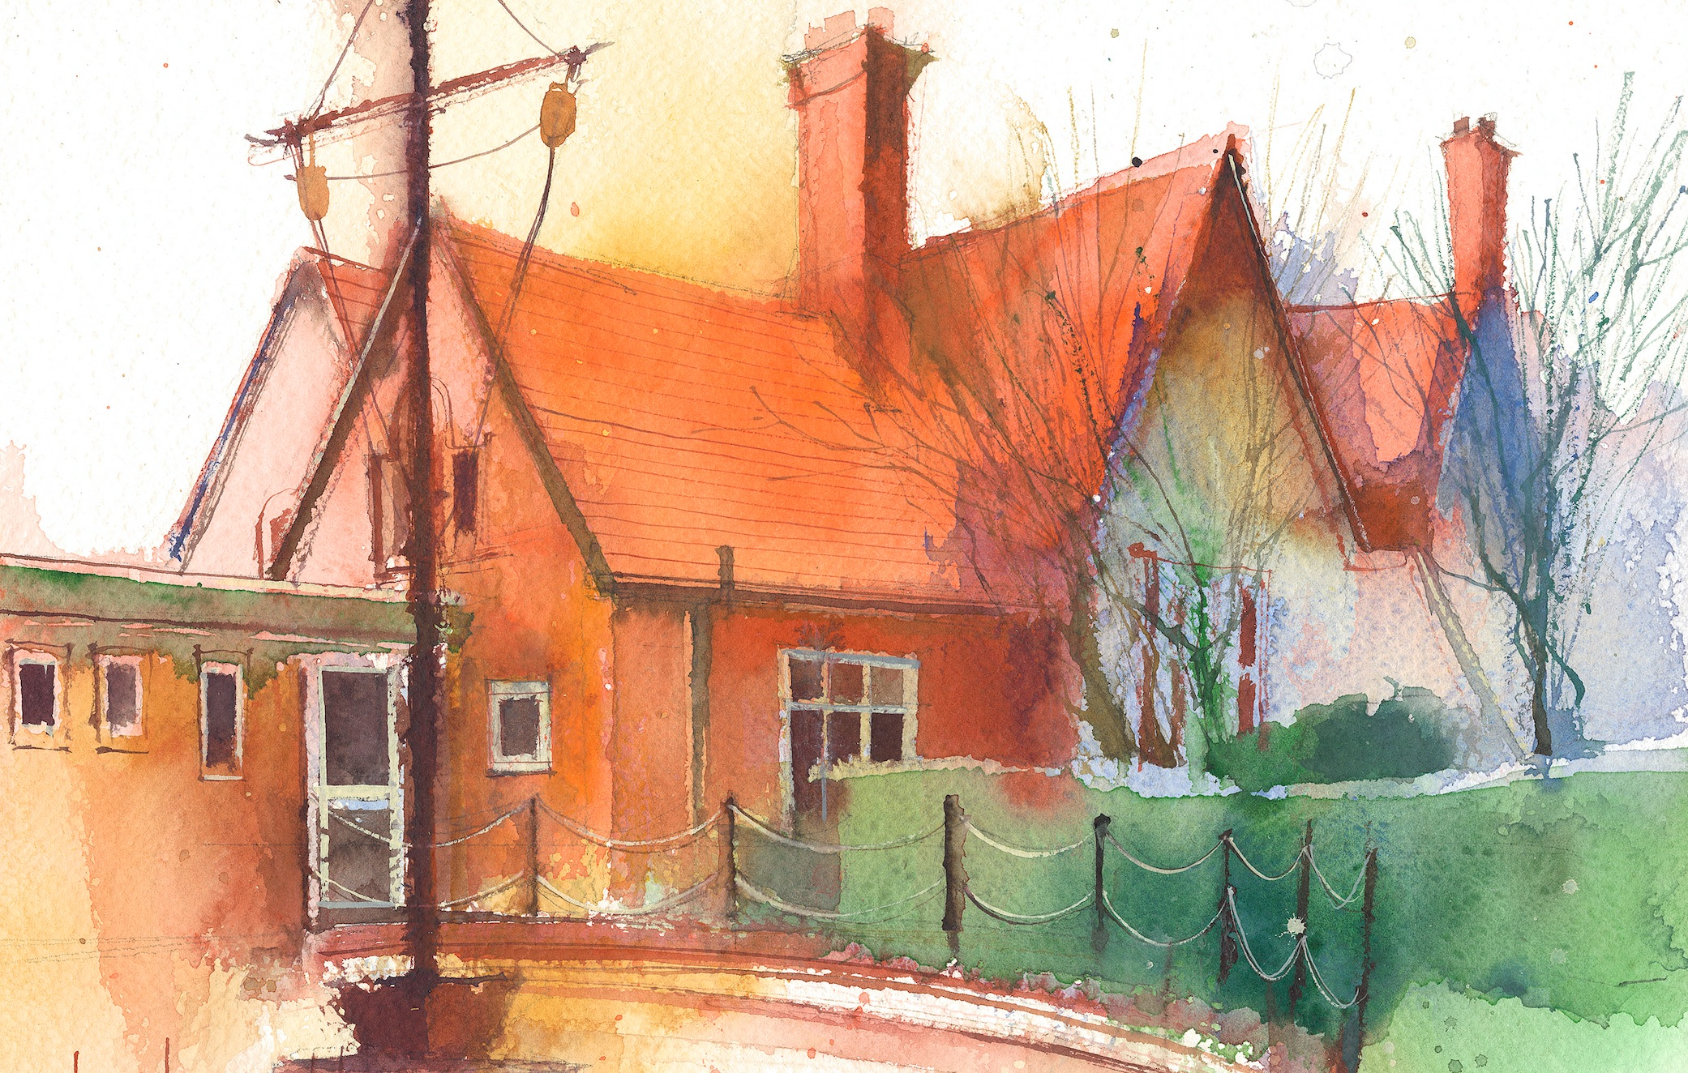

 | Lessons 09:00 – 10:30 |  | Lessons 10:45 – 12:15 |  | Lessons 13:15 – 15:30 (Incorporating 15-minute break) | Additional Tasks
Monday | Maths  Place value Magma Assessment  Collective Worship 10:10 |  | English  .The Lemmings  Writing 1  Write a compelling narrative opening. |  | Computing  Enhancing simple animation  RE  What is the purpose of sacred buildings? | Useful Links / Other Recommended Activities  Oak National Academy  https://classroom.thenational.academy/  BBC Bitesize  https://www.bbc.co.uk/bitesize  Purple Mash  https://www.purplemash.com/sch/dawpool#/  Times table practise:  https://www.timestables.co.uk/multiplication-tables-check/  Hit the button  https://www.topmarks.co.uk/maths-games/hit-the-button
Tuesday | Forest School |  | Forest School |  | Art  Plant Art 4  Develop printing skills.
Wednesday | Christmas Cards |  | Music  Ukulele  English  The Lemmings  Writing 2  Write the build up and arrival of the disruptive character. |  | Geography  Rivers 3  Use the language of rivers to describe the key features of a river
Thursday | Sing worship 9:10  Maths  Addition and Subtraction 1  How to add and subtract in 1’s, 10’s, 100’s, 1000’s  Class based worship: Heart Smart |  | English  The Lemmings  Writing 3  Convey character conflict through punctuated dialogue and action. |  | PE  Game sense invasion  Spanish  Write the name of rooms in school
Friday | Maths  Addition and Subtraction 2  Add numbers with up to 4 digits..  Celebration worship 10:10 |  | English  The Lemmings  Writing 4  Write a resolution where characters compromise and adapt. |  | Science  Identify different animals faeces  Spelling  Homophones or near homophones

