Year 6 Weekly Timetable Week Commencing 9.03.26
To contact your child’s class teacher, please email schooloffice@dawpool.wirral.sch.uk or phone 0151 648 3412
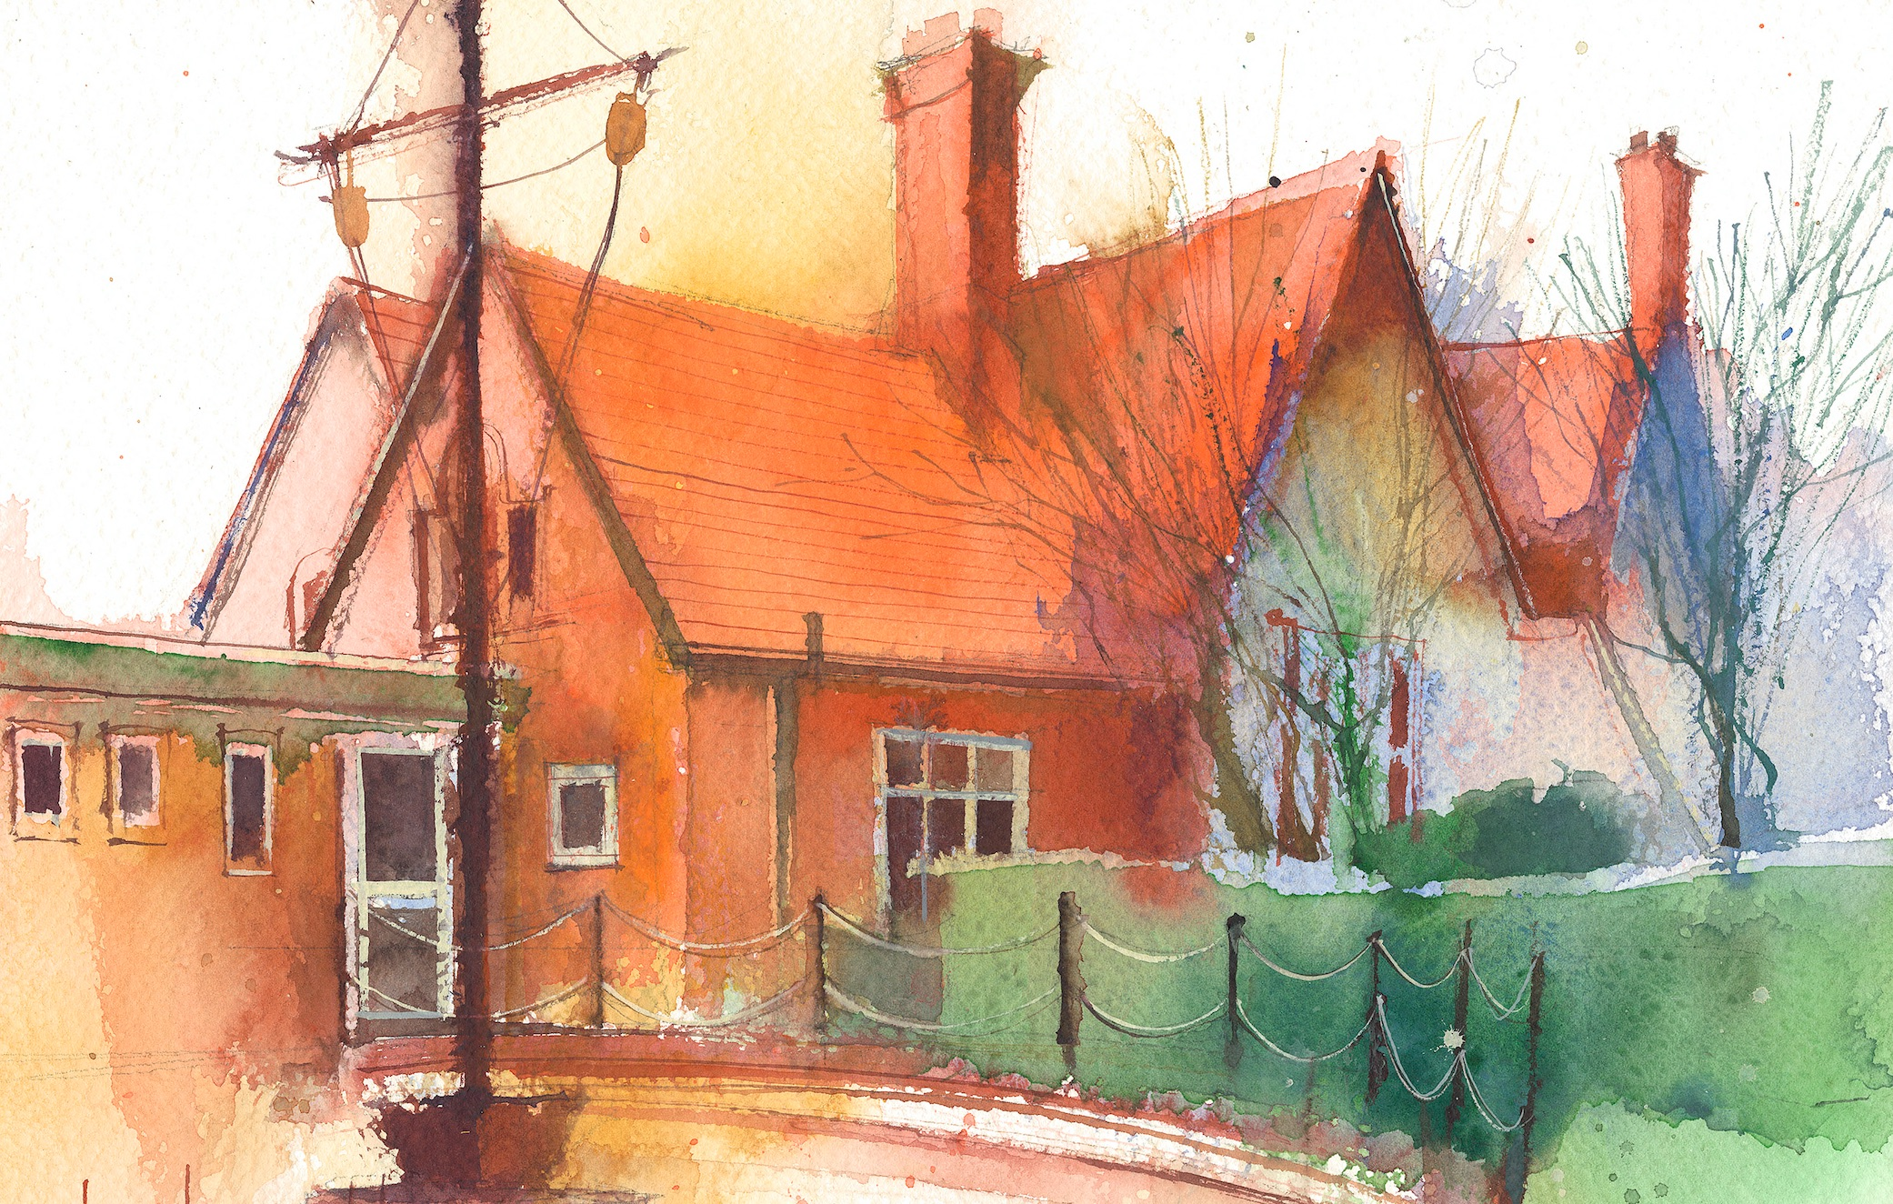

Mrs Croft Monday – Friday

 | Lessons 09:00 – 10:30 |  | Lessons 10:45 – 12:15 |  | Lessons 13:15 – 15:30  (Incorporating 15-minute break) | Additional Tasks
Monday | Fluent in Five/Rapid Reasoning and Arithmetic  Objective:  - To improve mental and written arithmetic strategies and algorithms within a timed period.  Maths  Objective:  - I can form equations. |  | English:  Objectives:  - I can write a narrative on Lost Happy Endings.  - I can check the non-negotiables of spelling, punctuation and Capital letters. |  | History:  Objective:  - I can explore where children were evacuated too and why.  PSHE:  Objective:  - I can explore too much selfie isn’t healthy. | - Explore the life of an Evacuee during WW2. Write a letter home from an evacuee to their parents.  - BBC bitesize:  https://www.bbc.co.uk/bitesize/levels/zbr9wmn
Tuesday | Fluent in Five/Rapid Reasoning and Arithmetic  Objective:  - To improve mental and written arithmetic strategies and algorithms within a timed period.  Maths  Objective:  - I can solve 1-step equations. |  | English: Narrative  Objectives:  - I can write a narrative on Lost Happy Endings.  - I can check the non-negotiables of spelling, punctuation and Capital letters. |  | PE: Dance  Objectives  - Specialist teacher in to teach the children dance.
Wednesday | Fluent in Five/Rapid Reasoning and Arithmetic  Objective:  - To improve mental and written arithmetic strategies and algorithms within a timed period.  Maths  Objective:  - I can solve 2-step equations. |  | English: Narrative  Objectives:  - I can write a narrative based on Lost Happy Endings.  - I can check the non-negotiables of spelling, punctuation and Capital letters. |  | PPA – Mrs Croft  Mrs McCann RE/Computing  Year 6 Computing  - I understand what a hotspot is in coding.  - I can write code that controls the actions of objects that enter or leave a hotspot.  - I can combine the use of hotspots with other coding structures to make a creative program.  Year 6 RE:  - I can describe the nature of God, his characteristics and his relationship with people connected to Old Testament stories.
Thursday | Fluent in Five/Rapid Reasoning and Arithmetic  Objective:  1.To improve mental and written arithmetic strategies and algorithms within a timed period.  Maths  Objective:  - I can find pairs of values. |  | English: Narrative  Objectives:  - I can write a narrative based on Lost Happy Endings.  - I can check the non-negotiables of spelling, punctuation and Capital letters. |  | Science: Inheritance and Evolution  Objective:  - I can research the work of Charles Darwin.  Music:  You’ve got a friend in me  Objective:  To listen and appraise ‘you’ve got a friend in me’
Friday | Fluent in Five/Rapid Reasoning and Arithmetic  Objective:  1.To improve mental and written arithmetic strategies and algorithms within a timed period.  Maths  Objective:  - I can find two unknowns. |  | English – Non-fiction  Objectives:  - I can write a narrative based on Lost Happy Endings.  - I can use basic punctuation and spellings. |  | DT:  Objective:  I can explain what rationing is.  Spanish:  Objective:  I can assess my understanding on ‘this is me’.

